

***Annex 11***

***STOCK ASSESSMENT UPDATE FOR STRIPED MARLIN (*KAJIKIA AUDAX*) IN THE WESTERN AND CENTRAL NORTH PACIFIC OCEAN THROUGH 2013***

***REPORT OF THE BILLFISH WORKING GROUP***

International Scientific Committee for Tuna and Tuna-Like Species in the North Pacific Ocean

15-­‐20 July 2015

Kona, Hawaii, U.SA.

### Acknowledgements

Completion of the Western and Central North Pacific striped marlin stock assessment report was a collaborative effort by the ISC BILLFISH Working Group. We sincerely thank Darryl Tagami, Russell Ito, Kotaro Yokawa, Seiji Oshimo, Minoru Kanaiwa, Chi-Lu Sun, Nan-Jay Su, and Su-Zan Yeh of ISC Billfish Working Group for their help in preparing and providing information for this assessment update. Yi-Jay Chang, with assistance from Brian Langseth and Annie Yau, were the lead modelers, and the Working Group is indebted to Peter Williams of the Western Central Pacific Fisheries Commission (WCPFC) and Michael Hinton of the Inter- American Tropical Tuna Commission (IATTC) for providing data inputs. In addition, Hui-hua Lee (NOAA Fisheries, Southwest Fisheries Science Center), Ian Taylor (NOAA Fisheries, Northwest Fisheries Science Center), and Rick Methot (NOAA Science Advisor for Stock Assessments) provided valuable feedback on the model diagnostics.

## Executive Summary: Western and Central North Pacific Striped Marlin Stock Assessment

**Stock Status:** Estimates of population biomass of the WCNPO striped marlin stock (*Kajikia audax*) exhibit a long-­‐term decline (Table A and Figure A) Population biomass (age-­‐1 and older) averaged roughly 20,513 t, or 46% of unfished biomass during 1975-­‐1979, the first 5 years of the assessment time frame, and declined to 6,819 t, or 15% of unfished biomass in 2013. Spawning stock biomass is estimated to be 1,094 t in 2013 (39% of *SSB*MSY, the spawning stock biomass to produce MSY, Figure B). Fishing mortality on the stock (average *F* on ages 3 and older) is currently high (Figure B) and averaged roughly *F* = 0.94 during 2010-­‐2012, or 49% above *F*MSY. The predicted value of the spawning potential ratio (SPR, the predicted spawning output at current *F* as a fraction of unfished spawning output) is currently *SPR2010-­‐2012* = 12% ,which is 33% below the level of SPR required to produce MSY. Recruitment averaged about 308,000 recruits during 1994-­‐2011, which was 25% below the 1975-­‐2013 average. No target or limit reference points have been established for the WCNPO striped marlin stock under the auspices of the WCPFC.

The WCNPO striped marlin stock is expected to be highly productive due to its rapid growth and high resilience to reductions in spawning potential. The status of the stock is highly dependent on the magnitude of recruitment, which has been below its long-­‐term average since 2007, with the exception of 2010 (Table A). Changes in recent size composition data in comparison to the previous assessment resulted in changes in fishery selectivity estimates and also affected recruitment estimates. This, in turn, affected the scaling of biomass and fishing mortality to reference levels (Figure E).

When the status of striped marlin is evaluated relative to MSY-­‐based reference points, the 2013 spawning stock biomass is 61% below *SSB*MSY (2819 t) and the 2010-­‐2012 fishing mortality exceeds *F*MSY by 49% (Figure D). Therefore, overfishing is occurring relative to MSY-­‐based reference points and the WCNPO striped marlin stock is overfished.

**Stock Identification and Distribution:** The Western and Central North Pacific striped marlin stock is separated from the Eastern North Pacific stock based on results of population genetic studies and empirical patterns in the spatial distribution of fishery catch-per-unit effort. The boundary of the Western and Central North Pacific stock is defined to be the waters of the Pacific Ocean west of 140°W and north of the equator.

**Catches:** Catches of WCNPO striped marlin have exhibited a long-term decline since the 1970s. Annual catches averaged roughly 8,173 mt during 1975-1979 and declined by 59% to an average of 3,385 mt per year during 2004-2013. Reported catches in 2013 totaled 2,984 mt, which was the third lowest reported catch since 1975 (Table A).

**Data and Assessment:** Catch data was collected from all ISC countries and from countries reporting catches to the WCPFC (Table A). The growth curve was re-estimated using newly developed ageing data and value of steepness and natural mortality were also re-estimated using available biological information. Standardized catch-per-unit effort data used to measure trends in relative abundance were provided by Japan, USA, and Chinese Taipei. The stock assessment was conducted using the Stock Synthesis assessment model. The assessment model was fit to relative abundance indices and size composition data in a likelihood-based statistical framework. Maximum likelihood estimates of model parameters, derived outputs, and their variances were used to characterize stock status and to develop stock projections.

**Biological Reference Points:** Reference points based on maximum sustainable yield (MSY) were estimated in the Stock Synthesis assessment model. The point estimate of maximum sustainable yield (± 1 standard error) was MSY = 5,657 mt ± 176. The point estimate of the spawning stock biomass to produce MSY was *SSB*MSY = 2,819 mt ± 85. The point estimate of *F*MSY, the fishing mortality rate to produce MSY (average fishing mortality on ages 3 and older) was *F*MSY = 0.63 ± 0.01 and the corresponding equilibrium value of spawning potential ratio at MSY was SPRMSY = 18.1% ± 0.1%.

**Table A.** Reported catch (mt), population biomass (mt), spawning stock biomass (mt), relative spawning biomass (*SSB*/*SSB*MSY), recruitment (thousands), fishing mortality (average of ages 3 and older), relative fishing mortality (*F*/*F*MSY), exploitation rate, and spawning potential ratio of Western and Central North Pacific striped marlin.

|  |  |  |  |  |  |  |  |  |  |  |
| --- | --- | --- | --- | --- | --- | --- | --- | --- | --- | --- |
| Year | 2007 | 2008 | 2009 | 2010 | 2011 | 2012 | 2013 | Mean1 | Min1 | Max1 |
| Reported Catch | 3084 | 3503 | 2468 | 2852 | 3125 | 3521 | 2984 | 5822 | 2468 | 10594 |
| Population Biomass | 6915 | 6773 | 6409 | 5156 | 7823 | 7349 | 6819 | 12758 | 5156 | 28440 |
| Spawning Stock Biomass | 1192 | 1171 | 970 | 984 | 873 | 1013 | 1094 | 2025 | 815 | 6946 |
| Relative Spawning Biomass | 0.42 | 0.42 | 0.34 | 0.35 | 0.31 | 0.36 | 0.39 | 0.75 | 0.29 | 2.46 |
| Recruitment (age 0) | 240 | 242 | 63 | 496 | 155 | 224 | 352 | 410 | 63 | 1369 |
| Fishing Mortality | 0.82 | 0.99 | 0.80 | 0.96 | 0.89 | 0.97 | 0.76 | 0.95 | 0.47 | 1.54 |
| Relative Fishing Mortality | 1.29 | 1.57 | 1.27 | 1.51 | 1.41 | 1.53 | 1.20 | 1.50 | 0.74 | 2.44 |
| Exploitation Rate | 45% | 52% | 39% | 55% | 40% | 48% | 44% | 48% | 32% | 65% |
| Spawning Potential Ratio | 15% | 12% | 16% | 13% | 12% | 12% | 14% | 13% | 7% | 24% |
| 1 During 1975-2013 |  |  |  |  |  |  |  |  |  |  |

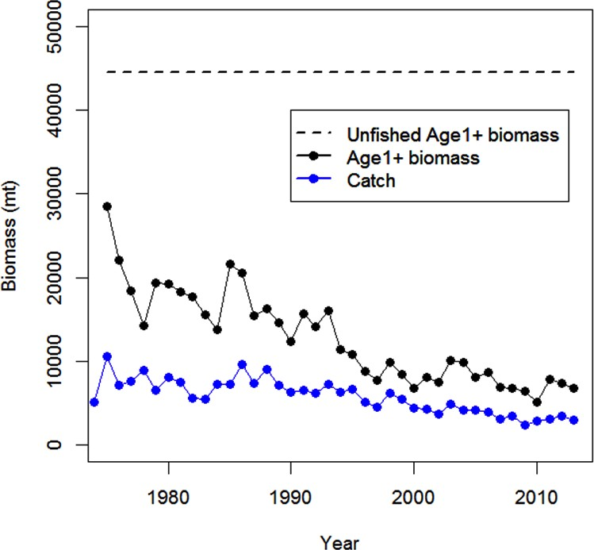

**Figure A**. Trend in population biomass and reported catch biomass of Western and Central North Pacific striped marlin (*Kajikia audax*) during 1975-2013.

**Projections:** Stock projections for future spawning biomass and catch biomasses of WCNPO striped marlin during 2013 to 2020 account for uncertainty in future stock size and recruitment. Three states of nature for future recruitment were assumed for the projections. These were: **Recent Recruitment** in which the recent low recruitment pattern (2007-2011) was randomly resampled; **Medium-Term Recruitment** in which the moderate recruitment pattern since 1994 (1994-2011) was randomly resampled; and **Stock-Recruitment Curve** in which the residuals from the estimated stock-recruitment curve (1975-2011) were randomly resampled and added to expected recruitment. Projections were run using a pooled-sex, age-structured simulation model, included estimation uncertainty for the initial population size at age, and used life history and fishery parameters from the base case stock assessment model.

Ten projected harvest scenarios1 were analyzed; there were six fishing mortality rate scenarios and four constant catch biomass scenarios. The six annual fishing mortality scenarios were: (1) constant fishing mortality equal to the 2001-2003 average (*F*2001-2003 = *F*10%); (2) constant fishing mortality equal to the current *F* (*F*current = *F*12%), the 2010-2012 average; (3) constant fishing mortality equal to FMSY (*F*MSY = *F*18%); (4) constant fishing mortality to produce a spawning potential ratio (SPR) of 0.2 (*F*20%); (5) constant fishing mortality to produce an SPR of 0.3 (*F*30%); and (6) no fishing (*F*100%). The four annual catch biomass scenarios were: 70% of the average catch during 2010-2012 (Cprojection = 2,216 mt); 80% of the average catch during 2010-2012 (Cprojection = 2,533 mt); 90% of the average catch during 2010-2012 (Cprojection = 2,849 mt); and 80% of highest catch by country during 2000-2003 as described in the WCPFC CMM 2010-01 (Cprojection = 3,490 mt). Spawning stock biomass (SSB) in the last projection year (2020) relative to 2015 was the performance measure to describe the future stock impacts while projected median annual catches during 2015-2020 measured the productivity of the fishery.

When the current status quo harvest rate is maintained (*F*12%), the stock is projected to have a 75% probability that SSB2020 < SSB2015 under the recent recruitment hypothesis. The risk that SSB2020 < SSB2015 is reduced to 25% and 5% under the medium-term recruitment and stock-recruitment curve hypotheses, respectively (Table B). In contrast, if harvest rates were to increase to 2001-2003 levels (*F*10%), then the probabilities that

SSB2020 < SSB2015 increase for all 3 recruitment hypotheses and range from 50% to 95%. Conversely, if fishing mortality was reduced to the MSY level (*F*18%) the stock has a 0% chance that SSB2020 < SSB2015 under the medium-term recruitment and stock-recruitment curve hypotheses, but a 5% chance that SSB2020 < SSB2015 under the recent recruitment hypothesis. Under all recruitment hypotheses, fishing at the FMSY level provides a safe level of harvest if one takes less than a 50% risk of declining SSB (SSB2020 < SSB2015) as a threshold. Also, fishing at the FMSY level under the medium-term recruitment and stock-recruitment curve hypotheses would likely produce larger increases in catches from 2015 to 2020 than the current fishing level compared to the recent recruitment hypothesis (Table C).

If fishing intensity were reduced to F30%, SSB2020 > SSB2015 under all recruitment hypotheses and there would be a 50% chance to rebuild the stock to *SSB*MSY by 2019 and 2018 under the medium-term recruitment and stock-recruitment curve hypotheses, respectively (Table 4). Last, if there was a cessation of fishing mortality after 2015, spawning stock biomass would have a 50% chance to rebuild to the *SSB*MSY level by 2017 under all recruitment hypotheses.

When catch is reduced 30% from the current level (2,216 mt; average 2010-2012), spawning stock biomass is projected to have a 5% probability of falling below the 2015 level for recent recruitment hypothesis, but 0% probability under the medium-term recruitment and stock-recruitment curve hypotheses.

If catches were to increase to 3,490 mt (about 80% of highest catches during 2000-2003; the highest catch scenario), the stock would projected to have a 25% chance that SSB2020 < SSB2015 under the recent recruitment hypothesis, and a 0% chance that SSB2020 < SSB2015 under the medium-term recruitment and stock-recruitment curve hypotheses.

Under the recent recruitment hypothesis, none of the constant catch scenarios result in a 50% chance that the stock rebuilds to *SSB*MSY level within the projection period (2015-2020) (Table D). Under the medium-term recruitment and stock-recruitment curve hypotheses, most of the constant catches scenarios allow the population to rebuild to the *SSB*MSY level within 2015-2020, except for constant catches of 3,500 mt (Table D).

Under all recruitment hypotheses, constant catches at levels less than or equal to 2,850 mt appear sustainable if one accepts a 50% risk as a threshold. Although constant catches at levels less than or equal to 3,500 also has less that a 50% chance that SSB2020 < SSB2015, constant catches at levels less than or equal to 2,850 mt would likely produce more stable catches over time under the three recruitment hypotheses (Table C).

**Conservation Advice**: The stock has been in an overfished condition since 1977, with the exception of 1982 and 1983, and fishing appears to be impeding rebuilding especially if recent (2007-­‐2011) low recruitment levels persist. Projection results show that fishing at FMSY could lead to median spawning biomass increases of 25%, 55%, and 95% from 2015 to 2020 under the recent recruitment, medium-­‐ term recruitment, and stock recruitment-­‐curve scenarios. Fishing at a constant catch of 2,850 t could lead to potential increases in spawning biomass of 19% to over 191% by 2020, depending upon the recruitment scenario. In comparison, fishing at the 2010-­‐2012 fishing mortality rate, which is 49% above *FMSY*, could lead to changes in spawning stock biomass of -­‐18% to +18% by 2020, while fishing at the average 2001-­‐2003 fishing mortality rate (*F2001-­‐2003*=1.15), which is 82% above FMSY, could lead to spawning stock biomass decreases of -­‐32% to -­‐9% by 2020, depending upon the recruitment scenario.

**Special Comments:** The WCNPO striped marlin stock is expected to be highly productive due to its rapid growth and high resilience to reductions in spawning potential. The status of the stock is highly dependent on the magnitude of recruitment, which has been below its long-term average since 2004 (Table A). Given the current depletion of spawning stock biomass, fishery catches of striped marlin should be closely monitored.

10000



8000

6000

Spawning Biomass (mt)

4000

2000

SSBMSY

0

1975

1980

1985

1990

1995

Year

2000

2005

2010

**Figure B**. Trends in estimates of spawning biomass of Western and Central North Pacific striped marlin (*Kajikia audax*) during 1975-­‐2013 along with 80% confidence intervals

**Table B**. Decision table of projected percentiles of relative spawning stock biomass in 2020 relative to 2015 (SSB2020/SSB2015) for alternative states of nature (columns) and harvest scenarios (rows). Fishing intensity (*F*x%) alternatives are based on 10% (average 2001-2003), 12% (average 2010- 2012 defined as current), 18% (MSY level), 20%, 30%, and 100% (no fishing). Catch alternatives are based on the 70%, 80%, and 90% of average

catches during 2010-2012 (2,216; 2,533; and 2,849 mt), and 80% of average catches during 2000-2003 (3,490 mt). Red blocks indicate the declining trend of SB in 2020 from 2015 where SSB2020/SSB2015 is less than one.

### Recent Recruitment Medium-Term Recruitment Stock-Recruitment Curve

**Run Harvest scenario**

|  |  |  |  |  |  |  |  |  |  |  |  |  |  |  |  |
| --- | --- | --- | --- | --- | --- | --- | --- | --- | --- | --- | --- | --- | --- | --- | --- |
| **5th** | **25th** | **50th** | **75th** | **95th** |  | **5th** | **25th** | **50th** | **75th** | **95th** | **5th** | **25th** | **50th** | **75th** | **95th** |
| 0.46 | 0.58 | 0.68 | 0.80 | 0.92 |  | 0.63 | 0.78 | 0.86 | 0.94 | 1.02 | 0.59 | 0.76 | 0.91 | 1.08 | 1.32 |
| 0.57 | 0.71 | 0.82 | 0.94 | 1.08 |  | 0.78 | 0.94 | 1.04 | 1.12 | 1.21 | 0.79 | 1.00 | 1.18 | 1.37 | 1.65 |
| 0.92 | 1.10 | 1.25 | 1.40 | 1.56 |  | 1.26 | 1.44 | 1.55 | 1.66 | 1.78 | 1.42 | 1.71 | 1.95 | 2.22 | 2.59 |
| 1.02 | 1.22 | 1.38 | 1.53 | 1.72 |  | 1.41 | 1.59 | 1.71 | 1.82 | 1.94 | 1.60 | 1.92 | 2.18 | 2.46 | 2.86 |
| 1.56 | 1.83 | 2.05 | 2.22 | 2.45 |  | 2.12 | 2.36 | 2.49 | 2.62 | 2.78 | 2.51 | 2.91 | 3.25 | 3.62 | 4.13 |
| 4.26 | 4.77 | 5.23 | 5.55 | 5.93 |  | 5.45 | 5.91 | 6.17 | 6.37 | 6.66 | 6.43 | 7.09 | 7.78 | 8.46 | 9.31 |
| 0.92 | 1.21 | 1.67 | 2.06 | 2.53 |  | 1.58 | 2.19 | 2.56 | 2.87 | 3.16 | 2.04 | 2.99 | 3.70 | 4.52 | 5.58 |
| 0.90 | 1.05 | 1.39 | 1.74 | 2.24 |  | 1.32 | 1.82 | 2.21 | 2.54 | 2.86 | 1.67 | 2.54 | 3.29 | 4.13 | 5.27 |
| 0.88 | 1.01 | 1.19 | 1.48 | 1.96 |  | 1.25 | 1.53 | 1.89 | 2.22 | 2.58 | 1.46 | 2.17 | 2.91 | 3.76 | 4.95 |
| 0.87 | 0.97 | 1.09 | 1.19 | 1.54 |  | 1.19 | 1.31 | 1.44 | 1.70 | 2.06 | 1.39 | 1.71 | 2.31 | 3.13 | 4.40 |

1 *F*2001-2003 = *F*10%

2 *F*2010-2012 = *F*12%

1. *F*MSY = *F*18%
2. *F*20%
3. *F*30%
4. *F*100%
5. 70% of average catch C2010-2012 = 2216.2 mt
6. 80% of average catch C2010-2012 = 2532.7 mt
7. 90% of average catch C2010-2012 = 2849.4 mt
8. 80% of average catch C2000-2003 = 3490.1 mt

**Table C**. Projected trajectory of catch (mt) for alternative states of nature (columns) and harvest scenarios (rows). Fishing intensity (*F*x%) alternatives are based on 10% (average 2001-2003), 12% (average 2010-2012 defined as current), 18% (MSY level), 20%, 30%, and 100% (no fishing). Catch

alternatives are based on the 70%, 80%, and 90% of average catches during 2010-2012 (2,216; 2,533; and 2,849 mt), and 80% of average catches

during 2000-2003 (3,490 mt).

**Recent Recruitment Medium-Term Recruitment Stock-Recruitment Curve**

**Run Harvest scenario**

|  |  |  |  |  |  |  |  |  |  |  |  |  |  |  |  |  |  |  |
| --- | --- | --- | --- | --- | --- | --- | --- | --- | --- | --- | --- | --- | --- | --- | --- | --- | --- | --- |
|  | **2015** | **2016** | **2017** | **2018** | **2019** | **2020** | **2015** | **2016** | **2017** | **2018** | **2019** | **2020** | **2015** | **2016** | **2017** | **2018** | **2019** | **2020** |
| 1 *F*2001-2003 = *F*10% | 3858 | 3289 | 2943 | 2843 | 2861 | 2850 | 4229 | 3995 | 3882 | 3820 | 3811 | 3836 | 4270 | 4167 | 4101 | 4051 | 3985 | 3986 |
| 2 *F*2010-2012 = *F*12% | 3391 | 3124 | 2838 | 2768 | 2760 | 2775 | 3707 | 3775 | 3757 | 3715 | 3710 | 3725 | 3744 | 3928 | 4031 | 4133 | 4166 | 4232 |
| 3 *F*MSY = *F*18% | 2458 | 2622 | 2646 | 2607 | 2590 | 2591 | 2674 | 3130 | 3335 | 3372 | 3381 | 3405 | 2697 | 3254 | 3632 | 3971 | 4213 | 4393 |
| 4 *F*20% | 2254 | 2478 | 2559 | 2517 | 2528 | 2530 | 2451 | 2953 | 3201 | 3265 | 3290 | 3315 | 2472 | 3070 | 3494 | 3872 | 4141 | 4363 |
| 5 *F*30% | 1525 | 1861 | 2068 | 2136 | 2178 | 2194 | 1652 | 2198 | 2558 | 2712 | 2791 | 2846 | 1665 | 2284 | 2797 | 3250 | 3624 | 3907 |
| 6 *F*100% | 0 | 0 | 0 | 0 | 0 | 0 | 0 | 0 | 0 | 0 | 0 | 0 | 0 | 0 | 0 | 0 | 0 | 0 |
| 7 70% of average catch | 2216 | 2216 | 2216 | 2216 | 2216 | 2216 | 2216 | 2216 | 2216 | 2216 | 2216 | 2216 | 2216 | 2216 | 2216 | 2216 | 2216 | 2216 |
| 8 80% of average catch | 2533 | 2533 | 2533 | 2533 | 2533 | 2533 | 2533 | 2533 | 2533 | 2533 | 2533 | 2533 | 2533 | 2533 | 2533 | 2533 | 2533 | 2533 |
| 9 90% of average catch | 2802 | 2792 | 2782 | 2813 | 2847 | 2849 | 2849 | 2849 | 2849 | 2849 | 2849 | 2849 | 2849 | 2849 | 2849 | 2849 | 2849 | 2849 |
| 10 80% of average catch | 2802 | 2760 | 2718 | 2653 | 2641 | 2644 | 3034 | 3310 | 3476 | 3490 | 3490 | 3490 | 3012 | 3447 | 3490 | 3490 | 3490 | 3490 |

C2010-2012 = 2216.2 mt C2010-2012 = 2532.7 mt C2010-2012 = 2849.4 mt C2000-2003 = 3490.1 mt

**Table D**. Projected trajectory of median spawning stock biomass (SSB in mt) for alternative states of nature (columns) and harvest scenarios (rows). Fishing intensity (*F*x%) alternatives are based on 10% (average 2001-2003), 12% (average 2010-2012 defined as current), 18% (MSY level), 20%, 30%, and 100% (no fishing). Catch alternatives are based on the 70%, 80%, and 90% of average catches during 2010-2012 (2,216; 2,533; and 2,849 mt), and 80% of average catches during 2000-2003 (3,490 mt). Green blocks indicate the projected SSB is greater than MSY level (*SSB*MSY = 2,819

mt).

**Recent Recruitment Medium-Term Recruitment Stock-Recruitment Curve**

**Run Harvest scenario**

|  |  |  |  |  |  |  |  |  |  |  |  |  |  |  |  |  |  |  |
| --- | --- | --- | --- | --- | --- | --- | --- | --- | --- | --- | --- | --- | --- | --- | --- | --- | --- | --- |
|  | **2015** | **2016** | **2017** | **2018** | **2019** | **2020** | **2015** | **2016** | **2017** | **2018** | **2019** | **2020** | **2015** | **2016** | **2017** | **2018** | **2019** | **2020** |
| 1 *F*2001-2003 = *F*10% | 1127 | 937 | 821 | 774 | 766 | 765 | 1182 | 1093 | 1051 | 1020 | 1014 | 1017 | 1185 | 1130 | 1111 | 1096 | 1085 | 1084 |
| 2 *F*2010-2012 = *F*12% | 1127 | 1058 | 985 | 940 | 927 | 927 | 1182 | 1225 | 1241 | 1227 | 1220 | 1225 | 1185 | 1264 | 1314 | 1346 | 1383 | 1402 |
| 3 *F*MSY = *F*18% | 1127 | 1316 | 1393 | 1412 | 1420 | 1414 | 1182 | 1496 | 1709 | 1794 | 1825 | 1837 | 1185 | 1540 | 1812 | 2019 | 2198 | 2316 |
| 4 *F*20% | 1127 | 1373 | 1495 | 1541 | 1559 | 1559 | 1182 | 1557 | 1830 | 1951 | 2001 | 2024 | 1185 | 1601 | 1936 | 2200 | 2425 | 2583 |
| 5 *F*30% | 1127 | 1581 | 1924 | 2142 | 2264 | 2313 | 1182 | 1780 | 2310 | 2647 | 2850 | 2949 | 1185 | 1824 | 2447 | 2986 | 3473 | 3856 |
| 6 *F*100% | 1127 | 2045 | 3109 | 4168 | 5105 | 5894 | 1182 | 2266 | 3611 | 5020 | 6270 | 7290 | 1185 | 2307 | 3797 | 5521 | 7380 | 9222 |
| 7 70% of average catch | 1324 | 1639 | 1829 | 1981 | 2100 | 2207 | 1378 | 1883 | 2368 | 2837 | 3217 | 3533 | 1391 | 1910 | 2556 | 3333 | 4190 | 5153 |
| 8 80% of average catch | 1324 | 1545 | 1639 | 1720 | 1774 | 1837 | 1378 | 1791 | 2168 | 2526 | 2807 | 3048 | 1391 | 1820 | 2356 | 3010 | 3745 | 4576 |
| 9 90% of average catch | 1324 | 1478 | 1494 | 1519 | 1556 | 1572 | 1378 | 1702 | 1997 | 2254 | 2443 | 2604 | 1391 | 1738 | 2170 | 2708 | 3360 | 4049 |
| 10 80% of average catch | 1324 | 1466 | 1463 | 1456 | 1448 | 1438 | 1378 | 1648 | 1798 | 1886 | 1946 | 1978 | 1391 | 1683 | 1945 | 2281 | 2743 | 3211 |

C2010-2012 = 2216.2 mt C2010-2012 = 2532.7 mt C2010-2012 = 2849.4 mt C2000-2003 = 3490.1 mt

2.0



1.8

Fishing Mortality (average, age-3 and older)

1.6

1.4

1.2

1.0

0.8

0.6 FMSY

0.4

0.2

0.0

1975

1980

1985

1990

1995

Year

2000

2005

2010

**Figure C.** Trends in estimates of fishing mortality of Western and Central North Pacific striped marlin (*Kajikia audax*) during 1975-­‐2013 along with 80% confidence intervals.

3.0

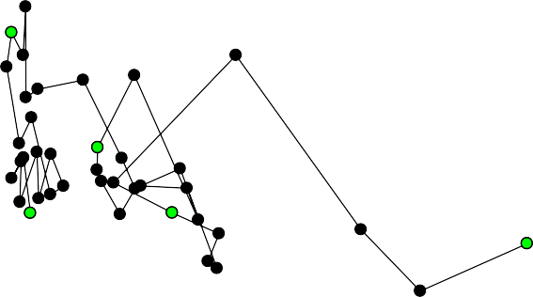

2000

1989

2013

1980

1975

2.5

Relative Fishing Mortality (F/FMSY)

2.0

1.5

1.0

0.5

0.0

0.0 0.5 1.0 1.5 2.0 2.5 3.0

Relative Spawning Biomass (SSB/SSBMSY)

**Figure D.** Kobe plot of the trends in fishing mortality and relative spawning biomass of Western and Central North Pacific striped marlin (*Kajikia audax*) during 1975-­‐2013.

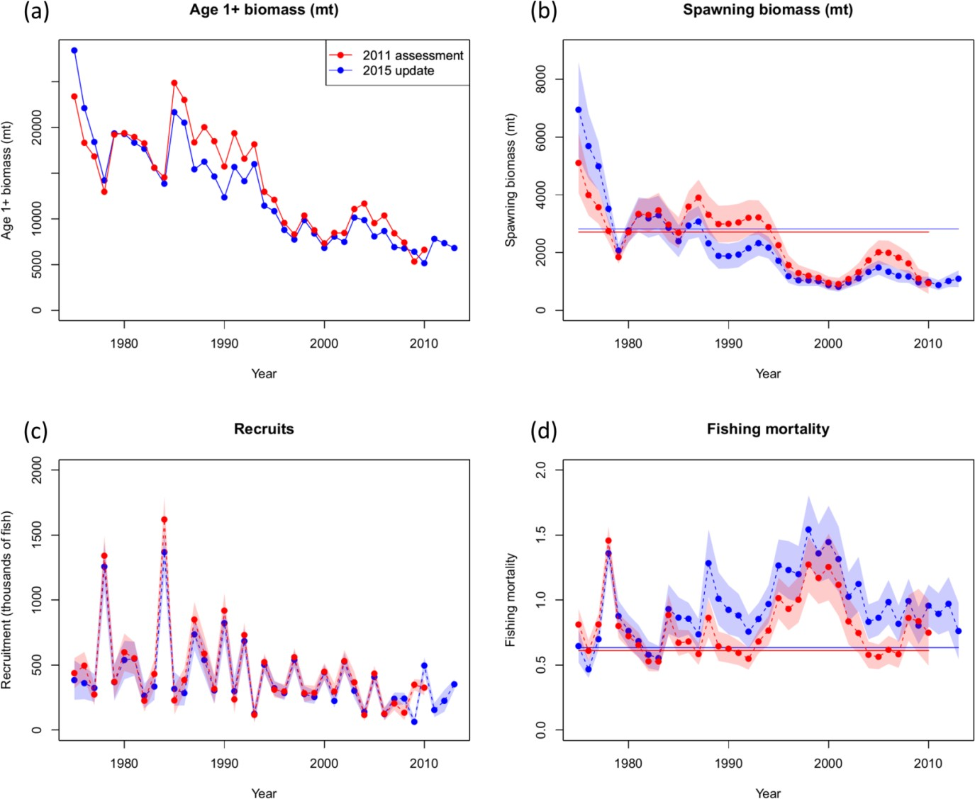

**Figure E.** Comparison of time series of total biomass (age 1 and older) (a), spawning biomass (b), age-0 recruitment (c), and instantaneous fishing mortality (year-1) (d) for the WCNPO striped marlin between the 2011 stock assessment (red) and the 2015 update (blue). The solid line with circles represents the maximum likelihood estimates for each quantity and the shadowed area represents the 95% asymptotic intervals of the estimates (± 1.96 standard deviations). The solid horizontal lines indicated the MSY-based reference points for 2011 (red) and 2015 (blue).

### Abstract

We present an update of the stock assessment of the Western and Central North Pacific Ocean (WCNPO) striped marlin (*Kajikia audax*) stock conducted in 2011 by the ISC Billfish Working Group (BILLWG). The assessment update consisted of refitting a Stock Synthesis model with newly available catch, abundance index, and size composition data for 1975–2013. We used the same model structure and parameters as were used in the base case run from the 2011 stock assessment. The model results indicated that biomass (age 1 and older) of the WCNPO striped marlin stock showed a long-term decline from 28,840 mt in 1975 to 5,516 mt in 2010 that was followed by an increase to 6,819 mt in 2013. Estimates of fishing mortality (*F*) were stable, and fluctuated around 0.90 year-1 over the last six years. Compared to MSY-based reference points, spawning stock biomass in 2013 was 61% below *SSB*MSY and current fishing mortality (the average *F* for 2010–2012) was 49% above *F*MSY. Consequently, the updated assessment indicated that the stock remained in an overfished state and that overfishing was still occurring.

### Introduction

The ISC Billfish Working Group (BILLWG) completed a stock assessment for striped marlin (*Kajikia audax)* in the Western and Central North Pacific Ocean (WCNPO) in 2011 (ISC, 2012). The 2011 assessment used data through 2010, and the results indicated a long-term decline in population biomass. Spawning stock biomass (SSB) was approximately 938 mt in 2010, or 35% of SSB at maximum sustainable yield (*SSB*MSY). Fishing mortality (*F*) on the stock (average *F* on ages 3 and older) was high, averaging roughly *F* = 0.76 during 2007-2009, or 24% above the fishing mortality rate to produce maximum sustainable yield (*F*MSY). The assessment suggested that overfishing was occurring relative to *F*MSY and that the WCNPO striped marlin stock was in an overfished state. In response to these findings, the BILLWG proposed to conduct an updated stock assessment using four additional years of fishery data (2010 to 2013) to monitor stock status, and this work plan was approved at the 2014 ISC plenary meeting (ISC, 2014).

This stock assessment report describes the updated 2015 assessment of striped marlin in the WCNPO, which was developed using the newly available catch, catch-per-unit-effort (CPUE), and size composition data provided by ISC countries and the WCPFC (ISC, 2014). We applied the same stock assessment model (Stock Synthesis, SS) but used a newer version (version 3.24f compared to 3.20b) for the modeling platform. The assessment update also used the same model structure and parameters as were used in the base case model from the 2011 stock assessment.

### Materials and Methods

*Spatial and temporal stratification*

The geographic area encompassed in the assessment for the WCNPO striped marlin were the waters of the Pacific Ocean west of 140°W and north of the equator (Fig. 1). Three types of data were used: fishery-specific catches, relative abundance indices, and length measurements. These data were compiled for 1975–2013. Available data, sources of data and temporal coverage of the datasets used in the updated stock assessment are summarized in Fig. 2. Details are presented below.

*Definition of fisheries*

As in the 2011 assessment, 18 fisheries were defined for the 2015 assessment update on the basis of country, gear type, location, and season and were considered to be relatively heterogeneous fishing units (Fig. 2 and Table 1). There were nine country-specific longline fisheries: the Japan distant water longline fishery in area A1 (JPN_DWLL_A1); the Japan distant water longline fishery in area A2 (JPN_DWLL_A2); the Japan distant water longline fishery in area A3 (JPN_DWLL_A3); the Japan coastal longline fishery (JPN_CLL); the Japan other longline fishery (JPN_OLL); the Taiwanese longline fishery (TWN_LL); the Taiwanese offshore longline fishery (TWN_OSLL); the Hawaii longline fishery (HW_LL); and the Korean longline fishery (KOR_LL). There were two driftnet fisheries: the Japanese driftnet fishery (JPN_DRIFT) and

the Japanese squid driftnet fishery (JPN_SQUID). There was one Japanese bait fishery (JPN_BAIT), one Japanese trap fishery (JPN_TRAP), one Japanese net fishery (JPN_NET), two Japanese harpoon fisheries (JPN_OTHER_Q12 and JPN_OTHER_Q34), one Taiwanese coastal fishery (TWN_CF) and one miscellaneous longline fishery (WCPO_OTHER). Detailed descriptions of each of these fisheries were reviewed and summarized (Table 1).

*Catch*

Total catch was input into the SS3 model seasonally (i.e., by calendar years and quarters) from 1975 to 2013 for the above 18 individual fisheries. Catch was recorded and reported in numbers (thousands of fish) for the Japan distant-water longline fisheries (JPN_DWLL_A1, JPN_DWLL_A2, and JPN_DWLL_A3) and in weight (metric tons) for the other 15 fisheries.

Several countries (i.e., Japan, Taiwan, Korea, and the USA) provided updated national catch data (Yokawa et al., 2015; Su et al., 2015; Ito, 2015; Sang-Chul Yoon, personal communication, Jan 6, 2015). Striped marlin catches for all other countries fishing in the WCNPO area (WCPO_OTHER) were collected from the WCPFC TASK I & II data, with preference for

TASK I when available, (Tagami and Wang, 2015; Yau and Chang, 2015) and with Chinese country-provided data (Xiaojie Dai, personal communication, Jan 4, 2015). The updated catch of the WCPO_OTHER fishery included catch data from Belize, Cook Islands, China, Spain, Fiji, Federated States of Micronesia, Guam, Kiribati, Marshall Islands, Philippines, New Caledonia, Papua New Guinea, and Vanuatu.

There were differences in some years prior to 2010 between the newly provided catch data for the 2015 assessment and the data from the 2011 assessment. The BILLWG discussed the choices to update old catch data from the last assessment with the new catch data for only 2010–2013 for two of three Taiwanese fleets, the Hawaiian fleet, and other fleets in WCNPO area. Concerns were raised by BILLWG about the selection methods of best available data. These initial

decisions were made because differences in these data were not available for full review at the January 2015 data workshop.

The BILLWG recognized that historical catch series of Taiwanese fisheries were revised since the 2011 assessment and that some differences were observed between old and new time series. The BILLWG discussed and agreed that the new Taiwanese time series workshop for the offshore longline fleet (TWN_OSLL) and coastal fisheries fleet (TWN_CF) provided at the January 2015 data workshop were more appropriate for the stock assessment than those used in the last assessment. The BILLWG noted that the new data series provided a more accurate representation of total catch which included foreign-based offshore longline fleets and also corrected previous double counting of some coastal fisheries data. The third Taiwanese fleet (distant water longline, TWN_LL) was also updated with new data to maintain consistency with other fleets.

The BILLWG discussed differences among the Hawaiian catches (HW_LL) and agreed that the use of only updated data from 2010–2013 provided the best available information due to possible misidentification of striped marlin as blue marlin, as discussed at the January 2015 data workshop (Ito, 2015). The BILLWG also noted that catches from the last assessment were generally greater than catches presented at the January data workshop.

The BILLWG discussed the treatment of the catch data for Indonesia and Belize, which were not reported in the newly provided data for the category of other fleets operating in the WCNPO area, as well as the catch data for China. Given that there was no new information provided at the data workshop, and no representation from the respective countries at this meeting, the BILLWG agreed that updating new 2010–2013 catch data to the data time series from the last assessment, which included Indonesia and Belize, constituted the best approach. The BILLWG discussed the issue of multiple catch series in 2010–2013 for the model’s WCNPO area fleet (WCPO_OTHER) as reported by TASK I and TASK II data from the WCPFC and by an additional series for China submitted by China to the January 2015 data workshop. Given the precedent for using country-

provided data if these were directly provided, and TASK I data over TASK II data, the BILLWG agreed to use TASK I data for individual counties within the WCNPO area fleet and the China data as directly provided by China. One sensitivity run was conducted using TASK I data for China and results were similar to those using the directly provided data. The BILLWG discussed the lack of new information on Indonesia and Belize catch data and recommended that data from these countries be routinely reported to improve future assessments.

The BILLWG discussions about catch data strongly supported the BILLWG recommendation that any revision of historical data used in the last assessment be explained in the systematic way by data-submitting countries at the BILLWG data workshop. Nonetheless, the time series of total annual catches of striped marlin was very similar to that used in the 2011 assessment with some minor differences occurring after 2000 (Fig. 3.1). Overall, the use of the updated data led to an increase in striped marlin catch biomass of about 4.7% during the 2003–2010 time period in comparison to the 2011 assessment.

The time series of finalized striped marlin catch biomasses from 1975–2013 were summarized and plotted by fishery (Fig. 3.2). The historical maximum and minimum annual striped marlin catches were 10,594 metric tons in 1975 and 2,468 metric tons in 2009, respectively. The JPN_DWLL_A2, JPN_DWLL_A3, JPN_CLL, and JPN_DRIFT fisheries took most of the striped marlin catch throughout the assessment period. However, striped marlin catches by the JPN_DWLL_A2 and JPN_DWLL_A3 fisheries have gradually decreased since 1995. For the updated time period (2010–2013), the average annual catch of striped marlin in the WCNPO was about 3,120 metric tons. The JPN_CLL fishery caught most of the striped marlin catch (30%) during that time. Striped marlin catches by the WCPO_OTHER fishery however, increased during 2010–2013 and comprised about 10% of the total catch biomass. Overall, there has been a decrease of striped marlin catch by the JPN_DRIFT fishery since 2010.

*Abundance indices*

Relative abundance indices of CPUE were available for this assessment and are shown in Fig. 4, Table 2 and Table 6.1. All indices were updated from the 2011 assessment except for S12_JPN_DRIFT1 (1977–1993) and S14_TWN_LL1 (1975–1993) fisheries. A monthly dataset aggregated by 5x5 degree grids from 1975–2013 was used in the CPUE standardization for Japanese distant water and offshore longline fisheries (Kanaiwa et al., 2015), which were also split into three areas and three time blocks (1975–1986, 1987–1999 and 2000–2013) as in the 2011 assessment. The generalized linear model (GLM) for the standardization of abundance indices was the same as was used for the CPUE standardization for the last 2011 assessment.

Logbook data from the Japanese coastal longline fishery (S11_JPN_CLL) during 1975–2013 was used in the CPUE standardization. Standardized CPUE was developed by GLM with negative binomial error (Oshimo et al., 2015). For S13_ JPN_DRIFT2, logbook data of core fishing seasons and fishing areas were standardized by GLMs with main effects and two way interactions of year*month and latitude*longitude (Yokawa and Shiozaki, 2015).

Data aggregated by 5x5 degree grids, quarters, latitude, longitude, and gear configurations were used for CPUE standardization for S15_TWN_LL2 (Sun et al., 2015). Information on hooks per basket has been available since 1995, and was thus incorporated in the updated CPUE standardization model for 1995–2013.

Operational data of S16_ HW_LL in 1995–2013 collected by fishery observers were used for CPUE standardization (Walsh and Chang, 2015). Additional work on striped marlin CPUE standardizations for Hawaii demonstrated that the results were similar among alternative assumptions about the error distribution and covariates (Langseth, 2015). For this reason, the same approach used in the last assessment (the Poisson GLM) was used to develop the relative abundance index for S16_HW_LL.

Visual inspection of all indices grouped by fishery type showed an upward trend since 2010, although this varied among fleets in the timing and magnitude of the increase (Fig. 4). Updated CPUE indices in relative scale were compared to the indices used in the 2011 assessment

(Appendix 1, Fig. A1.1). In general, the trend in the updated CPUE indices was consistent with the CPUE indices from the 2011 assessment, although there was an extreme CPUE value during 2011 in the S4_JPN_DWLL3_A1 CPUE series. In addition, the updated CPUE time series S4_JPN_DWLL3_A1 showed a higher variability during 2010–2013. The updated S10_JPN_DWLL3_A3 and S11_JPN_CLL time series were also more variable, and both showed a declining trend in comparison to the same CPUE indices used in the 2011 assessment.

Correlations among CPUE indices were compared in the 2011 assessment (Appendix 1, Table A1.1). Similarly, correlations among the updated CPUE indices were also examined within three time stratifications (1975–1986, 1987–1999, and 2000–2013). Pearson correlation coefficients (*ρ*) were interpreted as measuring the association among pairs of CPUE series. For the first time period, all Japanese DW longline indices (S2_JPN_DWLL1_A1, S6_JPN_DWLL1_A2, and S8_JPN_DWLL1_A3) showed a consistent trend (*ρ* ranged from 0.44 to 0.68). However, negative correlations were found between the Japanese DW longline indices and the early Japan drift (S12_JPN_DRIFT1) index (*ρ* ranged from -0.23 to -0.40). There were also some differences in the early trends between Japanese DW longline indices and early Taiwanese longline index (S14_TWN_LL1). There was a negative correlation between S8_JPN_DWLL1_A3 and S14_TWN_LL1 with *ρ* = -0.17.

During the second time period of 1987–1999, CPUE values varied over time among the Japanese distant water longline indices (S3_JPN_DWLL2_A1 and S7_JPN_DWLL2_A2, and S9_JPN_DWLL2_A3) except for a general increasing trend during 1990–1994. There was also a negative correlation between the CPUE series S7_JPN_DWLL2_A2 and S9_JPN_DWLL2_A3 (*ρ* = -0.33). The S11_JPN_CLL, late Taiwanese longline (S15_TWN_LL2), and Hawaii longline (S16_HW_LL) CPUE indices have all generally declined since 1995, and these indices were positively correlated (*ρ* ranged from 0.21 to 0.52). The Japanese DW longline indices (S3_JPN_DWLL2_A1 and S7_JPN_DWLL2_A2) and the other longline indices (S11_JPN_CLL, S15_TWN_LL2, and S16_HW_LL) were negatively correlated (*ρ* ranged from

-0.14 to -0.77). The early Japanese driftnet (S12_JPN_DRIFT1) and early Taiwanese longline

(S14_TWN_LL1) indices showed an increasing trend during this period. As a result, the S12_JPN_DRIFT1 and S7_JPN_DWLL2_A2 (*ρ* = 0.76) and S14_TWN_LL1 and

S7_JPN_DWLL2_A2 indices (*ρ* = 0.70) were positively correlated, but the S9_JPN_DWLL2_A3 index was negatively correlated with the S12_JPN_DRIFT1 series (*ρ* = - 0.43) and the S14_TWN_LL1 indices (*ρ* = -0.21).

During the third time period of 2000–2013, the Japanese distant water longline indices (S4_JPN_DWLL3_A1, S5_JPN_DWLL3_A2, and S10_JPN_DWLL3_A3) generally showed a consistent decline in CPUE during 2000–2009, followed by an increase during 2010–2013. A positive correlation existed between the S5_JPN_DWLL3_A2 and S10_JPN_DWLL3_A3 indices (*ρ* = 0.55). The Japanese coastal longline (S11_JPN_CLL), late Taiwanese longline (S15_TWN_LL2) and the Hawaiian longline (S16_HW_LL) indices were similar to the Japanese distant water longline indices. However, the S5_JPN_DWLL3_A2 and S15_TWN_LL2 indices exhibited dissimilar, negatively correlated trends (*ρ* = -0.20). The late Japanese driftnet (S13_JPN_DRIFT2) index increased gradually over time. Negative correlations were found between the S13_JPN_DRIFT2 index and the CPUE indices of S10_JPN_DWLL3_A3, S11_JPN_CLL and S16_HW_LL (*ρ* ranged from -0.28 to -0.42).

*Size composition data*

Quarterly length composition data from 1975–2013 were used in the assessment update, and are summarized in Table 3. In total, length composition data were available for 11 of the 18 fisheries. There were some inconsistencies in size composition data between the updated 2015 assessment and the 2011 assessment; the differences in the size composition were plotted and described in detail in Chang et al. (2015a). We used new time series of size composition data for each fleet except L9_HW_LL and L10_WCPO_OTHER, which were only updated from the last input year of the 2011 assessment. The new Japanese size composition data were used because they represented additional samples from the longline and other fisheries and constituted best

available information. A newer time-series of size composition data of L8_TWN_LL from

2006–2013 was used because it provided a more consistent pattern of size composition over time. The L11_KOR_LL data set was not used in the update assessment because the newly available size composition data of L11_KOR_LL (2009–2013) were much more variable than the size data of L11_KOR_LL (2005 season 4; *n* = 51) used in the 2011 assessment. Length measurements were compiled into 5-cm size bins, ranging from 120 to 230 cm eye-to-fork length (EFL). Each length frequency observation consisted of the actual number of striped marlin measured.

The updated quarterly size composition data and the updated aggregated size composition data (Figs. 5 and 6) were examined for expected seasonal patterns. Most of the fisheries exhibited consistent, clear seasonal cycles in size composition. However, the L1_JPN_DWLL_A1, L6_JPN_OTHER_Q12, L7_JPN_OTHER_Q34, L10_WCPO_OTHER, and L11_KOR_LL

fisheries had size distributions that varied considerably among years and seasons. There was also considerable variation in both the modal lengths and shapes of the size distributions among fisheries. Size distributions for the L2_JPN_DWLL_A2, L3_JPN_DWLL_A3, L4_JPN_CLL, L9_HW_LL, and L10_WCPO_OTHER fisheries were generally skewed to sizes less than 160 cm EFL and typically exhibited a single mode near 140 cm EFL. The L6_JPN_OTHER_Q12 and L8_TWN_LL fisheries exhibited modes at sizes larger than 160 cm EFL, meaning that these fisheries caught larger striped marlin.

*Model description*

The 2015 stock assessment update for WCNPO striped marlin was conducted using the same stock assessment model (Stock Synthesis, SS) as was used in the 2011 assessment, but employed a newer version of the modeling software (version 3.24f). In particular, the model structure and input parameters for the update were the same as used in the base case model from the 2011 stock assessment. Biological and demographic assumptions and the fishery dynamics assumptions were taken from ISC BILLWG working papers as previously agreed (Table 4 and Table 5). Growth was modeled with a von Bertalanffy growth curve, recruitment was modeled with a Beverton-Holt stock-recruit relationship and the natural mortality rate was age-specific.

The base case model structure allowed for the estimation of domed-shaped selectivity patterns for all fisheries except the JPN_DRIFT, JPN_SQUID, and JPN_OTHER_Q12; fishery selectivity patterns for these fisheries were assumed to be asymptotic (Table 5). Fishery selectivity patterns were also allowed to vary in time for the Japanese distant water longline fleets. The dynamics of the base case model started in 1975. It was assumed that the combined fisheries were in equilibrium in 1975 with an assumed equilibrium catch of 5,000 mt. There were 5 initial recruitment deviations estimated prior to the start of model dynamics and these deviations were used to initialize the population age structure in 1975. The base case model was fitted to the length composition data and CPUE indices.

*Data observation models*

The assessment model fits predicted values to three observed data components: 1) total catch biomass; 2) relative abundance indices; and 3) size composition data. The observed total catches were assumed to be unbiased and relatively precise, and were fitted assuming a lognormal error distribution with standard error (SE) of 0.05. The relative abundance indices were assumed to have log-normally distributed errors with SE in log-transformed units, which is approximately equivalent to the coefficient of variation (CV) in untransformed units. The CVs of each candidate index were first estimated by the statistical model to derive the standardized abundance index and were reported in each of the various BILLWG CPUE standardization working papers (values were summarized in Table 6.2). However, the reported CVs for the abundance indices only represented the within-index observation errors based on the standardization model and did not account for the process errors between the population abundance series and the set of observed CPUE indices.

During preliminary modeling analyses, CPUE indices that had a CV < 0.2 were scaled to have a CV = 0.2 through the addition of a constant to the CPUE series. Observed CPUE indices with a CV > 0.2 were input to the model with no adjustment of their CV. The amount of process error to be added to the CPUE indices was estimated following methods described in Francis (2011).

In particular, the method involved fitting a series of data smoothers having different amounts of smoothing tension to the CPUE index, and calculating the total error (i.e., observation + process) of the fitted residuals of the smoother to the CPUE data. For this assessment update, an appropriate CV was chosen qualitatively from the resulting plots of the fits, and was set to be the largest CV that still gave a smooth and good fit to the data (i.e., smooth.par = 0.7; Appendix 1, Fig. A1.2). The input CPUE values and the reported CVs for all indices are shown in Tables 6.1 and 6.2, respectively.

The size composition data were modeled with multinomial error distributions and the associated error variances determined by the effective sample sizes. Size measurements of fish are typically not random samples representing the entire population. Rather, they tend to be cluster samples that are highly correlated within a fishing operation or trip (Pennington et al., 2002). As a result, the effective sample size is usually substantially lower than the actual number of fish measured because the variance within each fishing operation or trip is substantially lower than the variance within the population.

An approximation of the realized effective sample size was taken from an analysis of observed trips sampled in the Hawaii-based longline fishery (Courtney, unpublished); the estimated effective sample size was roughly 10 fish per trip. This was the same approximation that was used in the 2011 assessment. As a result, the input effective sample size was calculated as the total number of fish measured divided by 10 for all longline fisheries (i.e., L1_JPN_DWLL_A1, L2_JPN_DWLL_A2, L3_JPN_DWLL_A3, L4_JPN_CLL, L8_TWN_LL, L9_HW_LL, and

L10_WCPO_OTHER) and one driftnet fishery, L5_JPN_DRIFT. The input effective sample size was set to be the observed number of fish measured for the L6_JPN_OTHER_Q12 and L7_JPN_OTHER_Q34 to reflect their very low sample sizes. Based on the 2011 stock assessment, the minimum and maximum quarterly input effective sample sizes were set to be 1 and 50, respectively. Quarterly size composition data sets with a calculated effective sample size of less than 1 fish were considered to be unrepresentative and were excluded from model analyses while data sets with effective sample sizes of over 50 fish were set to be 50.

*Data weighting*

The goodness of fit of model predictions of the observed relative abundance indices was prioritized in this assessment based on the principle that relative abundance indices should be fitted well. This principle reflects the fact that abundance indices should provide a direct measure of population trends and scale, and that other data components, such as size composition data, should not induce poor fits to the abundance indices (Francis, 2011). In the assessment update, we used the weighting scheme for a size composition data set recommended by Francis (2011, Method TA1.8), where the weighting coefficient ( *w* ) was

*w*  1

*Var* *O*

− *E* / *v*

/ *n* 0.5 



*y y y y*



and where *Oy*

and *Ey*

were the observed and expected mean lengths for year *y*, *vy* was the

variance of the expected length distribution for year *y*, and *ny* is the effective sample size for year

*y*. This method compares the mean observed length from some fleet and year to the expected length predicted by the model, relative to the confidence interval for the predicted mean length. For any given data set, the calculated weight depends on the distance between the observed and expected mean length values of the data set. The aim of this weighting is to make the standard deviation of the normalized residuals of the fit to the observed mean length close to one. This weighting method accounts for the possibility of substantial correlations within a dataset, and as a result, generally produces a more realistic and smaller effective sample size, which in turn, down weights the size composition data (Francis, 2011).

The Francis weighting method was applied in three iterations to show the effects on successive estimates of the data weighting coefficient for each length composition data set. The initial input mean sample sizes and re-weighted estimated sample sizes for three iterations were calculated (Table 7). Weights for the first iteration were used because this iteration resulted in the smallest

gradient for the objective function to be minimized among the three iterations of the model. Within the first iteration, the effective sample sizes of most of the size compositions were scaled down by factors between 0.20 and 0.97, with the greatest effect being on the L7_JPN_OTHER_Q34, L6_JPN_OTHER_Q12, and L3_JPN_DWLL_A3 size compositions. In contrast, the size compositions for the fisheries L9_HW_LL, L8_TWN_LL, L2_JPN_DWLL_A2, and L10_WCPO_OTHER were scaled up.

*Goodness-of-fit to abundance data*

For each abundance index, the standard deviation of the normalized (or standardized) residuals (SDNR) was used to examine the goodness-of-fit (Francis, 2011). For an abundance data set to

be well fitted, the SDNR should be less than

⬆⬆** 2 / *m*  1 where **2

is the 95th

 0.95, *m*1 ✗✗

0.5

0.95, *m*1

percentile of a

** 2 distribution with m–1 degrees of freedom or numbers of years. Various

residuals plots, including the observed and expected abundances, were also examined to assess goodness-of-fit in order to select the final weighting coefficient values and associated effective sample sizes.

*Sensitivity analyses*

The BILLWG developed a set of 10 sensitivity runs based on sensitivity analyses done in the last stock assessment and discussions at the January and April BILLWG meetings (Table 8.1). It was also requested that spawning stock biomass and spawning potential ratio, as provided in the 2011 assessment report (ISC, 2012) run, be provided for each sensitivity run to empirically evaluate how sensitive the base case model configuration was to alternative model assumptions and configurations.

Additional sensitivity runs from the last assessment (ISC, 2012) were discussed but were considered to be unimportant or not applicable. This included sensitivity runs comparing the

results from the 2007 assessment (starting at 1952, using older estimates of life history parameters) to the 2011 assessment.

*Retrospective analysis*

Retrospective analysis was conducted to examine the consistency among successive model estimates of population size, or related assessment variables obtained as new data are gathered. Within-model retrospective analysis which trims the most recent 5 years (2009–2013) of data in successive model runs were used to examined changes in the estimates of spawning biomass and fishing intensity (1-SPR). Mohn’s (1999) DR statistic was calculated as:

*npeels XY*  *X*

*DR*    *y* ,*tip Y*  *y* ,*ref*

*y*1

*XY*  *y* ,*ref*

where *X* denotes the variable from the stock assessment such as spawning biomass, *y* denotes year, *npeels* denotes the number of years that are dropped in successive fashion and the assessment rerun, *Y* is the last year in the full time series, *tip* denotes the terminal estimate from an assessment with a reduced time series, and *ref* denotes the assessment using the full time series.

*Stock projections*

The BILLWG discussed stock projection scenarios based on those used in the last assessment and agreed to use Rebuilder (Version 3.12b; Punt 2010) for conducting the projection analysis. The BILLWG noted that there was some ambiguity about the periods of the fishing mortality for one scenario from the last assessment because the CMM of WCPFC in 2010 (CMM 2010-01, 2010) mentioned that the reference years for harvest were 2000–2003 and that the fishing mortality reference was for 2003. However, reference years of 2001–2003 were used in the previous assessment. Overall, the BILLWG agreed to use the same reference period for fishing

mortality (2001–2003) to maintain consistency with the stock projections from the last stock assessment.

Stock projections for future spawning biomass and catch biomasses of WCNPO striped marlin during 2013 to 2020 accounted for both uncertainty in future stock size and recruitment. Three states of nature for future recruitment were assumed for the projections. These were: Recent Recruitment in which the recent low recruitment pattern (2007–2011) was randomly resampled; Medium-Term Recruitment in which the moderate recruitment pattern since 1994 (1994–2011) was randomly resampled; and Stock-Recruitment Curve in which the residuals from the estimated stock-recruitment curve (1975–2011) were randomly resampled and added to expected recruitment. Projections were run using a pooled-sex, age-structured simulation model, included estimation uncertainty for the initial population size at age, and used life history and fishery parameters from the base case stock assessment model.

Ten projected harvest scenarios were analyzed; there were six fishing mortality rate scenarios and four constant catch biomass scenarios (Table 8.2). The six annual fishing mortality scenarios were: (1) constant fishing mortality equal to the 2001–2003 average (*F*2001-2003 = *F*10%); (2) constant fishing mortality equal to the current F (*F*current = *F*12%), the 2010-2012 average; (3) constant fishing mortality equal to *F*MSY (*F*MSY = F18%); (4) constant fishing mortality to produce a spawning potential ratio (SPR) of 0.2 (*F*20%); (5) constant fishing mortality to produce an SPR of 0.3 (F30%); and (6) no fishing (*F*100%). The four annual catch biomass scenarios were: 70% of the average catch during 2010–2012 (Cprojection = 2,216 mt); 80% of the average catch during 2010–2012 (Cprojection = 2,533 mt); 90% of the average catch during 2010–2012 (Cprojection = 2,849 mt); and 80% of highest catch by country during 2000–2003 as described in the WCPFC CMM 2010–01 (Cprojection = 3,490 mt). Spawning stock biomass in the last projection year (2020) relative to 2015 was the performance measure to describe the future stock impacts while projected median annual catches during 2015–2020 measured the productivity of the fishery.

### Results

*Development of the base case model*

The BILLWG explored the use of the updated 2015 data and found that it supported the use of a base case model that was very similar to the one used for the 2011 assessment. Although some of the recalculated CPUE indices for the assessment update were more variable in comparison to the 2011 assessment (i.e., S4_JPN_DWLL3_A1, S10_JPN_DWLL3_A3, S11_JPN_CLL, and S13_JPN_DRIFT2), the correlation analyses supported the choice to use the same set of abundance indices in the 2015 assessment update (i.e., exclude S12_JPN_DRIFT1, S13_JPN_DRIFT2, and S14_TWN_LL1 from the total likelihood). Due to some inconsistencies between the size composition data from the 2011 and 2015 assessments, a new series of size composition data for the Taiwanese longline fishery (L8_TWN_LL) was used in the 2015 assessment while the Korean longline size composition (L11_KOR_LL) was dropped. The new Japanese size composition data were used because they represented additional samples from the longline and other fisheries and constituted best available information. Furthermore, the weighting of the CPUE indices and the weighting of size compositions were done in an improved manner using the guidelines from Francis (2011).

The BILLWG reran the model presented in the preliminary base case assessment model reported by Chang et al. (2015b). Comparisons between the previous results in Chang et al. (2015b) and the new results were compared to better understand the possible influences of agreed upon changes in both catch and size composition data to the assessment results. It was determined that recommended improvements in the treatment of the catch data had little effect on model results, but that improvements in the treatment of the size composition data were influential. In particular, changes in the size composition data affected the scale of historical fishing mortality estimates, although estimates of stock status did not change (Fig. 7). The new size composition data

affected the estimates of fishery selectivity, especially for the Japanese fleets, and also affected estimates of stock age structure and recruitment. These findings support the recommendation by the BILLWG to do further future research on striped marlin stock structure to better match

fishery assumptions with the spatial information in the size composition data. In what follows below, all of the model results incorporate the recommendations of the BILLWG about the input catch and size composition data (Fig. 7, third column).

The BILLWG discussed the choice of a data weighting method, particularly for size composition data. This was done because the method used in Chang et al. (2015b) (i.e., Francis, 2011, Table A1, Method TA1.8) differed slightly from that used in the previous stock assessment (i.e., Francis, 2011, Table A1, Method TA1.1). The weighting method used in the last assessment emphasized a preference for fitting the relative abundance indices in comparison to fitting size compositions (Francis, 2011). However, this weighting method does not account for correlations within the size composition data. The BILLWG noted that the TA1.8 weighting method proposed for this assessment in Chang et al. (2015b) reflected a preference to fitting abundance indices, accounted for correlations within size composition data, and was preferred in Francis (2011) to the TA1.1 method used in the last assessment.

The BILLWG compared the model diagnostics and fits using the two weighting methods. The comparison showed that model fits were generally similar. Likelihood profiles as a function of log-scale unfished recruitment (log(R0)) were constructed (Figs. A1.3 and A1.4). The likelihood profiles were generally similar between two weighing methods. However, the BILLWG noted a spike in the total likelihood component near the maximum likelihood estimate of log(R0), especially for the to the TA1.1 method (Figs. A1.3b). BILLWG recognized the spike was caused by a spike in the size composition component for the Japanese distant water longline (fleet F1). The shapes of the likelihood profiles for CPUE were acceptable under both weighting methods.

To alleviate misfitting of size composition data near the maximum likelihood estimate of log(R0), the BILLWG suggested the exploration of a model that down weighted the size data from fleet

F1 in order to reduce the effect of the misfit. Further exploration using the new weighting method with down weighted fleet F1 data showed that using the new weighting method with

down weighting of fleet F1 was superior to the previous weighting method, particularly for CPUE likelihood (Figs 8.1b and 8.2b).

Overall, the BILLWG noted that:

1. All alternative model fits were similar across weighting methods with and without down weighting fleet F1.
2. The shape of the likelihood profiles improved using the new weighting method with a down weighted fleet F1.
3. In general, the new weighting method was preferred to the old method because it better accounts for correlation within composition data (Francis, 2011).

As a result, the BILLWG agreed to use the new weighting method (TA1.8 in Francis (2011)) and a down-weighted size composition likelihood component of fleet F1 for the base case model.

The BILLWG agreed to use the previous weighting method (TA1.1 in Francis (2011)) as a sensitivity run to determine how model outcomes were affected by this assumption.

*Model Convergence*

All freely-estimated parameters in the base case model were estimated to be within the set parameter bounds and the final gradient of the objective function for the base case model was 0.0044727. We tested whether the minimum was local or not by running the base case model 50 times with randomized input parameters. A total of 21 of 50 randomization test runs have the same estimates of log(R0) (6.34) and negative log-likelihood value (3510.25) as the maximum likelihood estimate, and suggested that a global minimum was obtained, that is, there was no evidence of a lack of convergence to the minimum (Fig. 8.3).

*Likelihood profile of virgin recruitment*

Changes in the likelihood of a data component indicated how informative that component was to the overall estimated population scale. Ideally, the relative abundance indices should be the primary sources of information on population scale in a model (Francis, 2011). The smallest value of log(R0) (6.2) of the combined abundance index data component was around the maximum likelihood estimate of log(R0) (6.34) (Fig. 8.2b). Results indicated that the changes in negative loglikelihoods of the abundance indices among various fleets were relatively small over the range of R0, except S7_JPN_DWLL2_A2 and S11_JPN_CLL. The most likely log(R0) values occurred around the maximum likelihood estimate of log(R0) or at higher values of the profile range of log(R0) (6.4 – 7, see Table 9).

The smallest value of log(R0) (6.1) of the combined size composition data component was smaller than the maximum likelihood estimate of log(R0) (6.34) (Fig. 8.2b). Important sources of information on scale for the size composition data in the model were the fisheries with logistic selectivity (Lee et al., 2014). In this assessment, the fisheries with estimated asymptotic selectivity were F5_JPN_DRIFT, F11_JPN_OTHER_Q12, F13_TWN_LL, and F17_WCPO_OTHER. The F5_JPN_DRIFT contributed most of the striped marlin catch throughout the assessment period. The smallest value of log(R0) of F5_JPN_DRIFT (i.e., L5_JPN_DRIFT) occurred at 6.5 (Table 10). This value was slightly larger than the maximum likelihood estimate (MLE) of 6.34, which indicated that size composition data from this fishery was informative regarding population scale. In general, the changes in log-likelihoods of size composition data were larger than abundance data over the range of log(R0) values. The most likely log(R0) values occurred at values around 6.3 or smaller than the MLE of log(R0) = 6.34.

Although the changes in log-likelihoods of size composition data were larger than abundance data, the abundance indices were informative with respect to population scale in the base case model. The maximum likelihood estimate does not appears to be a tradeoff between the composition data and the abundance indices based on log(R0) likelihood profiles (e.g., Fig. 1 in Francis (2011)).

*Diagnostics of the goodness-of-fit*

Model diagnostics of the goodness-of-fit to CPUE indices were calculated (Table 11) and predicted and observed CPUE by fishery for the base case model were plotted (Fig. 9). As in the last stock assessment, the root-mean-square-error (RSME) was used as a goodness-of-fit diagnostic, with relatively low RMSE values (i.e., RMSE < 0.4) being indicative of a good fit to a CPUE index. As in the 2011 assessment, the model fit several abundance indices well with RMSE < 0.4; these were the S2_JPN_DWLL1 (0.32), S8_JPN_DWLL1_A3 (0.32) and S9_JPN_DWLL2_A3 (0.25), and S15_TWN_LL2 indices (0.16). The model fit some indices moderately well (0.4< RMSE < 0.5); these were the S3_JPN_DWLL2_A1 (0.45), S6_JPN_DWLL1_A2 (0.49), S11_JPN_CLL (0.44), and S16_HW_LL (0.47) indices. The model also fit some indices poorly (RMSE > 0.5);. These were the S4_JPN_DWLL3_A1 (0.62), S5_JPN_DWLL3_A2 (0.60), S7_JPN_DWLL2_A2 (0.61), and S10_JPN_DWLL3_A3 (0.72)

indices. There was a trend of negative residuals in the early time period (1987–1993) and of positive residuals in the late time period (1994–1999) for the S7_JPN_DWLL2_A2 index (Fig. 9). Although the S11_JPN_CLL (0.44) fitted moderately well, there were some patterns in the residuals for the S11_JPN_CLL index. These were opposite those for the S7_JPN_DWLL2_A2 index, and consisted of positive and negative residuals patterns early (1994−2012) and later in the index time series (2003–2013), respectively (Fig. 9).

In comparison to the 2011 assessment, the model did not produce a good fit to the S4_JPN_DWLL3_A1 (0.62 > 0.24), S10_JPN_DWLL3_A3 (0.72 > 0.55), and S11_JPN_CLL

(0.44 > 0.34) indices. This reduction in model fit was caused by higher variability in the CPUE values later (2007−2013) in the S4_JPN_DWLL3_A1, (2000−2004) in S10_JPN_DWLL3_A3 and by higher variability in the entire S11_JPN_CLL index. The standard deviation of normalized residuals (SDNR) of CPUE fits was also used as a goodness-of-fit diagnostic (Table 11). The SDNR is less sensitive than the RMSE to variability in the CPUE indices. The SDNR diagnostic indicated that the base case model did not fit the indices S5_JPN_DWLL3_A2

(SDNR=1.58 > 1.5), S7_JPN_DWLL2_A2 (2.39 > 1.5), and S11_JPN_CLL (1.58 > 1.5)

particularly well.

Model diagnostics of the goodness-of-fit to size compositions by fishery were also calculated and the 95% credible intervals for mean size for all 10 size composition data sets were plotted (Fig. 10). The reweighted model fit passed through almost all of the credible intervals (Fig. 10), although there was a lack of fit between the observed and predicted mean sizes of the L1_JPN_DWLL_A1 fishery during 1994–2006, the L2_JPN_DWLL_A2 fishery during 1975– 1978, the L7_JPN_OTHER_Q34 during 1986–1990 and 1999–2011, and the L10_WCPO_OTHER fishery in 2010. Similar patterns indicating a lack of fit were also observed in the Pearson residuals plots for these three fisheries (Fig. 11).

The poor fit for L1_JPN_DWLL_A1 may have resulted from it having a less flexible selectivity pattern in comparison to the other Japanese distant water longline fisheries. The poor fit of L7_JPN_OTHER_Q34 is due to the more variable size composition data from the new Japanese size composition dataset. It is important to note that the base case model generally fit the L3_JPN_DWLL_A3 fishery size composition data well. This was important because most of the Japanese distant water longline catch of striped marlin during 1975−1999 was harvested in area 3, and as a result, fitting these data well was of primary concern. In contrast to the 2011 stock assessment, it is notable that the data from the L5_JPN_DRIFT and L6_JPN_OTHER_Q12 fisheries did not exhibit poor fits to their size composition data in this assessment update.

Model diagnostics were also examined for the size composition fits to the aggregate data by fishery. The updated size composition data is different for L5_JPN_DRIFT, L6_JPN_OTHER_Q12, L7_JPN_OTHER_Q34, and L8_TWN_LL compared to the 2011 assessment. The base case model provided similar fits among these size composition datasets except L8_TWN_LL (Fig. 12). Estimates of effective sample size were used as goodness-of-fit diagnostics for the size composition data in the 2011 assessment and the precision of each estimate was directly related to effective sample size. In this stock assessment update, the re-

weighted effective sample sizes as derived from Francis (2011)’s TA1.8 method were much smaller than the input effective sample sizes used in the 2011 assessment for L1_JPN_DWLL_A1, L3_JPN_DWLL_A3, L4_JPN_CLL, L6_JPN_OTHER_Q12,

L7_JPN_OTHER_Q34 (Table 12). In general, the precision of the model predictions was greater than that of the observations except for the L2_JPN_DWLL_A2 and L9_HW_LL fishery. It was also notable that the fit to the size composition data of these two fisheries was reasonable for the fitted mean size and Pearson residual plots.

*Estimates of fishery selectivity*

We used the same selectivity configurations in this 2015 stock assessment as were used in 2011. The 2015 estimates of selectivity pattern were consistent with the previous selectivity patterns. There was a slight change for the JPN_DWLL_A2 fishery, as well as the JPN_DWLL_A3, JPN_OTHER_Q34, HW_LL fisheries. These selectivity patterns had lower vulnerabilities for the smaller fish and higher vulnerabilities for the larger fish (i.e., the selectivity curves shifted right) than were estimated in the 2011 assessment (Fig. 13). A moderate changes in selectivity were also observed for the JPN_DWLL_A1, JPN_CLL, JPN_DRIFT fishery. The TWN_LL fishery was unique, in that there was a considerable change in selectivity compared to 2011. The results suggested that the updated new size composition data affected the estimates of fishery selectivity.

*Stock assessment results*

Estimates of population biomass (age 1 and older; quarter 1) showed a long-term decline from 1975 to 2000, increased to 10,149 mt in 2003, decreased again to the lowest level of 5,156 mt in 2010, and slightly increased to around 7,300 mt during the final three years (2011−2013) (Fig.

14a). Compared to the 2011 stock assessment, the population biomass estimates were lower over the assessment period except 1975–1978 and 2009.

Spawning stock biomass also exhibited a declining trend during 1975−2001, an increase and a decrease before and after 2005, respectively, and a slight increase during 2011−2013 (Fig. 14b). The spawning stock biomass at the beginning of the spawning cycle (season 2) averaged 4,642 mt, or 25% of unfished spawning biomass, during 1975−1979, 2,803 mt (15% of unfished spawning biomass) during 1980−1989, 1,644 mt (9% of unfished spawning biomass) during 1990−1999, 1,124 mt (6% of unfished spawning biomass) during 2000−2009, and 991 mt (5% of unfished spawning biomass) in 2010−2013. Compared to the 2011 stock assessment, the spawning biomass estimates were higher in 1975−1979 and lower afterward.

Recruitment (age-­‐0 fish) estimates declined from 2000−2009, but the trend has apparently changed in the most recent years. Recruitment increased during 2010−2013 (Fig. 14c). Average annual estimated recruitment was roughly 538,800 recruits during 1975−1979, 523,500 recruits during 1980–1989, 411,200 recruits during 1990−1999, 271,100 recruits during 2000−2009, and 306,700 recruits during 2010−2013. Compared to the 2011 stock assessment, the recruitment estimates were lower over the assessment period except 1977, 1985, 1991, 2007–2008, and 2010.

Estimates of fishing mortality (average on ages 3 and older) peaked at 1.36 year-1 in 1978, but then decreased to 0.55 year-1 in 1983 (Fig. 14d). Estimates of fishing mortality increased for roughly two decades after 1980, with high mortality estimates in 1988 (1.28 year-1) and 1998 (1.54 year-1). Fishing mortality estimates then decreased to 0.82 year-1 in 2007, and have since fluctuated around 0.9 year-1. Compared to the 2011 stock assessment, fishing mortality estimates were higher over the assessment period except 1975–1978.

In summary, the base case model indicated that slight increases of SSB and recruitment occurred during 2011–2013. Yet in comparison to the 2011 results, the scales of spawning stock biomass and fishing morality were shifted. One reason for this change was the updated size composition data from the Japanese offshore and distant-water longline and Taiwanese distant-water longline fisheries. The changes in size composition data resulted in changes in fishery selectivity estimates and also affected recruitment estimates.

*Biological reference points*

Reference points based on maximum sustainable yield (MSY) were estimated in the Stock Synthesis assessment model. The point estimate of maximum sustainable yield (± 1 standard error) was MSY = 5,657 mt ± 176. The point estimate of the spawning stock biomass to produce MSY was *SSB*MSY = 2,819 mt ± 85. The point estimate of *F*MSY, the fishing mortality rate to produce MSY (average fishing mortality on ages 3 and older) was *F*MSY = 0.63 ± 0.01 and the corresponding equilibrium value of spawning potential ratio at MSY was *SPR*MSY = 18.1% ± 0.1%.

*Stock status*

Estimates of population biomass of the WCNPO striped marlin stock (Kajikia audax) exhibit a long-term decline (Table 1, Executive Summary and Figure 15.1). Population biomass (age-1 and older) averaged roughly 20,513 t, or 46% of unfished biomass during 1975-1979, the first 5 years of the assessment time frame, and declined to 6,819 t, or 15% of unfished biomass in 2013. Spawning stock biomass is estimated to be 1,094 t in 2013 (39% of SSBMSY, the spawning stock biomass to produce MSY, Figure 15.2). Fishing mortality on the stock (average F on ages 3 and older) is currently high (Figure 15.2) and averaged roughly F = 0.94 during 2010-2012, or 49% above FMSY. The predicted value of the spawning potential ratio (SPR, the predicted spawning output at current F as a fraction of unfished spawning output) is currently SPR2010- 2012 = 12% ,which is 33% below the level of SPR required to produce MSY. Recruitment averaged about 308,000 recruits during 1994-2011, which was 25% below the 1975-2013 average. No target or limit reference points have been established for the WCNPO striped marlin stock under the auspices of the WCPFC.

The WCNPO striped marlin stock is expected to be highly productive due to its rapid growth and high resilience to reductions in spawning potential. The status of the stock is highly dependent on

the magnitude of recruitment, which has been below its long-term average since 2007, with the exception of 2010 (Table 1, Executive Summary). Changes in recent size composition data in comparison to the previous assessment resulted in changes in fishery selectivity estimates and also affected recruitment estimates. This, in turn, affected the scaling of biomass and fishing mortality to reference levels. See Figure 14.

### When the status of striped marlin is evaluated relative to MSY-based reference points, the 2013 spawning stock biomass is 61% below SSBMSY (2819 t) and the 2010-2012 fishing mortality exceeds FMSY by 49% (Figure 15.4). Therefore, overfishing is occurring relative to MSY-based reference points and the WCNPO striped marlin stock is overfished.

*Sensitivity analyses*

The sensitivity analyses produced results that were similar to those in the previous assessment (Table 13 and Figs 16.1 and 16.2). Key outputs of the base model case were most sensitive to a few factors. These included, in declining order of sensitivity, the natural mortality rate, the growth model configuration, and the stock-recruitment steepness (Fig. 16.1). Natural mortality rate and steepness affected scale of biomass and SPR, and reference point values, as expected. Values for length at maximum reference age affected only scale of biomass and SPR. The base case model was not sensitive to changes in the updated base case model configuration (Fig. 16.2). In particular, the exclusion of fits for fleets F5, F7, and F11 had little effect on model results.

Similarly, the application of the data weighting method used in the 2011 assessment had no practical effect on results. Last, the use of an alternative source for the Chinese catch data had a negligible impact on results. Overall, the BILLWG concluded that the base case model appeared to be robust to alternative model configurations and assumptions.

*Retrospective analysis*

A five-year retrospective analysis was conducted and completed at the April 2015 assessment meeting. The Mohn’s (1999) DR statistic was -1.17 for spawning stock biomass and 0.24 for the

1-SPR, which suggested that there was a moderate retrospective pattern of overestimating spawning biomass and underestimating fishing intensity in recent years (Fig. 17).

*Stock projections*

When the current status quo harvest rate is maintained (F12%), the stock is projected to have a 75% probability that SSB2020 < SSB2015 under the recent recruitment hypothesis. The risk that SSB2020 < SSB2015 is reduced to 25% and 5% under the medium-term recruitment and stock- recruitment curve hypotheses, respectively (Table 14.1). In contrast, if harvest rates were to increase to 2001–2003 levels (F10%), then the probabilities that SSB2020 < SSB2015 increase for all 3 recruitment hypotheses and range from 50% to 95%. Conversely, if fishing mortality was reduced to the MSY level (F18%) the stock has a 0% chance that SSB2020 < SSB2015 under the medium-term recruitment and stock-recruitment curve hypotheses, but a 5% chance that SSB2020

< SSB2015 under the recent recruitment hypothesis. Under all recruitment hypotheses, fishing at the *F*MSY level provides a safe level of harvest if one takes less than a 50% risk of declining SSB (SSB2020 < SSB2015) as a threshold. Also, fishing at the *F*MSY level under the medium-term recruitment and stock-recruitment curve hypotheses would likely produce larger increases in catches from 2015 to 2020 than the current fishing level compared to the recent recruitment hypothesis (Table 14.2).

If fishing intensity were reduced to F30%, SSB2020 > SSB2015 under all recruitment hypotheses and there would be a 50% chance to rebuild the stock to *SSB*MSY by 2019 and 2018 under the medium-term recruitment and stock-recruitment curve hypotheses, respectively (Table 14.3).

Last, if there was a cessation of fishing mortality after 2015, spawning stock biomass would have a 50% chance to rebuild to the *SSB*MSY level by 2017 under all recruitment hypotheses.

When catch is reduced 30% from the current level (2,216 mt; average 2010–2012), spawning stock biomass is projected to have a 5% probability of falling below the 2015 level for recent recruitment hypothesis, but 0% probability under the medium-term recruitment and stock-

recruitment curve hypotheses. If catches were to increase to 3,490 mt (about 80% of highest catches during 2000–2003; the highest catch scenario), the stock would projected to have a 25% chance that SSB2020 < SSB2015 under the recent recruitment hypothesis, and a 0% chance that SSB2020 < SSB2015 under the medium-term recruitment and stock-recruitment curve hypotheses.

Under the recent recruitment hypothesis, none of the constant catch scenarios result in a 50% chance that the stock rebuilds to *SSB*MSY level within the projection period (2015–2020) (Table 14.3). Under the medium-term recruitment and stock-recruitment curve hypotheses, most of the constant catches scenarios allow the population to rebuild to the *SSB*MSY level within 2015–2020, except for constant catches of 3,500 mt (Table 14.3).

Under all recruitment hypotheses, constant catches at levels less than or equal to 2,850 mt appear sustainable if one accepts a 50% risk as a threshold. Although constant catches at levels less than or equal to 3,500 also has less than a 50% chance that SSB2020 < SSB2015, constant catches at levels less than or equal to 2,850 mt would likely produce more stable catches over time under the three recruitment hypotheses (Table 14.2).

### References

Brodziak, J. and Mangel, M. (2011) Probable values of stock-­‐recruitment steepness for north Pacific striped marlin. Working paper submitted to the ISC Billfish Working Group Meeting, 24 May-­‐1 June 2011, Taipei, Taiwan. ISC/11/BILLWG-­‐2/11.

Brodziak, J., Mangel, M., and Sun, C.L. (2015) Stock-recruitment resilience of North Pacific striped marlin based on reproductive ecology. Fisheries Research, 166: 140-150.

Chang, Y.J., Fletcher, E., Walsh, W., Brodziak, J. (2015a) Graphical Presentations of the Striped marlin *Kajikia audax* Size Composition Data to be used in the 2015 Stock Assessment Update. Working paper submitted to the ISC Billfish Working Group Meeting, 20-28 April 2015, Yokohama, Japan. ISC/15/BILLWG-­‐2/01

Chang, Y.J, Langseth, B., Yau, A., Brodziak, J. (2015b) Stock assessment update for striped marlin (*Kajikia audax*) in the Western and Central North Pacific Ocean through 2013. Working paper submitted to the ISC Billfish Working Group Meeting, 20-28 April 2015, Yokohama, Japan. ISC/15/BILLWG-­‐2/02

CMM 2010-01. (2010). Conservation and Management Measure for North Pacific Striped Marlin. The Seventh Regular Session for the Western and Central Pacific Fisheries Commission. 6-10 December, 2010, Honolulu, Hawaii. Available at: https://[www.wcpfc.int/system/files/CMM%202010-](http://www.wcpfc.int/system/files/CMM%202010-) 01%20%5BNorth%20Pacific%20Striped%20Marlin%5D.pdf

Francis, R.I.C.C (2011) Data weighting in statistical fisheries stock assessment models. Canadian Journal of Fisheries and Aquatic Sciences, 68:1124-1138.

ISC (2012) Stock assessment of striped marlin in the Western and Central North Pacific Ocean in 2011, Report of the Billfish Working Group Stock Assessment Workshop. July, Sapporo, Japan. ISC/SAR/MLS/2012. Available at: <http://isc.ac.affrc.go.jp/pdf/Stock_assessment/ISC-> BILLWG%202011%20Stock%20Assessment%20of%20Striped%20Marlin.pdf

ISC (2014) Report of the fourteenth meeting of the international scientific committee for tuna and tuna-like species in the North Pacific Ocean. July, Taipei, Taiwan. Available at: <http://isc.ac.affrc.go.jp/pdf/ISC14pdf/ISC14_Plenary_Report_draft%20cleared%20140721-> 2_2Sept14_sms_forpostingonweb.pdf

Ito, R.Y. (2015) U.S. commercial fisheries for marlins in the North Pacific Ocean. Working paper submitted to the ISC Billfish Working Group Meeting, 13-20 January 2015, Honolulu, Hawaii. ISC/15/BILLWG-­‐1/01

Kanaiwa, M., Oshimo, S., and Yokawa, K. (2015) Update of standardized CPUE of striped marlin in North Western Central Pacific Ocean by Japanese offshore and distance longline. Working paper submitted to the ISC Billfish Working Group Meeting, 13-20 January 2015, Honolulu, Hawaii. ISC/15/BILLWG-­‐1/07.

Langseth, B.J. (2015) Standardization of striped marlin (*Kajikia audax*) CPUE in the Hawaiian longline fishery II: additional covariates, distribution, and use of data from the deep-set fishery sector only. Working paper submitted to the ISC Billfish Working Group Meeting, 13-20 January 2015, Honolulu, Hawaii. ISC/15/BILLWG-­‐1/06.

Lee, H.H., Piner, K.R., Methot Jr., R.D., and Maunder, M.N. (2014) Use of likelihood profiling over a global scaling parameter to structure the population dynamics model: An example using blue marlin in the Pacific Ocean. Fisheries Research 158: 138-146.

McAllister, M.K. and Ianelli, J.N. (1997) Bayesian stock assessment using catch-age data and the sampling-importance resampling algorithm. Canadian Journal of Fisheries and Aquatic Sciences, 54:1094-1151

Oshimo, S., Kanaiwa, M., and Yokawa, K. (2015) Update of standardized CPUE of striped marlin in the Northwestern Pacific Ocean, based on coastal small longline fishery from 1994 to 2013. Working paper submitted to the ISC Billfish Working Group Meeting, 13-20 January 2015, Honolulu, Hawaii. ISC/15/BILLWG-­‐1/04.

Pennington, M., Burmeister, L. M., and Hjellvik, V. (2002) Assessing the precision of frequency distributions estimated from trawl-survey samples. Fishery Bulletin, US, 100: 74–81.

Piner, K.R. and Lee, H.H. (2011) Correction to Meta-­‐analysis of striped marlin natural mortality. Working paper submitted to the ISC Billfish Working Group Meeting, 24 May-­‐1 June 2011, Taipei, Taiwan. ISC/11/BILLWG-­‐2/08. Available at: <http://isc.ac.affrc.go.jp/pdf/BILL/ISC11_BILL_2/ISC11BILLWG2_WP08.pdf>

Punt, A.E. 2010. SSC Default Rebuilding Analysis: Technical specifications and User Manual. Jan. 2010.

Su, N.J., Sun, C.L., and Yeh, S.Z. (2015) Catch and length data of striped marlin (*Kajikia audax*) from Taiwanese fisheries in the Western and Central North Pacific Ocean. Working paper submitted to the ISC Billfish Working Group Meeting, 13-20 January 2015, Honolulu, Hawaii. ISC/15/BILLWG-­‐1/08

Sun, C.L., Hsu, W.S., Chang, Y.J., Yeh, S.Z., Chiang, W.C., and Su, N.J. (2011a) Age and growth of striped marlin (*Kajikia audax*) in waters off Taiwan: A revision. Working paper submitted to the ISC Billfish Working Group Meeting, 24 May-­‐1 June 2011, Taipei, Taiwan. ISC/11/BILLWG-­‐2/07: 12p. Available at: <http://isc.ac.affrc.go.jp/pdf/BILL/ISC11_BILL_2/ISC11BILLWG2_WP07.pdf>

Sun, C.L., Hsu, W.S., Chang, Y.J., Yeh, S.Z., Chiang, W.C., and Su, N.J. (2011b) Reproductive biology of male striped marlin, *Kajikia audax*, in the waters off Taiwan. Working paper submitted to the ISC Billfish Working Group Meeting, 24 May-­‐1 June 2011, Taipei, Taiwan.

ISC/11/BILLWG-­‐2/09

Sun, C.L., Su, N.J., Yeh, S.Z., and Chang, Y.J. (2011c) Standardized catch-rates for striped marlin (*Kajikia audax*) for Taiwanese distant-water longline fishery in the North Pacific Ocean for 1967-2009. Working paper submitted to the ISC Billfish Working Group Meeting, 19-27 January 2011, Honolulu, Hawaii, USA. ISC/11/BILLWG-1/07. Available at: <http://isc.ac.affrc.go.jp/pdf/BILL/ISC11_BILL_1/ISC11BILLWG1_WP07.pdf>

Sun, C.L., Su, N.J., Yeh, S.Z. (2015) Standardized CPUE of striped marlin for the Taiwanese distant-water tuna longline fishery in the western and central North Pacific Ocean. Working paper submitted to the ISC Billfish Working Group Meeting, 13-20 January 2015, Honolulu, Hawaii. ISC/15/BILLWG-­‐1/09.

Tagami, D.T., and Wang, H. (2015) Spatial distribution of striped marlin in the North Pacific from WCPFC data. Working paper submitted to the ISC Billfish Working Group Meeting, 13-20 January 2015, Honolulu, Hawaii. ISC/15/BILLWG-­‐1/12

Walsh, W. A., and Chang, Y.J. (2015) Standardization of Striped Marlin *Kajikia audax* CPUE for the Hawaii-based Longline Fishery during 1995–2013 using Generalized Linear Models: An Update from 2011. Working paper submitted to the ISC Billfish Working Group Meeting, 13-20 January 2015, Honolulu, Hawaii. ISC/15/BILLWG-­‐1/03.

Yau, A.J.Y., and Chang, Y.J. (2015) Summary of striped marlin (*Kajikia audax*) catch and size data from the Western and Central Pacific Fisheries Commission. Working paper submitted to the ISC Billfish Working Group Meeting, 13-20 January 2015, Honolulu, Hawaii.

ISC/15/BILLWG-­‐1/05

Yokawa, K. (2005). Standardized CPUE of striped marlin caught by Japanese (High Seas) large‐mesh drift fishery in the north Pacific for the periods between 1977 and 1993. Working paper submitted to the ISC Marlin and Swordfish Working Group Meeting, 29 August‐2 September 2005, Shimizu, Japan. ISC/05/MAR&SWOWG/18. Available at: [http://isc.ac.affrc.go.jp/pdf/BILL/ISC05_MARLIN&SWO/ISC_05_MAR&SWO-WGs_18.pdf](http://isc.ac.affrc.go.jp/pdf/BILL/ISC05_MARLIN%26SWO/ISC_05_MAR%26SWO-WGs_18.pdf)

Yokawa, K., Kimoto, A., and Shiozaki, K. (2015) Update of input information of the North Pacific striped marlin caught by Japanese fisheries to stock assessment. Working paper submitted to the ISC Billfish Working Group Meeting, 13-20 January 2015, Honolulu, Hawaii. ISC/15/BILLWG-­‐1/11

Yokawa, K., and Shiozaki, K. (2015) CPUE of the North Pacific striped marlin caught by Japanese coastal drift netters. Working paper submitted to the ISC Marlin and Swordfish Working paper submitted to the ISC Billfish Working Group Meeting, 13-20 January 2015, Honolulu, Hawaii. ISC/15/BILLWG-­‐1/10.

Table 1. Descriptions of fisheries included in the base case model for the stock assessment update including fishing countries, gear types, catch units (biomass (B)

or numbers (#)), and references for catch data sources.

|  |  |  |  |  |  |
| --- | --- | --- | --- | --- | --- |
| **Fishery Code** | **Fishery Acronym** | **Fishing Countries** | **Gear Types** | **Catch Units** | **Source** |
| F1 | JPN_DWLL_A1 | Japan | Offshore and distant-­‐ | # | Yokawa et al. |
| F2 F3 | JPN_DWLL_A2 JPN_DWLL_A3 | Japan Japan | water longline in area 1 Offshore and distant-­‐ water longline in area 2  Offshore and distant-­‐ water longline in area 3 | # # | (2015)  Yokawa et al. (2015)  Yokawa et al. (2015) |
| F4 | JPN_CLL | Japan | Coastal longline | B | Yokawa et al. |
| F5 | JPN_DRIFT | Japan | High-sea large-­‐mesh | B | (2015)  Yokawa et al. |
|  |  |  | driftnet and coastal |  | (2015) |
|  |  |  | driftnet |  |  |
| F6 | JPN_OLL | Japan | Other longline | B | Yokawa et al. |
|  |  |  |  |  | (2015) |
| F7 | JPN_SQUID | Japan | Squid drift net | B | Yokawa et al. |
|  |  |  |  |  | (2015) |
| F8 | JPN_BAIT | Japan | Bait fishing | B | Yokawa et al. |
|  |  |  |  |  | (2015) |
| F9 | JPN_NET | Japan | Net fishing | B | Yokawa et al. |
|  |  |  |  |  | (2015) |
| F10 | JPN_TRAP | Japan | Trap fishing | B | Yokawa et al. |
|  |  |  |  |  | (2015) |
| F11 | JPN_OTHER_Q | Japan | Harpoon and trolling in | B | Yokawa et al. |
|  | 12 |  | quarters 1 and 2 |  | (2015) |
| F12 | JPN_OTHER_Q | Japan | Harpoon and trolling in | B | Yokawa et al. |
| F13 | 34  TWN_LL | Taiwan | quarters 3 and 4  Distant-­‐water longline | B | (2015)  Su et al. (2015) |
| F14 | TWN_OSLL | Taiwan | Offshore longline | B | Su et al. (2015) |
| F15 | TWN_CF | Taiwan | Offshore & coastal | B | Su et al. (2015) |
|  |  |  | gillnet, coastal harpoon, |  |  |
|  |  |  | coastal set net and other |  |  |
| F16 | HW_LL | USA | Longline | B | Ito (2015) |
| F17 | WCPO_OTHER | See text | Miscellaneous longline | B | Yau and Chang |
|  |  | for full list |  |  | (2015); Tagami |
|  |  |  |  |  | and Wang (2015) |
| F18 | KOR_LL | Korea | Longline | B | Sang Chul Yoon, |
|  |  |  |  |  | pers. comm., Jan |
|  |  |  |  |  | 6, 2015 |

Table 2. Descriptions of standardized relative abundance indices (catch-per-unit effort, CPUE) for striped marlin from the Western and Central North Pacific Ocean used in the stock assessment update including whether the index was used in the base case, sample size (n), years of coverage, and reference source. For all indices,

catch was in numbers.

|  |  |  |  |  |  |
| --- | --- | --- | --- | --- | --- |
| **Fishery CPUE Index Acronym** | **Used** | **Fishery Description** | ***n*** | **Time series** | **Source** |
| S2_JPN_DWLL1_A1 | Yes | Japanese | 12 | 1975-­‐1986 | Kanaiwa et al. (2015) |

S3_JPN_DWLL2_A1 Yes S4_JPN_DWLL3_A1 Yes

offshore and distant-­‐water longline area 1

S6_JPN_DWLL1_A2 Yes Japanese 12 1975-­‐1986 Kanaiwa et al. (2015)

|  |  |  |
| --- | --- | --- |
| 13 | 1987-­‐1999 | Kanaiwa et al. (2015) |
| 14 | 2000-­‐2013 | Kanaiwa et al. (2015) |

|  |  |  |
| --- | --- | --- |
| 13 | 1987-­‐1999 | Kanaiwa et al. (2015) |
| 14 | 2000-­‐2013 | Kanaiwa et al. (2015) |

S7_JPN_DWLL2_A2 Yes S5_JPN_DWLL3_A2 Yes

offshore and distant-­‐water longline area 2

S8_JPN_DWLL1_A3 Yes Japanese 12 1975-­‐1986 Kanaiwa et al. (2015)

|  |  |  |
| --- | --- | --- |
| 13 | 1987-­‐1999 | Kanaiwa et al. (2015) |
| 14 | 2000-­‐2013 | Kanaiwa et al. (2015) |

S9_JPN_DWLL2_A3 Yes S10_JPN_DWLL3_A3 Yes

offshore and distant-­‐water longline area 3

S11_JPN_CLL Yes Japanese

coastal longline

S12_JPN_DRIFT1 No Japanese high-

sea large-­‐ mesh driftnet

20 1994-­‐2013 Oshimo et al. (2015)

17 1977-­‐1993 Yokawa (2005)

S13_JPN_DRIFT2 No Japanese

coastal driftnet

S14_TWN_LL1 No Taiwanese distant-­‐water longline

11 2001-­‐2002;

2004-2011;

2013

16 1975-­‐1984,

1987, 1989-­‐

1993

Yokawa and Shiozaki (2015)

Sun et al. (2011c)

S15_TWN_LL2 Yes Taiwanese distant-­‐water longline

S16_HW_LL Yes Hawaiian

19 1995-­‐2013 Sun et al. (2015)

18 1996-­‐2013 Walsh and Chang (2015)

longline

Table 3. Description of size composition data (eye-fork lengths, EFL, cm) for striped marlin from the Western and Central North Pacific Ocean used in the stock assessment update, including number of observations (*n*), years of coverage, and reference sources.

|  |  |  |  |  |
| --- | --- | --- | --- | --- |
| **Fishery Size**  **Composition Acronym** | **Fishery**  **Description *n* Time series Source** | | | |
| L1_JPN_DWLL_A1 | Japanese offshore | 71 | 1975-1990 | Yokawa et al. |
|  | and distant-­‐water |  | 1992-2000 | (2015) |
|  | longline in area1 |  | 2002; 2004;  2006; 2011; |  |
|  |  |  | 2012 |  |
| L2_JPN_DWLL_A2 | Japanese offshore  and distant-­‐water | 152 | 1975-2013 | Yokawa et al.  (2015) |
|  | longline in area2 |  |  |  |
| L3_JPN_DWLL_A3 | Japanese offshore  and distant-­‐water | 154 | 1975-2013 | Yokawa et al.  (2015) |
|  | longline in area3 |  |  |  |
| L4_JPN_CLL | Japanese coastal | 109 | 1986-2013 | Yokawa et al. |
|  | longline |  |  | (2015) |
| L5_JPN_DRIFT | Japanese high-sea  large-­‐mesh driftnet | 46 | 1980-1983;  1991; 2000; | Yokawa et al. (2015) |
|  | and coastal driftnet |  | 2004-2013 |  |
| L6_JPN_OTHER_Q12 | Japanese harpoon | 47 | 1976-1997; | Yokawa et al. |
|  | and trolling in |  |  | (2015) |
|  | quarters 1 and 2 |  | 2000; 2006- |  |
|  |  |  | 2008; 2010 |  |
| L7_JPN_OTHER_Q34 | Japanese harpoon | 26 | 1977-1979; | Yokawa et al. |
|  | and trolling in |  | 1982-1990; | (2015) |
|  | quarters 3 and 4 |  | 1992-1993; |  |
| L8_TWN_LL | Taiwanese distant-­‐ | 29 | 1995; 2007-2011  2006-2013 | Su et al. (2015) |
|  | water longline |  |  |  |
| L9_HW_LL | Hawaii longline | 77 | 1994-2013 | Eric Fletcher, pers. |
|  |  |  |  | comm., Jan 13, |
|  |  |  |  | 2015 |
| L10_WCPO_OTHER | Miscellaneous | 54 | 1993-2010 | Yau and Chang |
|  | longline |  |  | (2015) |

Table 4. Key life history parameters and model structures for striped marlin from the Western and Central North Pacific Ocean used in the stock assessment update

including values, pertinent comments, and references.

### Parameter Value Comments Source

Gender 1 Pooled sexes ISC (2012)

Natural mortality 0.54 (age 0)

0.47 (age 1)

0.43 (age 2)

0.40 (age 3)

0.38 (age 4-15)

Fixed parameter For age-specific natural mortality

Piner and Lee (2011)

Reference age (a1) 0.3 Fixed parameter Refit from Sun et al. (2011a); ISC(2012)

Maximum age (a2) 15 Fixed parameter

Length at a1 (L1) 104 Fixed parameter Refit from Sun et al. (2011a); ISC(2012)

Length at a2 (L2) 214 Fixed parameter Refit from Sun et al. (2011a); ISC(2012)

Growth rate (K) 0.24 Fixed parameter Refit from Sun et al.

(2011a); ISC(2012)

CV of L1 (CV=f(LAA)) 0.14 Fixed parameter ISC (2012)

CV of L2 0.08 Fixed parameter ISC (2012) Weight-at-length W=4.68e-006×L3.16 Fixed parameter Sun et al. (2011a) Size-at-50% Maturity 177 Fixed parameter Sun et al. (2011b) Slope of maturity ogive -0.064 Fixed parameter Sun et al. (2011b)

Fecundity Proportional to spawning biomass

Fixed parameter Sun et al. (2011b)

Spawning season 2 Model structure Sun et al. (2011b)

Spawner-recruit relationship

Spawner-recruit steepness (*h*)

Log of Recruitment at virgin biomass log(R0) Recruitment variability (σR)

Beverton-Holt Model structure Brodziak and Mangel

(2011); Brodziak

et al. (2015)

0.87 Fixed parameter Brodziak and Mangel (2011); Brodziak

et al. (2015)

6.31642 Estimated ISC (2012)

0.6 Fixed parameter ISC (2012)

Initial age structure 5 yrs Estimated ISC (2012)

Main recruitment 1975-2012 Estimated ISC (2012)

deviations

Table 5. Fishery-specific selectivity assumptions for striped marlin from the Western and Central North Pacific Ocean. The selectivity curves for fisheries lacking size composition data were assumed to be the same as (i.e., mirror gear)

closely related fisheries or fisheries operating in the same area.

### Fishery Code

### Fishery Acronym Selectivity Assumption Mirror Gear

F1 JPN_DWLL_A1 Double-normal

F2 JPN_DWLL_A2 Double-normal for 1975-1986; 1987-1999; 2000-

2013

|  |  |  |  |
| --- | --- | --- | --- |
| F3 | JPN_DWLL_A3 | Double-normal for 1975-1986; 1987-1999; 2000-  2013 |  |
| F4 | JPN_CLL | Double-normal |
| F5 | JPN_DRIFT | Logistic |
| F6 | JPN_OLL | Double-normal | F4 |
| F7 | JPN_SQUID | Logistic | F5 |
| F8 | JPN_BAIT | Double-normal | F4 |
| F9 | JPN_NET | Double-normal | F4 |
| F10 | JPN_TRAP | Double-normal | F4 |
| F11 | JPN_OTHER_Q12 | Logistic |  |
| F12 | JPN_OTHER_Q34 | Double-normal |  |
| F13 | TWN_LL | Double-normal |  |
| F14 | TWN_OSLL | Double-normal | F13 |
| F15 | TWN_CF | Double-normal | F13 |
| F16 | HW_LL | Double-normal |  |
| F17 | WCPO_OTHER | Double-normal |  |
| F18 | KOR_LL | Double-normal | F2 |

Table 6.1. Standardized catch-per-unit-effort (CPUE) indices for striped marlin from the Western and Central North Pacific Ocean used in the stock assessment update. Season refers to the calendar quarter(s) in which most of the catch was taken by each fishery, where 1 = Jan-Mar, 2 = Apr-June, 3 = July-Sept, and 4 = Oct-Dec.

|  |  |  |  |  |  |  |  |  |  |  |  |  |  |  |  |
| --- | --- | --- | --- | --- | --- | --- | --- | --- | --- | --- | --- | --- | --- | --- | --- |
| **Year** | **S2** | **S3** | **S4** | **S5** | **S6** | **S7** | **S8** | **S9** | **S10** | **S11** | **S12** | **S13** | **S14** | **S15** | **S16** |
| Season | 1 | 1 | 1 | 2 | 2 | 2 | 1 | 1 | 1 | 2 | 3 | 3 | 2 | 2 | 2 |
| 1975 | 0.0015 |  |  |  | 0.0063 |  | 0.1400 |  |  |  |  |  | 0.6547 |  |  |
| 1976 | 0.0018 |  |  |  | 0.0060 |  | 0.0911 |  |  |  |  |  | 1.2102 |  |  |
| 1977 | 0.0009 |  |  |  | 0.0026 |  | 0.0538 |  |  |  | 0.2857 |  | 1.0415 |  |  |
| 1978 | 0.0008 |  |  |  | 0.0025 |  | 0.0904 |  |  |  | 0.1876 |  | 1.2697 |  |  |
| 1979 | 0.0016 |  |  |  | 0.0063 |  | 0.1370 |  |  |  | 0.1458 |  | 1.4185 |  |  |
| 1980 | 0.0017 |  |  |  | 0.0128 |  | 0.1230 |  |  |  | 0.1487 |  | 1.2002 |  |  |
| 1981 | 0.0015 |  |  |  | 0.0045 |  | 0.1170 |  |  |  | 0.1321 |  | 1.2697 |  |  |
| 1982 | 0.0010 |  |  |  | 0.0044 |  | 0.0872 |  |  |  | 0.0715 |  | 1.9839 |  |  |
| 1983 | 0.0011 |  |  |  | 0.0033 |  | 0.0651 |  |  |  | 0.0685 |  | 0.6547 |  |  |
| 1984 | 0.0012 |  |  |  | 0.0039 |  | 0.1460 |  |  |  | 0.0993 |  | 0.6051 |  |  |
| 1985 | 0.0011 |  |  |  | 0.0135 |  | 0.1300 |  |  |  | 0.0959 |  |  |  |  |
| 1986 | 0.0033 |  |  |  | 0.0154 |  | 0.1340 |  |  |  | 0.0991 |  |  |  |  |
| 1987 |  | 0.0014 |  |  |  | 0.0064 |  | 0.1640 |  |  | 0.1094 |  | 0.2976 |  |  |
| 1988 |  | 0.0020 |  |  |  | 0.0060 |  | 0.2300 |  |  | 0.1377 |  |  |  |  |
| 1989 |  | 0.0017 |  |  |  | 0.0067 |  | 0.1850 |  |  | 0.1321 |  | 0.7539 |  |  |
| 1990 |  | 0.0010 |  |  |  | 0.0056 |  | 0.0903 |  |  | 0.1625 |  | 0.6249 |  |  |
| 1991 |  | 0.0007 |  |  |  | 0.0074 |  | 0.0865 |  |  | 0.1732 |  | 1.1209 |  |  |
| 1992 |  | 0.0013 |  |  |  | 0.0084 |  | 0.1380 |  |  | 0.1587 |  | 0.6348 |  |  |
| 1993 |  | 0.0018 |  |  |  | 0.0181 |  | 0.1570 |  |  | 0.2065 |  | 1.2598 |  |  |
| 1994 |  | 0.0018 |  |  |  | 0.0100 |  | 0.1180 |  | 0.1210 |  |  |  |  |  |
| 1995 |  | 0.0010 |  |  |  | 0.0130 |  | 0.1410 |  | 0.2190 |  |  |  | 0.1650 |  |
| 1996 |  | 0.0014 |  |  |  | 0.0107 |  | 0.0882 |  | 0.1560 |  |  |  | 0.1240 | 1.6200 |
| 1997 |  | 0.0007 |  |  |  | 0.0140 |  | 0.0738 |  | 0.1400 |  |  |  | 0.1040 | 1.1100 |
| 1998 |  | 0.0019 |  |  |  | 0.0247 |  | 0.0987 |  | 0.1890 |  |  |  | 0.0660 | 1.1600 |
| 1999 |  | 0.0025 |  |  |  | 0.0140 |  | 0.0892 |  | 0.1110 |  |  |  | 0.1130 | 1.1200 |
| 2000 |  |  | 0.0010 | 0.0130 |  |  |  |  | 0.0320 | 0.0960 |  |  |  | 0.1070 | 0.5500 |
| 2001 |  |  | 0.0009 | 0.0095 |  |  |  |  | 0.0495 | 0.1510 |  | 0.8948 |  | 0.1080 | 1.7000 |
| 2002 |  |  | 0.0012 | 0.0074 |  |  |  |  | 0.0241 | 0.1090 |  | 1.1741 |  | 0.1260 | 0.6600 |

|  |  |  |  |  |  |  |  |
| --- | --- | --- | --- | --- | --- | --- | --- |
| 2003 | 0.0009 | 0.0040 | 0.0374 | 0.0650 |  | 0.1120 | 2.2100 |
| 2004 | 0.0012 | 0.0046 | 0.0333 | 0.1020 | 1.3441 | 0.1630 | 0.9300 |
| 2005 | 0.0008 | 0.0024 | 0.0203 | 0.0810 | 1.0680 | 0.1650 | 0.9200 |
| 2006 | 0.0010 | 0.0014 | 0.0172 | 0.0520 | 1.1235 | 0.1300 | 1.1500 |
| 2007 | 0.0003 | 0.0034 | 0.0060 | 0.0690 | 1.3138 | 0.1170 | 0.3100 |
| 2008 | 0.0003 | 0.0027 | 0.0134 | 0.0330 | 1.2955 | 0.1050 | 0.8200 |
| 2009 | 0.0003 | 0.0028 | 0.0076 | 0.0510 | 0.9752 | 0.0940 | 0.3900 |
| 2010 | 0.0013 | 0.0037 | 0.0022 | 0.0500 | 1.3216 | 0.1140 | 0.1900 |
| 2011 | 0.0032 | 0.0031 | 0.0151 | 0.0710 | 1.2859 | 0.1090 | 1.0500 |
| 2012 | 0.0012 | 0.0054 | 0.0145 | 0.0730 |  | 0.1170 | 0.5500 |
| 2013 | 0.0012 | 0.0060 | 0.0094 | 0.0710 | 1.9176 | 0.1340 | 0.7700 |

Table 6.2. Input coefficients of variations (CVs) for the catch-per-unit-effort (CPUE) series for striped marlin from the Western and Central North Pacific Ocean used in the stock assessment update. Lognormal errors were assumed. Season refers to the calendar quarter(s) in which most of the catch was taken by each fishery, where 1 = Jan-Mar, 2

= Apr-June, 3 = July-Sept, and 4 = Oct-Dec.

|  |  |  |  |  |  |  |  |  |  |  |  |  |  |  |  |
| --- | --- | --- | --- | --- | --- | --- | --- | --- | --- | --- | --- | --- | --- | --- | --- |
| **Year** | **S2** | **S3** | **S4** | **S5** | **S6** | **S7** | **S8** | **S9** | **S10** | **S11** | **S12** | **S13** | **S14** | **S15** | **S16** |
| Season | 1 | 1 | 1 | 2 | 2 | 2 | 1 | 1 | 1 | 2 | 3 | 3 | 2 | 2 | 2 |
| 1975 | 0.17 |  |  |  | 0.16 |  | 0.12 |  |  |  |  |  | 0.40 |  |  |
| 1976 | 0.09 |  |  |  | 0.16 |  | 0.12 |  |  |  |  |  | 0.40 |  |  |
| 1977 | 0.12 |  |  |  | 0.17 |  | 0.15 |  |  |  | 0.30 |  | 0.40 |  |  |
| 1978 | 0.11 |  |  |  | 0.18 |  | 0.10 |  |  |  | 0.08 |  | 0.40 |  |  |
| 1979 | 0.09 |  |  |  | 0.18 |  | 0.10 |  |  |  | 0.11 |  | 0.40 |  |  |
| 1980 | 0.09 |  |  |  | 0.16 |  | 0.12 |  |  |  | 0.08 |  | 0.40 |  |  |
| 1981 | 0.10 |  |  |  | 0.17 |  | 0.10 |  |  |  | 0.05 |  | 0.40 |  |  |
| 1982 | 0.10 |  |  |  | 0.18 |  | 0.11 |  |  |  | 0.07 |  | 0.40 |  |  |
| 1983 | 0.11 |  |  |  | 0.18 |  | 0.12 |  |  |  | 0.07 |  | 0.40 |  |  |
| 1984 | 0.09 |  |  |  | 0.18 |  | 0.10 |  |  |  | 0.07 |  | 0.40 |  |  |
| 1985 | 0.10 |  |  |  | 0.20 |  | 0.11 |  |  |  | 0.07 |  |  |  |  |
| 1986 | 0.10 |  |  |  | 0.16 |  | 0.10 |  |  |  | 0.08 |  |  |  |  |
| 1987 |  | 0.19 |  |  |  | 0.19 |  | 0.09 |  |  | 0.11 |  | 0.40 |  |  |
| 1988 |  | 0.20 |  |  |  | 0.20 |  | 0.07 |  |  | 0.07 |  |  |  |  |
| 1989 |  | 0.20 |  |  |  | 0.22 |  | 0.08 |  |  | 0.08 |  | 0.40 |  |  |
| 1990 |  | 0.20 |  |  |  | 0.26 |  | 0.10 |  |  | 0.05 |  | 0.40 |  |  |
| 1991 |  | 0.22 |  |  |  | 0.20 |  | 0.11 |  |  | 0.06 |  | 0.40 |  |  |
| 1992 |  | 0.20 |  |  |  | 0.24 |  | 0.10 |  |  | 0.07 |  | 0.40 |  |  |
| 1993 |  | 0.19 |  |  |  | 0.19 |  | 0.10 |  |  | 0.12 |  | 0.40 |  |  |
| 1994 |  | 0.19 |  |  |  | 0.19 |  | 0.09 |  | 0.06 |  |  |  |  |  |
| 1995 |  | 0.20 |  |  |  | 0.19 |  | 0.09 |  | 0.06 |  |  |  | 0.14 |  |
| 1996 |  | 0.19 |  |  |  | 0.21 |  | 0.10 |  | 0.06 |  |  |  | 0.12 | 0.08 |
| 1997 |  | 0.22 |  |  |  | 0.24 |  | 0.11 |  | 0.06 |  |  |  | 0.12 | 0.08 |

|  |  |  |  |  |  |  |  |  |  |  |
| --- | --- | --- | --- | --- | --- | --- | --- | --- | --- | --- |
| 1998 | 0.19 |  |  | 0.20 | 0.10 |  | 0.06 |  | 0.14 | 0.08 |
| 1999 | 0.17 |  |  | 0.25 | 0.10 |  | 0.06 |  | 0.11 | 0.07 |
| 2000 |  | 0.23 | 0.19 |  |  | 0.13 | 0.06 |  | 0.12 | 0.06 |
| 2001 |  | 0.26 | 0.22 |  |  | 0.12 | 0.06 | 0.32 | 0.09 | 0.03 |
| 2002 |  | 0.24 | 0.23 |  |  | 0.14 | 0.06 | 0.23 | 0.09 | 0.03 |
| 2003 |  | 0.30 | 0.21 |  |  | 0.12 | 0.07 |  | 0.09 | 0.02 |
| 2004 |  | 0.26 | 0.24 |  |  | 0.13 | 0.06 | 0.13 | 0.08 | 0.03 |
| 2005 |  | 0.35 | 0.26 |  |  | 0.14 | 0.06 | 0.12 | 0.08 | 0.02 |
| 2006 |  | 0.36 | 0.28 |  |  | 0.15 | 0.07 | 0.12 | 0.08 | 0.03 |
| 2007 |  | 0.61 | 0.24 |  |  | 0.21 | 0.06 | 0.12 | 0.08 | 0.03 |
| 2008 |  | 0.67 | 0.23 |  |  | 0.18 | 0.51 | 0.13 | 0.09 | 0.03 |
| 2009 |  | 0.66 | 0.23 |  |  | 0.20 | 0.12 | 0.13 | 0.09 | 0.03 |
| 2010 |  | 0.34 | 0.26 |  |  | 0.32 | 0.09 | 0.12 | 0.09 | 0.04 |
| 2011 |  | 0.31 | 0.25 |  |  | 0.21 | 0.07 | 0.18 | 0.09 | 0.03 |
| 2012 |  | 0.38 | 0.22 |  |  | 0.19 | 0.07 |  | 0.09 | 0.03 |
| 2013 |  | 0.40 | 0.21 |  |  | 0.21 | 0.06 | 0.13 | 0.09 | 0.03 |

Table 7. Fishery-specific initial multinomial effective sample sizes (N) and re- weighted effective sample sizes based on weights derived from Francis (2011)’s TA1.8 for size composition data of striped marlin from the Western and Central North Pacific Ocean as used in developing the base case update model.

|  |  |  |  |  |
| --- | --- | --- | --- | --- |
| **Reference code** | **Initial mean N** | **Iteration 1** | **Iteration 2** | **Iteration 3** |
| L1_JPN_DWLL_A1 | 9.56 | 9.25 | 9.00 | 8.79 |
| L2_JPN_DWLL_A2 | 35.94 | 41.12 | 46.58 | 48.45 |
| L3_JPN_DWLL_A3 | 40.60 | 17.46 | 15.15 | 14.38 |
| L4_JPN_CLL | 39.58 | 26.68 | 25.17 | 24.46 |
| L5_JPN_DRIFT | 38.89 | 25.41 | 24.39 | 24.47 |
| L6_JPN_OTHER_Q12 | 34.93 | 7.59 | 6.00 | 5.80 |
| L7_JPN_OTHER_Q34 | 21.19 | 4.18 | 3.19 | 2.61 |
| L8_TWN_LL | 12.01 | 16.16 | 13.94 | 13.06 |
| L9_HW_LL | 25.99 | 35.68 | 44.31 | 48.91 |
| L10_WCPO_OTHER | 3.26 | 3.47 | 3.55 | 3.63 |

Table 8.1. Ten sensitivity runs conducted for the base case assessment model.

|  |  |  |  |  |
| --- | --- | --- | --- | --- |
| **Run** | **Type** | **Original value** | **Sensitivity value** | **Done in last**  **assessment and if so values** |
| 1 | CPUE fits | NA | Drop fits to poor fitting  CPUE indices S5, S7, and | Yes – dropped S15 for  one run; S4, S5, and S6 |
|  |  |  | S11 | for another |
| 2 and 3 | Steepness | 0.87 | 0.75, 0.95 | Yes – 0.65, 0.75, 0.85,  0.95 |

4 and 5

Length at maximum reference age (L2)

214 cm 205 cm and 225 cm Yes – 205 cm, 225 cm Yes - 0.12. Also

6 CV of L2 0.08 0.12

discussed at data workshop

7 and 8 Natural mortality

Catch for WCNPO

0.38 for adults (age 4) and scaled for younger fish

Included country

0.3, 0.05: values for adults (age 4), scaled for younger fish

TASK I data for China,

Yes - 0.3, 0.05: for adults (age 4), scaled for younger fish

1. area fleet
2. Reweighting

provided china data, 2010-2013

New weighting method TA1.8 in Francis (2011)

2010-2013 No

Old weighting method from

2011 assessment, i.e., No TA1.1 in Francis (2011)

Table 8.2. Detailed configuration of stock projection scenarios for the 2015

assessment along with comparisons to projections from the 2011 assessment.

|  |  |  |
| --- | --- | --- |
| **Projection model** | **2011 assessment** | **2015 assessment** |
| Start year July 1st | 2010 | 2013 |

First two years with current exploitation level or catch

2010, 2011 2013, 2014

|  |  |  |
| --- | --- | --- |
| Average over which current exploitation or catch calculated | 2007-2009 | 2010-2012 |
| Projections begin July 1st | 2012 | 2015 |
| End year (8 years) | 2017 | 2020 |

Metrics (2 of them) SSB2017/SSB2012 by percentile* Catch by year 2012-2017

SSB2020/SSB2015 by percentile* Catch by year 2015-2020

Percentiles used across simulations 5, 25, median, 75, 95 over 4000 (40

times of 100 samples) simulations

5, 25, median, 75, 95 over 4000 (40 times of 100 samples) simulations

States of nature (3 of them)

Average recruitment 1994-2008

Average 2004-2008

Stock recruitment relationship

Average recruitment 1994-2011

Average 2007-2011

Stock recruitment relationship

**Fishing Mortality Scenarios**

Constant *F* (6 levels)

Average 2001-2003 *F*12% 2001-2003 *F*10% 2001-2003

Average recent *F*14% 2007-2009 *F*12% 2010-2012

*F*MSY *F*17.8% *F*18.1%

*F*20% *F*20% *F*20%

*F* 30% *F*30% *F*30%

*F* =0 (no fishing) *F*=0 *F*=0

**Constant Catch Scenarios**

70% of recent average catches Not done 2010-2012: 2216.2 mt 80% of recent average catches 2007-2009: 2,500 mt 2010-2012: 2532.7 mt 90% of recent average catches Not done 2010-2012: 2849.4 mt

80% of catches for years from (CMM 2010-01)

2000-2003: 3,600 mt 2000-2003: 3490.1 mt

Table 9. Relative negative log-likelihoods of abundance index data components in the base case model over a range of fixed levels of virgin recruitment in log-scale (log(R0)). Likelihoods are relative to the minimum negative log-likelihood (best-fit) for each respective data component. Colors indicate relative likelihood (green: low negative log-likelihood, better-fit; red: high negative log-likelihood, poorer-fit).

Maximum likelihood estimate of log(R0) was 6.34 for the base case model. See Table 2 for a description of the abundance indices.

|  |  |  |  |  |  |  |  |  |  |  |  |
| --- | --- | --- | --- | --- | --- | --- | --- | --- | --- | --- | --- |
| **S2** | **S3** | **S4** | **S5** | **S6** | **S7** | **S8** | **S9** | **S10** | **S11** | **S15** | **S16** |
| 0. |  |  |  |  |  |  |  |  |  |  |  |
| 70 | 2.60 | 1.20 | 2.53 | 0.49 | 6.07 | 3.40 | 1.69 | 0.00 | 0.30 | 3.09 | 0.00 |
| 0. |  |  |  |  |  |  |  |  |  |  |  |
| 88 | 2.60 | 1.19 | 2.41 | 0.46 | 6.21 | 3.09 | 1.68 | 0.00 | 0.00 | 3.03 | 0.01 |
| 0. |  |  |  |  |  |  |  |  |  |  |  |
| 72 | 2.54 | 1.15 | 2.32 | 0.64 | 6.04 | 3.33 | 1.67 | 0.02 | 0.07 | 2.60 | 0.01 |
| 0. |  |  |  |  |  |  |  |  |  |  |  |
| 74 | 2.29 | 1.13 | 2.25 | 0.70 | 5.61 | 3.31 | 1.36 | 0.04 | 0.10 | 2.34 | 0.02 |
| 0. |  |  |  |  |  |  |  |  |  |  |  |
| 74 | 2.13 | 1.09 | 2.14 | 0.76 | 5.34 | 3.24 | 1.14 | 0.07 | 0.11 | 1.96 | 0.02 |
| 0. |  |  |  |  |  |  |  |  |  |  |  |
| 74 | 2.08 | 1.05 | 2.02 | 0.79 | 5.31 | 3.12 | 1.04 | 0.12 | 0.10 | 1.57 | 0.03 |
| 0. |  |  |  |  |  |  |  |  |  |  |  |
| 75 | 2.04 | 1.00 | 1.91 | 0.83 | 5.33 | 2.99 | 0.96 | 0.19 | 0.12 | 1.18 | 0.05 |
| 0. |  |  |  |  |  |  |  |  |  |  |  |
| 05 | 1.12 | 0.88 | 1.80 | 0.82 | 5.77 | 2.81 | 0.89 | 0.23 | 0.13 | 0.77 | 0.05 |
| 0. |  |  |  |  |  |  |  |  |  |  |  |
| 00 | 1.12 | 0.79 | 1.75 | 0.92 | 5.90 | 2.67 | 0.82 | 0.42 | 0.46 | 0.34 | 0.17 |
| 1. |  |  |  |  |  |  |  |  |  |  |  |
| 26 | 1.90 | 0.74 | 1.73 | 1.22 | 5.52 | 2.60 | 0.65 | 0.82 | 1.13 | 0.00 | 0.44 |
| 2. |  |  |  |  |  |  |  |  |  |  |  |
| 38 | 1.66 | 0.62 | 2.15 | 1.88 | 5.37 | 3.10 | 0.35 | 1.58 | 3.12 | 0.18 | 1.06 |
| 3. |  |  |  |  |  |  |  |  |  |  |  |
| 57 | 1.15 | 0.61 | 2.94 | 2.73 | 4.18 | 4.23 | 0.00 | 2.45 | 6.81 | 1.17 | 1.91 |
| 4. |  |  |  |  |  |  |  |  |  |  |  |
| 74 | 4.34 | 0.04 | 0.61 | 3.63 | 15.75 | 4.57 | 1.59 | 1.46 | 4.10 | 0.64 | 1.36 |
| 2. |  |  |  |  |  |  |  |  |  |  |  |
| 85 | 3.30 | 0.00 | 0.29 | 2.40 | 12.51 | 2.50 | 1.17 | 1.53 | 7.28 | 0.42 | 1.87 |
| 0. |  |  |  |  |  |  |  |  |  |  |  |
| 58 | 1.00 | 0.12 | 0.06 | 0.53 | 4.07 | 0.28 | 0.88 | 1.12 | 9.20 | 0.80 | 1.82 |
| 0. |  |  |  |  |  |  |  |  |  |  |  |
| 14 | 0.00 | 0.26 | 0.00 | 0.00 | 0.00 | 0.00 | 1.32 | 0.73 | 10.34 | 1.22 | 1.65 |

**Log(R0)**

5.5

5.6

5.7

5.8

5.9

6

6.1

6.2

6.3

6.4

6.5

6.6

6.7

6.8

6.9

7

Table 10. Relative negative log-likelihoods of size composition data components in the base case model over a range of fixed levels of virgin recruitment in log-scale (log(R0)). Likelihoods are relative to the minimum negative log-likelihood (best-fit) for each respective data component. Colors indicate relative likelihood (green: low negative log-likelihood, better-fit; red: high negative log-likelihood, poorer-fit).

Maximum likelihood estimate of log(R0) was 6.34 for the base case model. See Table 3 for a description of the composition data.

|  |  |  |  |  |  |  |  |  |  |  |
| --- | --- | --- | --- | --- | --- | --- | --- | --- | --- | --- |
| **log(R0)** | **L1** | **L2** | **L3** | **L4** | **L5** | **L6** | **L7** | **L8** | **L9** | **L10** |
| 5.5 | 1.33 | 15.64 | 22.90 | 9.41 | 6.79 | 0.01 | 0.05 | 3.26 | 1.07 | 1.41 |
| 5.6 | 1.73 | 27.08 | 29.40 | 9.63 | 6.10 | 1.16 | 0.06 | 3.09 | 0.64 | 1.24 |
| 5.7 | 1.19 | 8.88 | 20.86 | 4.80 | 6.02 | 0.00 | 0.26 | 2.87 | 0.37 | 0.97 |
| 5.8 | 1.20 | 4.69 | 20.38 | 2.83 | 5.77 | 0.17 | 0.10 | 2.78 | 0.16 | 0.84 |
| 5.9 | 1.16 | 2.20 | 19.58 | 1.51 | 5.64 | 0.25 | 0.00 | 2.65 | 0.00 | 0.66 |
| 6 | 1.09 | 1.14 | 18.37 | 0.65 | 5.61 | 0.26 | 0.01 | 2.55 | 0.10 | 0.46 |
| 6.1 | 1.04 | 0.88 | 16.91 | 0.10 | 5.50 | 0.36 | 0.04 | 2.51 | 0.38 | 0.27 |
| 6.2 | 12.53 | 0.00 | 15.38 | 0.23 | 6.11 | 1.22 | 0.07 | 2.54 | 0.69 | 0.86 |
| 6.3 | 12.77 | 0.61 | 14.88 | 0.00 | 4.92 | 2.33 | 0.17 | 2.63 | 1.24 | 0.00 |
| 6.4 | 1.92 | 3.26 | 16.47 | 0.36 | 2.69 | 4.67 | 0.40 | 2.92 | 2.36 | 1.05 |
| 6.5 | 3.21 | 5.23 | 20.91 | 1.59 | 0.00 | 10.76 | 0.79 | 3.71 | 4.22 | 0.69 |
| 6.6 | 4.74 | 8.19 | 28.59 | 1.92 | 0.33 | 17.92 | 1.07 | 7.51 | 6.74 | 1.87 |
| 6.7 | 2.03 | 5.43 | 0.00 | 25.89 | 64.22 | 44.60 | 1.39 | 0.12 | 8.58 | 0.10 |
| 6.8 | 1.05 | 7.04 | 1.63 | 21.26 | 107.56 | 41.64 | 0.92 | 0.00 | 11.30 | 4.40 |
| 6.9 | 0.15 | 7.81 | 4.89 | 18.13 | 149.92 | 34.14 | 0.47 | 3.13 | 12.66 | 9.46 |
| 7 | 0.00 | 7.73 | 6.18 | 16.92 170.90 | | 32.90 | 0.32 | 1.08 | 12.50 | 11.81 |

Table 11. Mean input coefficients of variation (CVs), root-mean-square-errors (RMSE), and standard deviations of the normalized residuals (SDNR) for the relative abundance indices for striped marlin from the Western and Central North Pacific Ocean used in the 2011 stock assessment and in this stock assessment

update.

**2011 assessment 2015 update**

**Reference code**

|  |  |  |  |  |  |  |  |  |
| --- | --- | --- | --- | --- | --- | --- | --- | --- |
| ***n*** | | **Input CV** | **RMSE** | ***n*** | **Input CV** | **RMSE** | **SDNR** | ***χ*2** |
| S2_JPN_DWLL1_A1 | 12 | 0.31 | 0.31 | 12 | 0.33 | 0.32 | 1.01 | 1.34 |
| S3_JPN_DWLL2_A1 | 13 | 0.41 | 0.48 | 13 | 0.36 | 0.45 | 1.27 | 1.32 |
| S4_JPN_DWLL3_A1 | 10 | 0.16 | 0.24 | 14 | 0.76 | 0.62 | 0.76 | 1.31 |
| S5_JPN_DWLL3_A2 | 10 | 0.62 | 0.7 | 14 | 0.39 | 0.60 | 1.58 | 1.31 |
| S6_JPN_DWLL1_A2 | 12 | 0.39 | 0.41 | 12 | 0.55 | 0.49 | 0.93 | 1.34 |
| S7_JPN_DWLL2_A2 | 13 | 0.55 | 0.64 | 13 | 0.27 | 0.61 | 2.39 | 1.32 |
| S8_JPN_DWLL1_A3 | 12 | 0.26 | 0.26 | 12 | 0.30 | 0.32 | 1.12 | 1.34 |
| S9_JPN_DWLL2_A3 | 13 | 0.22 | 0.26 | 13 | 0.25 | 0.25 | 1.04 | 1.32 |
| S10_JPN_DWLL3_A3 | 10 | 0.45 | 0.55 | 14 | 0.59 | 0.72 | 1.20 | 1.31 |
| S11_JPN_CLL | 16 | 0.31 | 0.34 | 20 | 0.28 | 0.44 | 1.58 | 1.26 |
| S15_TWN_LL2 | 15 | 0.23 | 0.2 | 19 | 0.20 | 0.16 | 0.81 | 1.27 |
| S16_HW_LL | 14 | 0.48 | 0.47 | 18 | 0.52 | 0.47 | 0.93 | 1.27 |

Table 12. Mean input multinomial effective sample sizes (N) and model estimated effective sample sizes (effN) in the 2011 stock assessment and the stock assessment update.

### Reference code 2011 assessment 2015 update

|  |  |  |  |  |
| --- | --- | --- | --- | --- |
|  | **Input mean N** | **Mean effN** | **Input mean N** | **Mean effN** |
| L1_JPN_DWLL_A1 | 9.79 | 13.13 | 1.03 | 12.85 |
| L2_JPN_DWLL_A2 | 33.22 | 33.18 | 41.12 | 35.13 |
| L3_JPN_DWLL_A3 | 42.16 | 47.55 | 17.46 | 42.21 |
| L4_JPN_CLL | 39.04 | 47.93 | 26.68 | 51.13 |
| L5_JPN_DRIFT | 18.32 | 39.72 | 25.41 | 92.61 |
| L6_JPN_OTHER_Q12 | 32.26 | 31.49 | 7.59 | 24.69 |
| L7_JPN_OTHER_Q34 | 34.02 | 33.86 | 4.18 | 18.53 |
| L8_TWN_LL | 10.05 | 33.82 | 16.16 | 53.89 |
| L9_HW_LL | 26.79 | 25.78 | 35.68 | 27.32 |
| L10_WCPO_OTHER | 3.3 | 26.05 | 3.47 | 25.92 |

Table 13. Age 1+ biomass and SPR estimates in 2013 along with comparisons to reference points and reference point ratios for each sensitivity run and the base case. Run number is from Table 8.1.

|  |  |  |  |  |  |  |  |  |
| --- | --- | --- | --- | --- | --- | --- | --- | --- |
| **Run** | **Type** | **Age 1+ B** | **SSB** | **SSBMSY** | **SSBratio** | **SPR** | **SPRMSY** | **SPRratio** |
|  | Base case | 6819 | 1094 | 2819 | 0.39 | 0.14 | 0.18 | 0.78 |
| 1 | Drop F5,F7,F11 | 6880 | 1106 | 2826 | 0.39 | 0.14 | 0.18 | 0.79 |
| 2 | h=0.75 | 6907 | 1160 | 5773 | 0.20 | 0.15 | 0.28 | 0.52 |
| 3 | h=0.95 | 6966 | 1119 | 1386 | 0.81 | 0.14 | 0.10 | 1.44 |
| 4 | Lmax=205 | 8323 | 1267 | 2141 | 0.59 | 0.19 | 0.17 | 1.06 |
| 5 | Lmax=225_nc | 5908 | 1041 | 3880 | 0.27 | 0.11 | 0.19 | 0.61 |
| 6 | AmaxCV=0.12 | 6216 | 1053 | 2947 | 0.36 | 0.13 | 0.18 | 0.75 |
| 7 | M=0.3 | 6204 | 1053 | 4793 | 0.22 | 0.10 | 0.19 | 0.50 |
| 8 | M=0.5 | 8068 | 1234 | 1548 | 0.80 | 0.23 | 0.16 | 1.38 |

1. Use alternative Chinese catch

|  |  |  |  |  |  |  |
| --- | --- | --- | --- | --- | --- | --- |
| 6805 | 1083 | 2844 | 0.38 | 0.13 | 0.18 | 0.74 |
| 7150 | 1129 | 2698 | 0.42 | 0.15 | 0.18 | 0.80 |

1. Use old weighting

method

Table 14.1. Decision table of projected percentiles of relative spawning stock biomass in 2020 relative to 2015 (SSB2020/SSB2015) for alternative states of nature (columns) and harvest scenarios (rows). Fishing intensity (*F*%SPR) alternatives are based on 10% (average 2001-2003), 12% (average 2010-2012 defined as current), 18% (MSY level), 20%, 30%, and 100% (no fishing). Catch alternatives are based on the 70%, 80%, and 90% of

average catches during 2010-2012 (2,216; 2,533; and 2,849 mt), and 80% of average catches during 2000-2003 (3,490 mt). Red blocks indicate the declining trend of SB in 2020 from 2015 where SSB2020/SSB2015 is less than one.

### Recent Recruitment Medium-Term Recruitment Stock-Recruitment Curve

**Run Harvest scenario**

|  |  |  |  |  |  |  |  |  |  |  |  |  |  |  |  |
| --- | --- | --- | --- | --- | --- | --- | --- | --- | --- | --- | --- | --- | --- | --- | --- |
| **5th** | **25th** | **50th** | **75th** | **95th** |  | **5th** | **25th** | **50th** | **75th** | **95th** | **5th** | **25th** | **50th** | **75th** | **95th** |
| 0.46 | 0.58 | 0.68 | 0.80 | 0.92 |  | 0.63 | 0.78 | 0.86 | 0.94 | 1.02 | 0.59 | 0.76 | 0.91 | 1.08 | 1.32 |
| 0.57 | 0.71 | 0.82 | 0.94 | 1.08 |  | 0.78 | 0.94 | 1.04 | 1.12 | 1.21 | 0.79 | 1.00 | 1.18 | 1.37 | 1.65 |
| 0.92 | 1.10 | 1.25 | 1.40 | 1.56 |  | 1.26 | 1.44 | 1.55 | 1.66 | 1.78 | 1.42 | 1.71 | 1.95 | 2.22 | 2.59 |
| 1.02 | 1.22 | 1.38 | 1.53 | 1.72 |  | 1.41 | 1.59 | 1.71 | 1.82 | 1.94 | 1.60 | 1.92 | 2.18 | 2.46 | 2.86 |
| 1.56 | 1.83 | 2.05 | 2.22 | 2.45 |  | 2.12 | 2.36 | 2.49 | 2.62 | 2.78 | 2.51 | 2.91 | 3.25 | 3.62 | 4.13 |
| 4.26 | 4.77 | 5.23 | 5.55 | 5.93 |  | 5.45 | 5.91 | 6.17 | 6.37 | 6.66 | 6.43 | 7.09 | 7.78 | 8.46 | 9.31 |
| 0.92 | 1.21 | 1.67 | 2.06 | 2.53 |  | 1.58 | 2.19 | 2.56 | 2.87 | 3.16 | 2.04 | 2.99 | 3.70 | 4.52 | 5.58 |
| 0.90 | 1.05 | 1.39 | 1.74 | 2.24 |  | 1.32 | 1.82 | 2.21 | 2.54 | 2.86 | 1.67 | 2.54 | 3.29 | 4.13 | 5.27 |
| 0.88 | 1.01 | 1.19 | 1.48 | 1.96 |  | 1.25 | 1.53 | 1.89 | 2.22 | 2.58 | 1.46 | 2.17 | 2.91 | 3.76 | 4.95 |
| 0.87 | 0.97 | 1.09 | 1.19 | 1.54 |  | 1.19 | 1.31 | 1.44 | 1.70 | 2.06 | 1.39 | 1.71 | 2.31 | 3.13 | 4.40 |

1 *F*2001-2003 = *F*10%

2 *F*2010-2012 = *F*12%

1. *F*MSY = *F*18%
2. *F*20%
3. *F*30%
4. *F*100%
5. 70% of average catch C2010-2012 = 2216.2 mt
6. 80% of average catch C2010-2012 = 2532.7 mt
7. 90% of average catch C2010-2012 = 2849.4 mt
8. 80% of average catch C2000-2003 = 3490.1 mt

Table 14.2. Projected trajectory of catch (mt) for alternative states of nature (columns) and harvest scenarios (rows). Fishing intensity (Fx%) alternatives are based on 10% (average 2001-2003), 12% (average 2010-2012 defined as current), 18% (MSY level), 20%, 30%, and 100% (no

fishing). Catch alternatives are based on the 70%, 80%, and 90% of average catches during 2010-2012 (2,216; 2,533; and 2,849 mt), and 80% of

average catches during 2000-2003 (3,490 mt).

**Recent Recruitment Medium-Term Recruitment Stock-Recruitment Curve**

**Run Harvest scenario**

|  |  |  |  |  |  |  |  |  |  |  |  |  |  |  |  |  |  |  |
| --- | --- | --- | --- | --- | --- | --- | --- | --- | --- | --- | --- | --- | --- | --- | --- | --- | --- | --- |
|  | **2015** | **2016** | **2017** | **2018** | **2019** | **2020** | **2015** | **2016** | **2017** | **2018** | **2019** | **2020** | **2015** | **2016** | **2017** | **2018** | **2019** | **2020** |
| 1 *F*2001-2003 = *F*10% | 3858 | 3289 | 2943 | 2843 | 2861 | 2850 | 4229 | 3995 | 3882 | 3820 | 3811 | 3836 | 4270 | 4167 | 4101 | 4051 | 3985 | 3986 |
| 2 *F*2010-2012 = *F*12% | 3391 | 3124 | 2838 | 2768 | 2760 | 2775 | 3707 | 3775 | 3757 | 3715 | 3710 | 3725 | 3744 | 3928 | 4031 | 4133 | 4166 | 4232 |
| 3 *F*MSY = *F*18% | 2458 | 2622 | 2646 | 2607 | 2590 | 2591 | 2674 | 3130 | 3335 | 3372 | 3381 | 3405 | 2697 | 3254 | 3632 | 3971 | 4213 | 4393 |
| 4 *F*20% | 2254 | 2478 | 2559 | 2517 | 2528 | 2530 | 2451 | 2953 | 3201 | 3265 | 3290 | 3315 | 2472 | 3070 | 3494 | 3872 | 4141 | 4363 |
| 5 *F*30% | 1525 | 1861 | 2068 | 2136 | 2178 | 2194 | 1652 | 2198 | 2558 | 2712 | 2791 | 2846 | 1665 | 2284 | 2797 | 3250 | 3624 | 3907 |
| 6 *F*100% | 0 | 0 | 0 | 0 | 0 | 0 | 0 | 0 | 0 | 0 | 0 | 0 | 0 | 0 | 0 | 0 | 0 | 0 |
| 7 70% of average catch | 2216 | 2216 | 2216 | 2216 | 2216 | 2216 | 2216 | 2216 | 2216 | 2216 | 2216 | 2216 | 2216 | 2216 | 2216 | 2216 | 2216 | 2216 |
| 8 80% of average catch | 2533 | 2533 | 2533 | 2533 | 2533 | 2533 | 2533 | 2533 | 2533 | 2533 | 2533 | 2533 | 2533 | 2533 | 2533 | 2533 | 2533 | 2533 |
| 9 90% of average catch | 2802 | 2792 | 2782 | 2813 | 2847 | 2849 | 2849 | 2849 | 2849 | 2849 | 2849 | 2849 | 2849 | 2849 | 2849 | 2849 | 2849 | 2849 |
| 10 80% of average catch | 2802 | 2760 | 2718 | 2653 | 2641 | 2644 | 3034 | 3310 | 3476 | 3490 | 3490 | 3490 | 3012 | 3447 | 3490 | 3490 | 3490 | 3490 |

C2010-2012 = 2216.2 mt C2010-2012 = 2532.7 mt C2010-2012 = 2849.4 mt C2000-2003 = 3490.1 mt

10 August 2015 BILLWG

Table 14.3. Projected trajectory of median spawning stock biomass (SSB in mt) for alternative states of nature (columns) and harvest scenarios (rows). Fishing intensity (Fx%) alternatives are based on 10% (average 2001-2003), 12% (average 2010-2012 defined as current), 18% (MSY level), 20%, 30%, and 100% (no fishing). Catch alternatives are based on the 70%, 80%, and 90% of average

catches during 2010-2012 (2,216; 2,533; and 2,849 mt), and 80% of average catches during 2000-2003 (3,490 mt). Green blocks

indicate the projected SSB is greater than MSY level (*SSB*MSY = 2,819 mt).

**Recent Recruitment Medium-Term Recruitment Stock-Recruitment Curve**

**Run Harvest scenario**

|  |  |  |  |  |  |  |  |  |  |  |  |  |  |  |  |  |  |  |
| --- | --- | --- | --- | --- | --- | --- | --- | --- | --- | --- | --- | --- | --- | --- | --- | --- | --- | --- |
|  | **2015** | **2016** | **2017** | **2018** | **2019** | **2020** | **2015** | **2016** | **2017** | **2018** | **2019** | **2020** | **2015** | **2016** | **2017** | **2018** | **2019** | **2020** |
| 1 *F*2001-2003 = *F*10% | 1127 | 937 | 821 | 774 | 766 | 765 | 1182 | 1093 | 1051 | 1020 | 1014 | 1017 | 1185 | 1130 | 1111 | 1096 | 1085 | 1084 |
| 2 *F*2010-2012 = *F*12% | 1127 | 1058 | 985 | 940 | 927 | 927 | 1182 | 1225 | 1241 | 1227 | 1220 | 1225 | 1185 | 1264 | 1314 | 1346 | 1383 | 1402 |
| 3 *F*MSY = *F*18% | 1127 | 1316 | 1393 | 1412 | 1420 | 1414 | 1182 | 1496 | 1709 | 1794 | 1825 | 1837 | 1185 | 1540 | 1812 | 2019 | 2198 | 2316 |
| 4 *F*20% | 1127 | 1373 | 1495 | 1541 | 1559 | 1559 | 1182 | 1557 | 1830 | 1951 | 2001 | 2024 | 1185 | 1601 | 1936 | 2200 | 2425 | 2583 |
| 5 *F*30% | 1127 | 1581 | 1924 | 2142 | 2264 | 2313 | 1182 | 1780 | 2310 | 2647 | 2850 | 2949 | 1185 | 1824 | 2447 | 2986 | 3473 | 3856 |
| 6 *F*100% | 1127 | 2045 | 3109 | 4168 | 5105 | 5894 | 1182 | 2266 | 3611 | 5020 | 6270 | 7290 | 1185 | 2307 | 3797 | 5521 | 7380 | 9222 |
| 7 70% of average catch | 1324 | 1639 | 1829 | 1981 | 2100 | 2207 | 1378 | 1883 | 2368 | 2837 | 3217 | 3533 | 1391 | 1910 | 2556 | 3333 | 4190 | 5153 |
| 8 80% of average catch | 1324 | 1545 | 1639 | 1720 | 1774 | 1837 | 1378 | 1791 | 2168 | 2526 | 2807 | 3048 | 1391 | 1820 | 2356 | 3010 | 3745 | 4576 |
| 9 90% of average catch | 1324 | 1478 | 1494 | 1519 | 1556 | 1572 | 1378 | 1702 | 1997 | 2254 | 2443 | 2604 | 1391 | 1738 | 2170 | 2708 | 3360 | 4049 |
| 10 80% of average catch | 1324 | 1466 | 1463 | 1456 | 1448 | 1438 | 1378 | 1648 | 1798 | 1886 | 1946 | 1978 | 1391 | 1683 | 1945 | 2281 | 2743 | 3211 |

C2010-2012 = 2216.2 mt C2010-2012 = 2532.7 mt C2010-2012 = 2849.4 mt C2000-2003 = 3490.1 mt

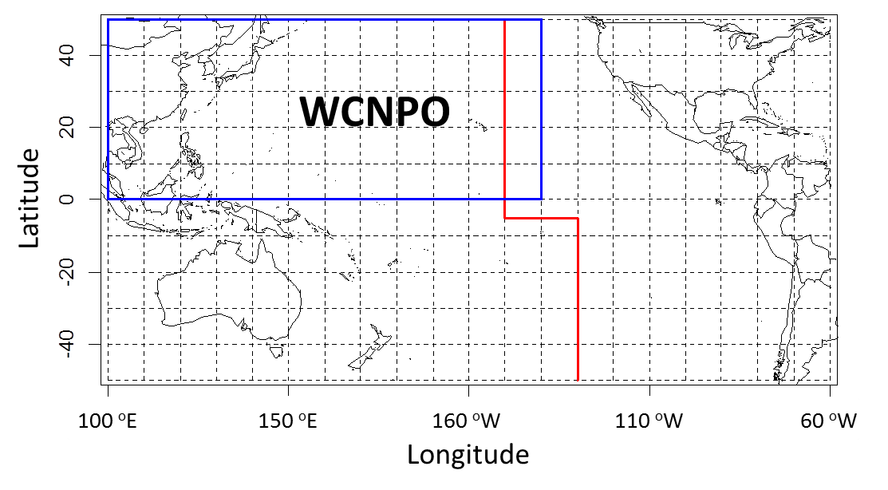

Figure 1. Stock boundary for the stock assessment update of Western and Central North Pacific Ocean striped marlin (WCNPO) as indicated by the blue lines. Red lines indicates the WCPFC convention area.

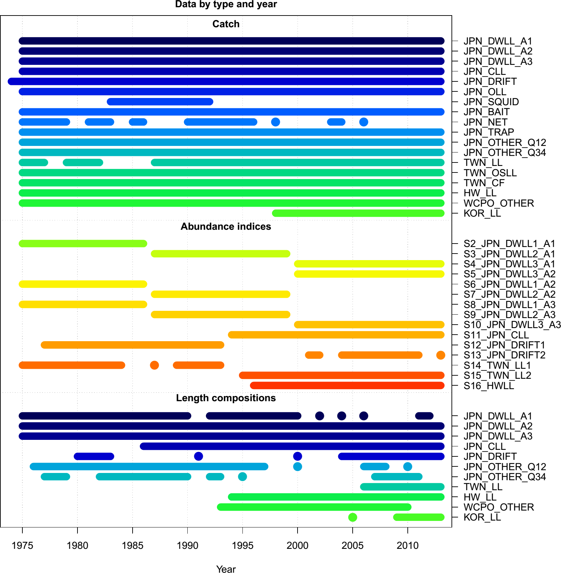

Figure 2. Available temporal coverage and sources of catch, CPUE (abundance indices), and length composition data for the stock assessment update of Western and Central North Pacific Ocean striped marlin. The first year denotes the initial equilibrium catch.

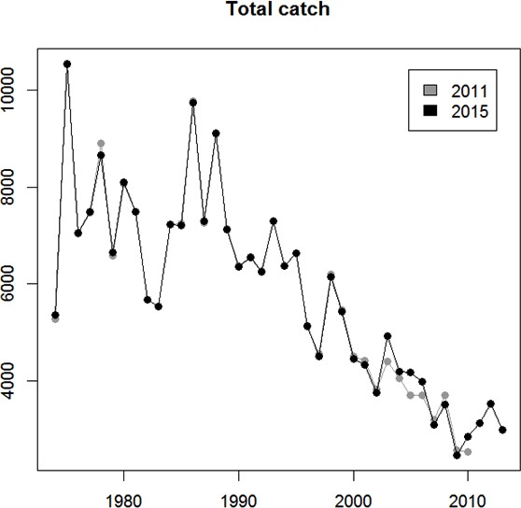

Figure 3.1. Total catch biomass (mt) used in the previous 2011 assessment (gray) in comparison to total catch biomass used in the 2015 assessment update (black).

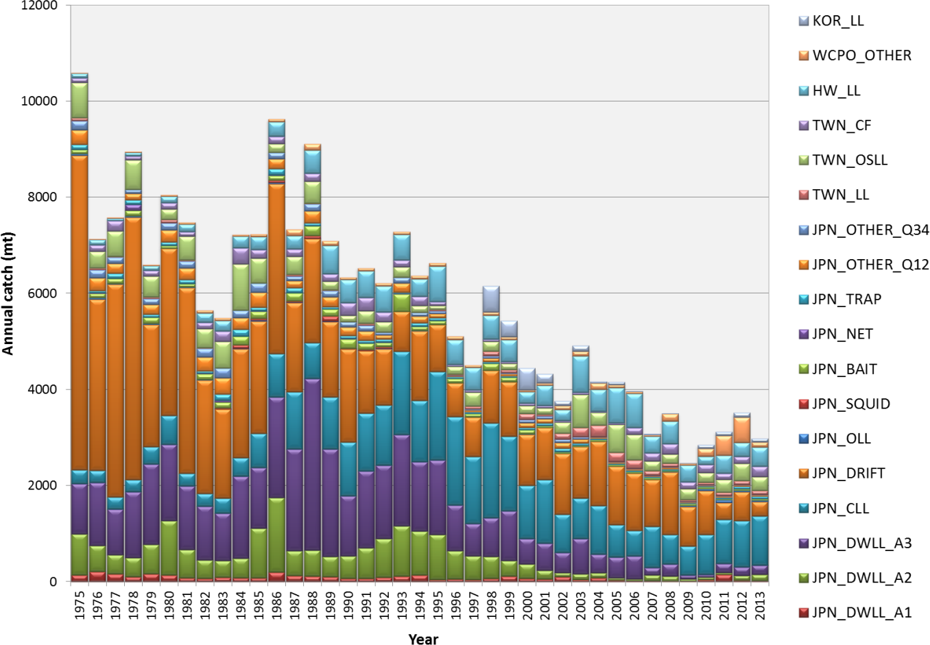

Figure 3.2. Total annual catch of Western and Central North Pacific Ocean striped marlin by all fisheries harvesting the stock during 1975-2013. See Table 1 for the fishery reference codes.

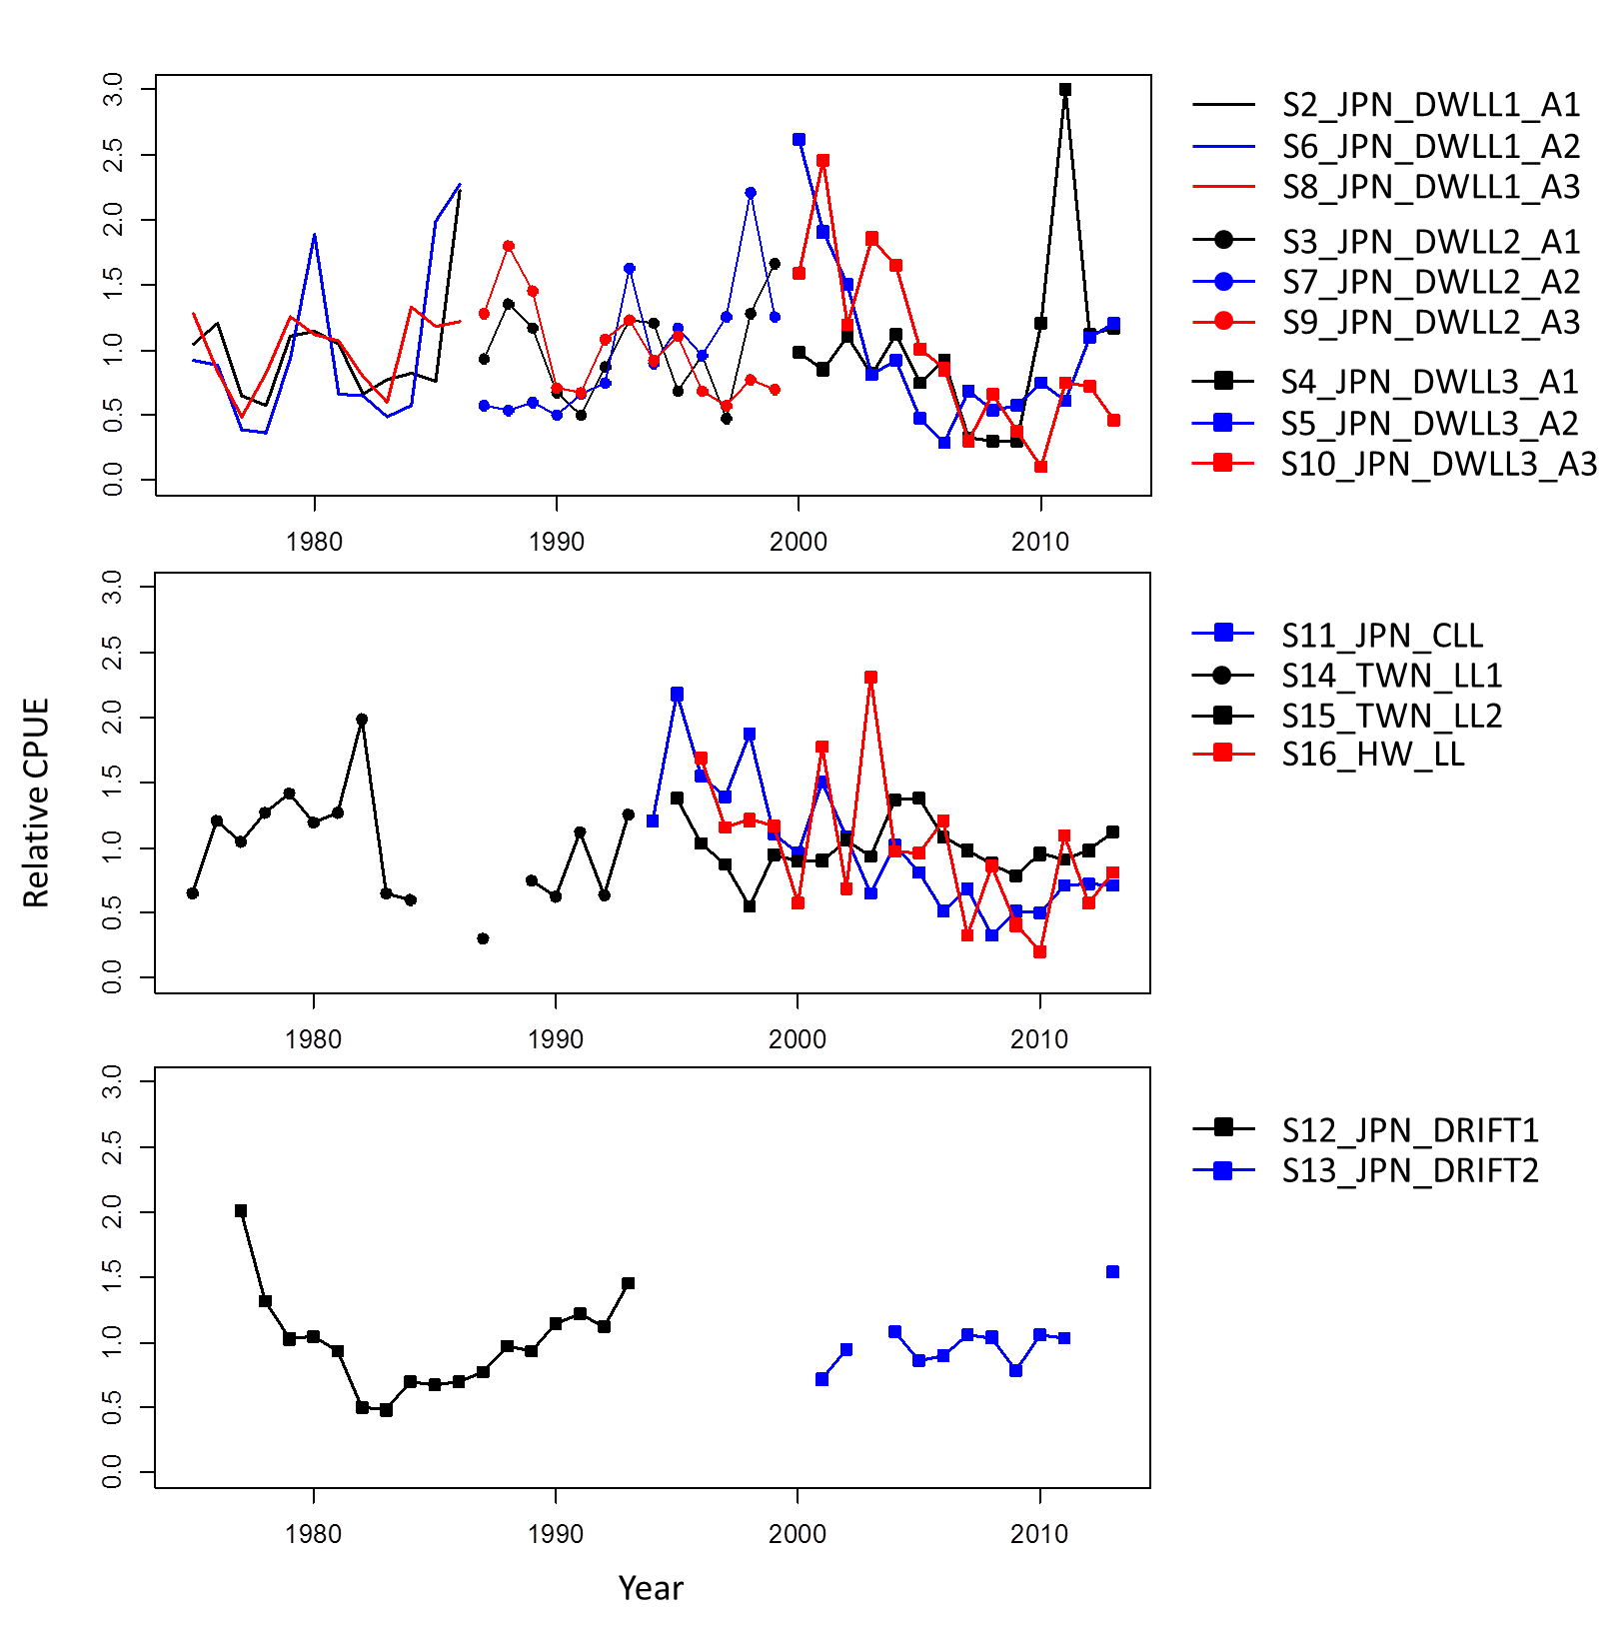

Figure 4. Time series of annual standardized indices of catch-per-unit-effort (CPUE) for the Japanese distant water longline fisheries (top panel); Japanese coastal longline, Taiwan distant water longline, and Hawaii-based longline fisheries (middle panel); and Japan driftnet fisheries (bottom panel) for Western and Central North Pacific Ocean striped marlin as described in Table 2. Index values in the figures were rescaled by the mean of each index for comparison purposes.

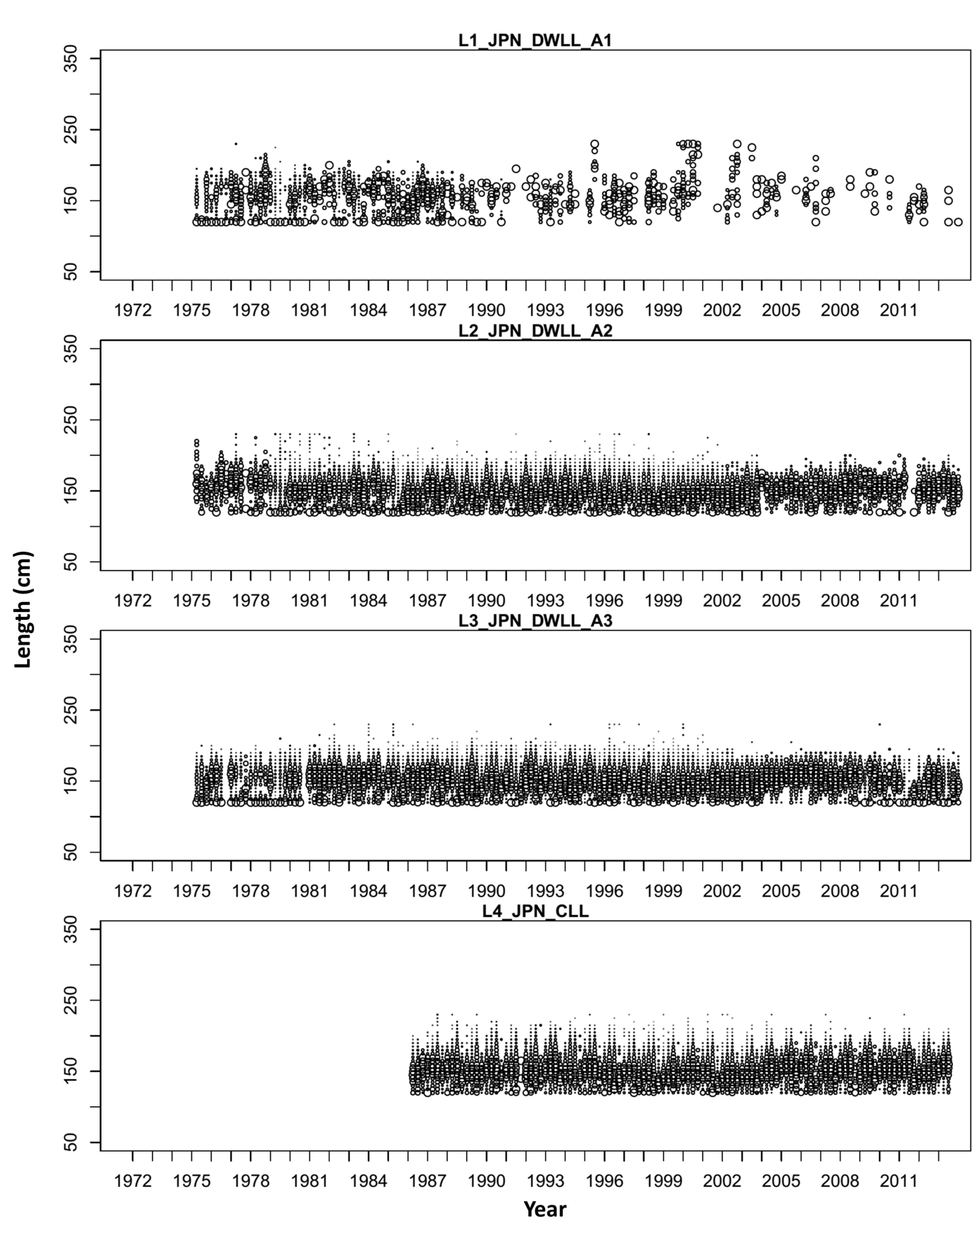

Figure 5. Quarterly length composition data by fishery used in the stock assessment update (see Table 3). The sizes of the circles are proportional to the number of observations. All measurements were eye- fork lengths (EFL, cm).

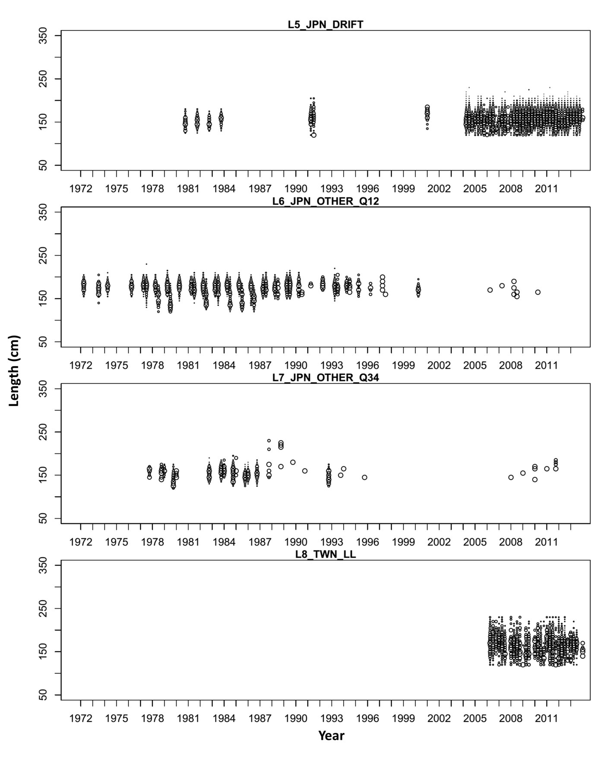

Figure 5. Continued.

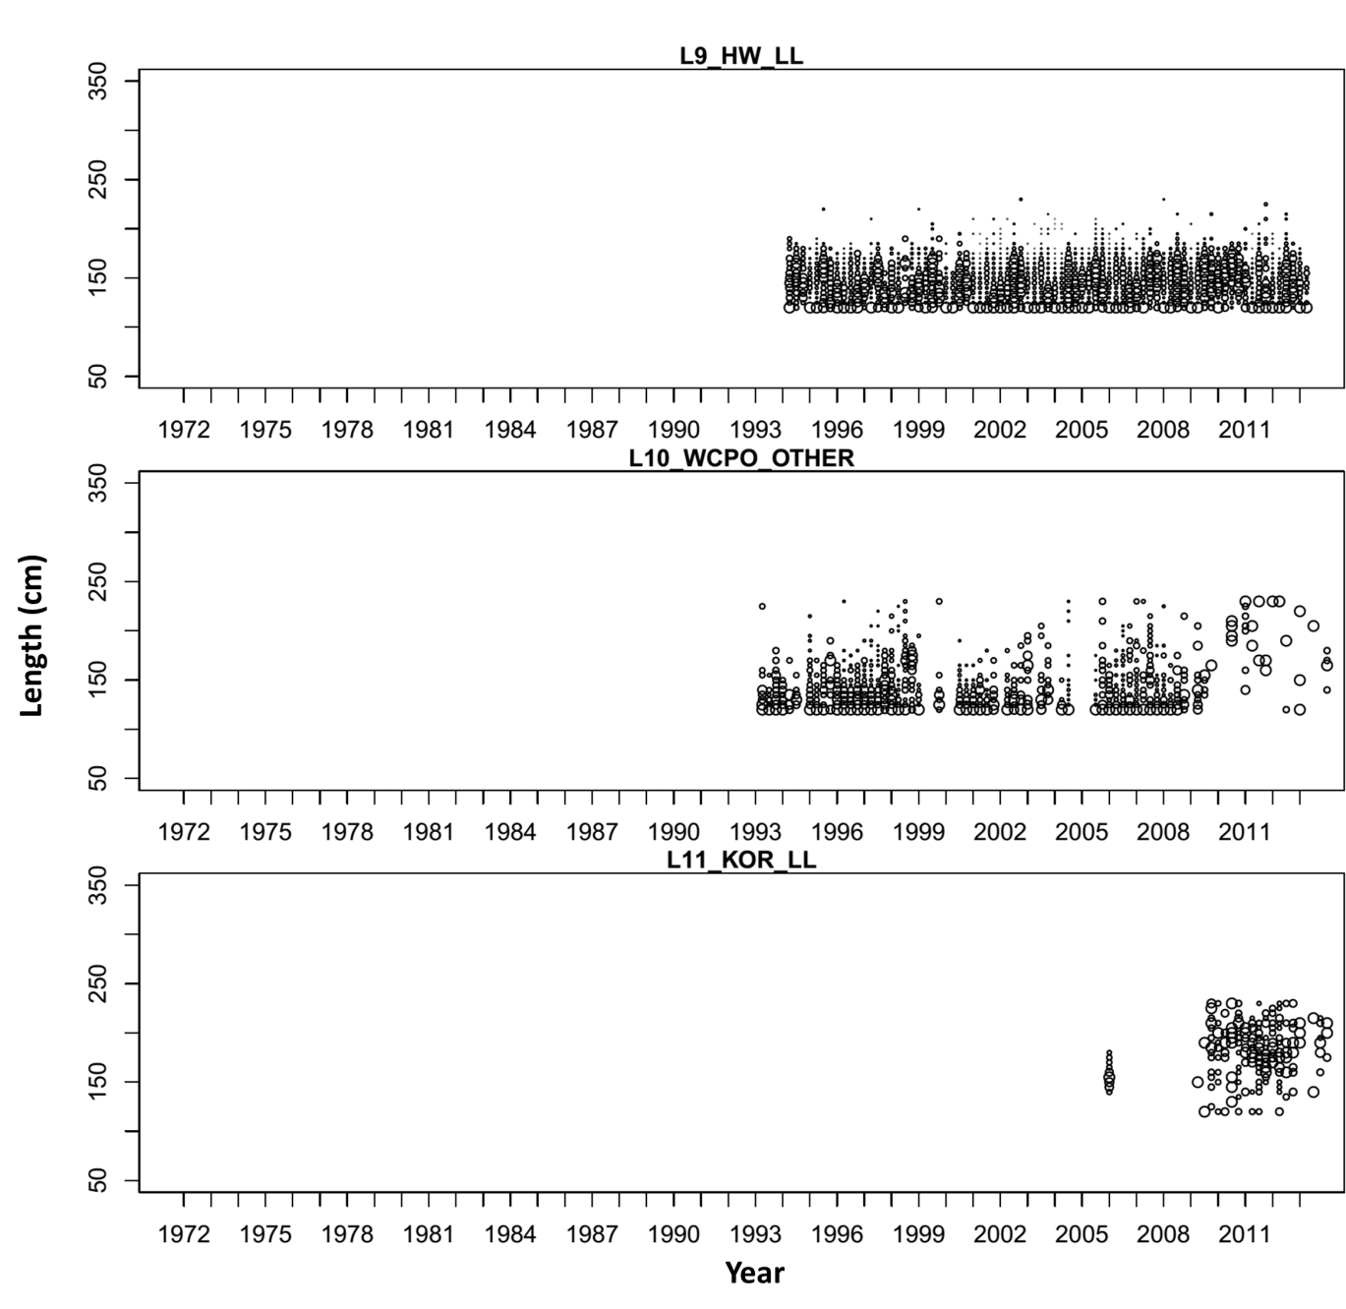

Figure 5. Continued.

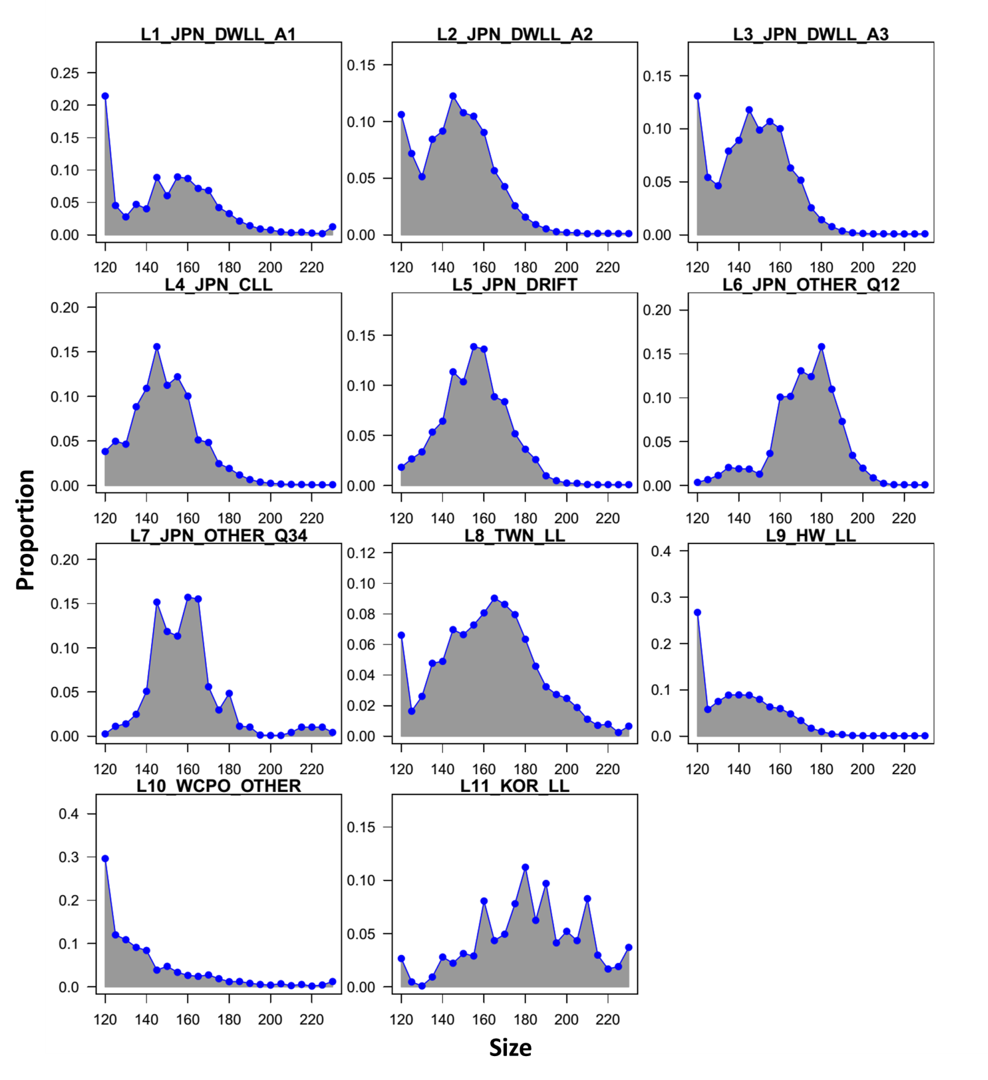

Figure 6. Aggregated length compositions used in the stock assessment update (see Table 3 for descriptions of the composition data). Data were compiled using 5-cm size bins from 120 to 230 cm, where the lower boundary of each bin (blue point) was used to define each bin.

Results from WP2

SSB

Results using input catch data recommended by WG

Results with recommended changes to input catch and size composition data

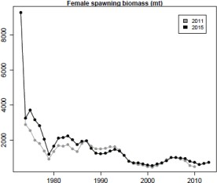 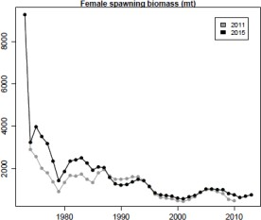

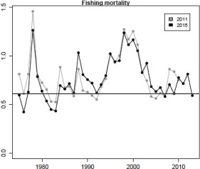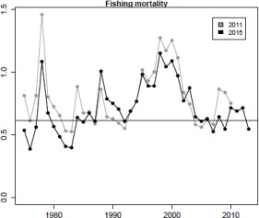Figure 7. Spawning stock biomass (SSB) and fishing mortality (*F*) estimates from the 2011 stock assessment (red line – 2011) compared to those for the 2015 assessment update (blue line – 2015) under three input data assumptions: Chang et al. (2015b) model using original Chang et al. (2015b) input data (first column), Chang et al. (2015b) model using input catch data recommended by BILLWG (second column), and Chang et al. (2015b) model using input catch and size composition data recommended by BILLWG (third column). Horizontal lines in fishing mortality plots (second row) show estimates of *F*MSY.

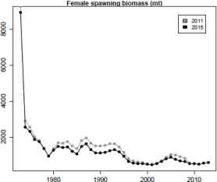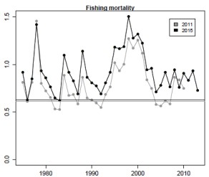

F

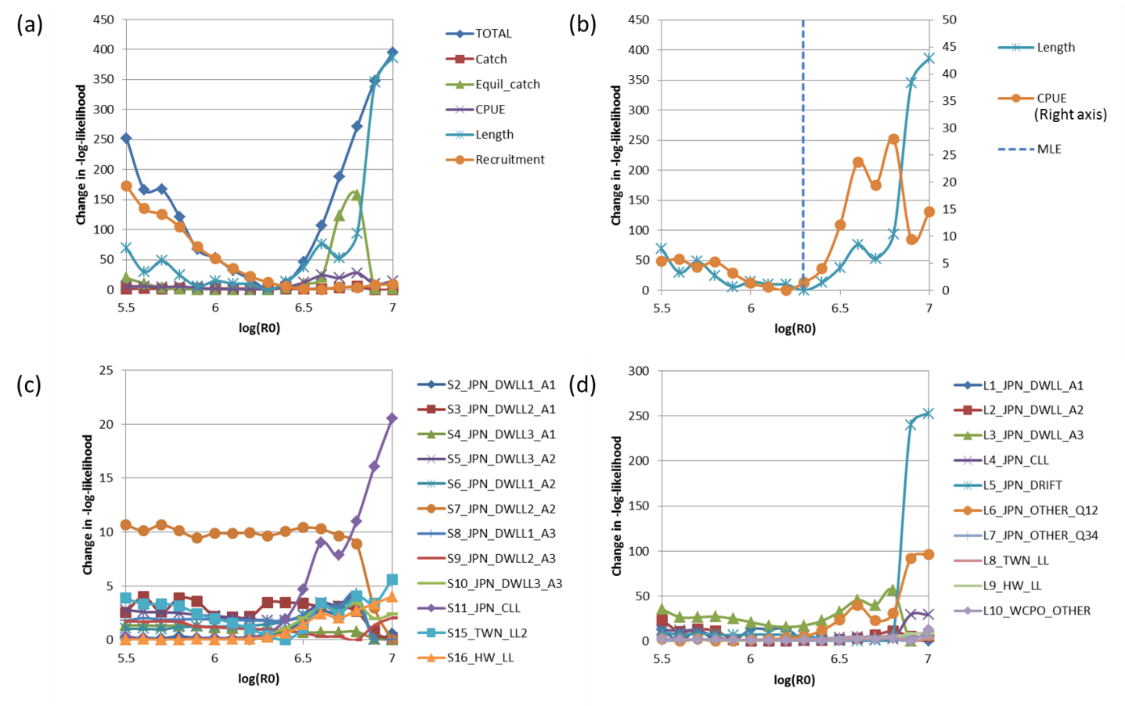

Figure 8.1. Profiles of the relative-negative log likelihoods for: (a) the different main likelihood components; (b) fleet-combined abundance index and size composition components; (c) fleet-specific abundance index; and (d) fleet-specific size composition over fixed values of the virgin recruitments in log-scale (log(R0)) from model using the Francis (2011)’s TA1.1 method with downweighted size composition data for fleet F1. See Tables 2 and 3 for the definitions of abundance and size composition data sets by fishery.

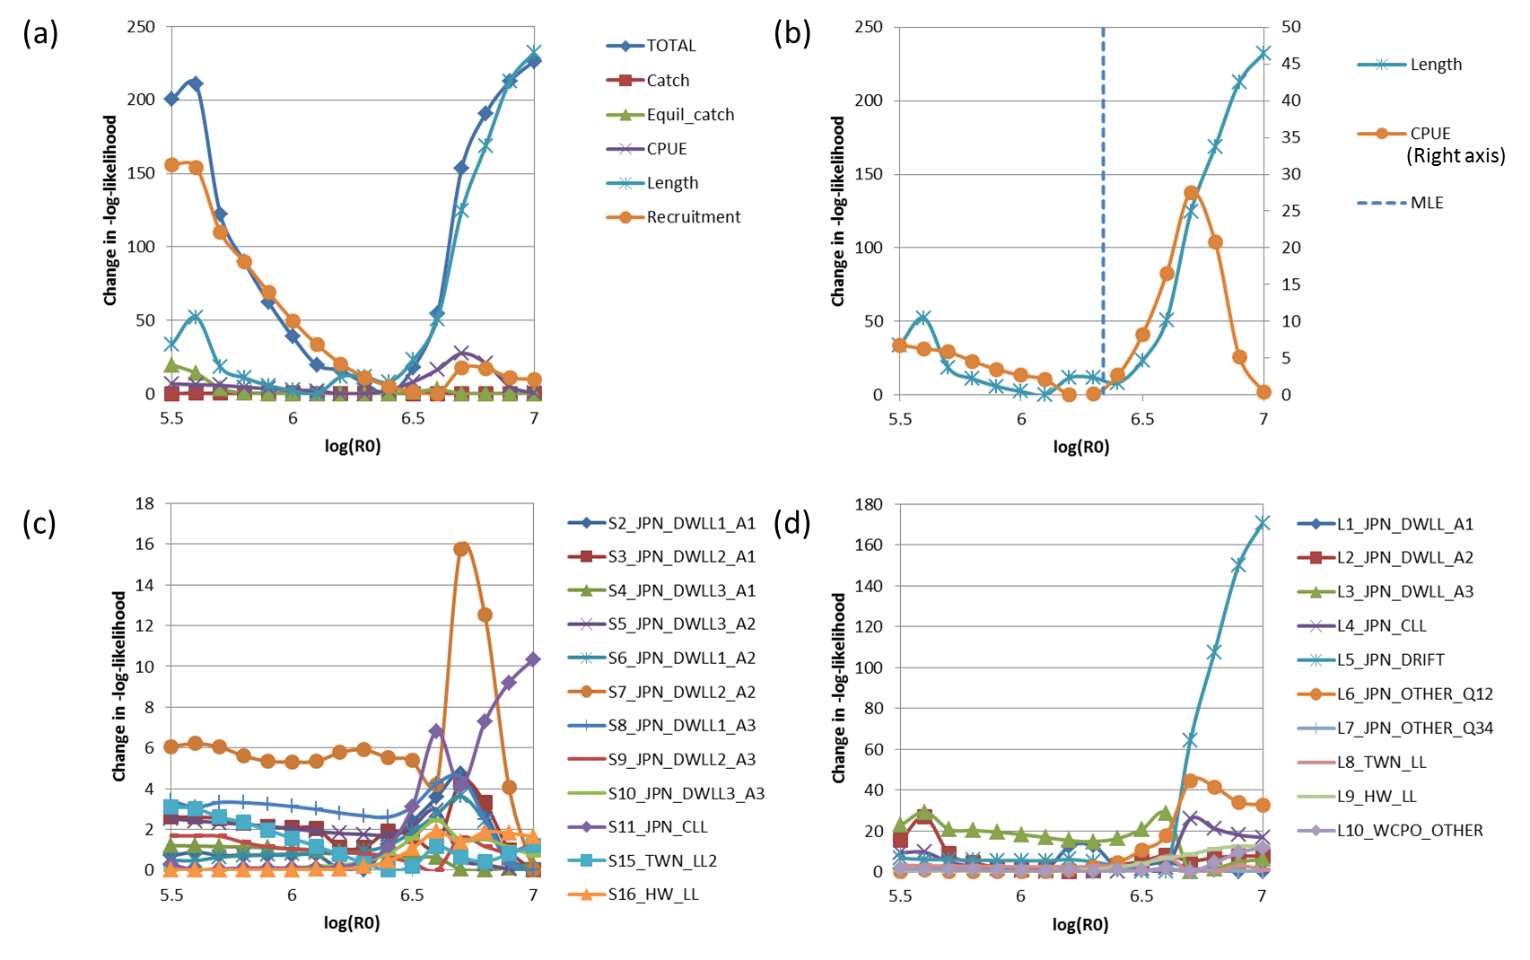

Figure 8.2. Profiles of the relative-negative log likelihoods for: (a) the different main likelihood components; (b) fleet-combined abundance index and size composition components; (c) fleet-specific abundance index; and (d) fleet-specific size composition over fixed values of the virgin recruitments in log-scale (log(R0)) from model using the Francis (2011)’s TA1.8 method with downweighted size composition data for fleet F1. See Tables 2 and 3 for the definitions of abundance and size composition data sets by fishery.

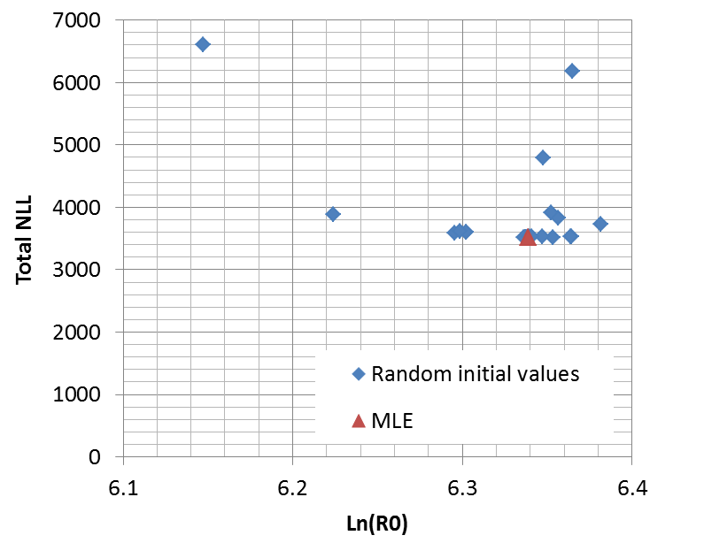

Figure 8.3. Total negative log-likelihood and estimated virgin recruitment in log- scale (log(R0)) from 50 model runs with different initial values of log(R0) and other important parameters in the base case model. Red triangle indicates results from model run using initial parameters from the updated base case model, which has the lowest total negative log-likelihood (3510.25) of all 50 model runs.

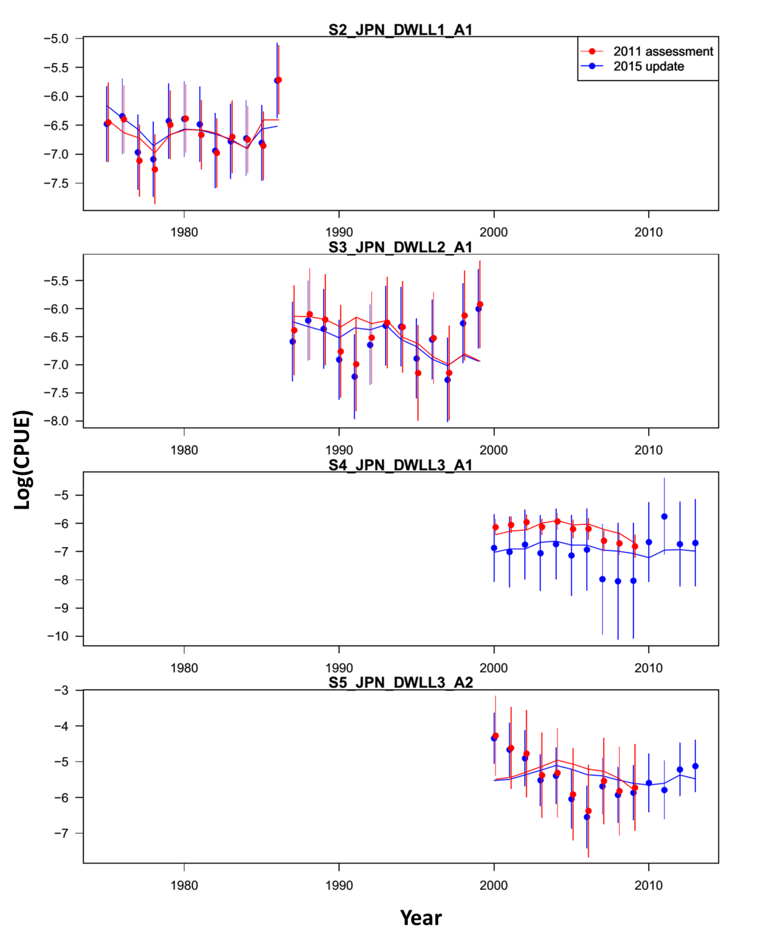

Figure 9. Model fits to the standardized catch-per-unit-effort (CPUE) data sets from different fisheries for the base case scenario. The line is the model predicted value and the points are observed (data) values. The vertical lines represent the estimated confidence intervals (± 1.96 standard deviations) around the CPUE values. Red color = 2011 assessment, blue color = 2015 update.

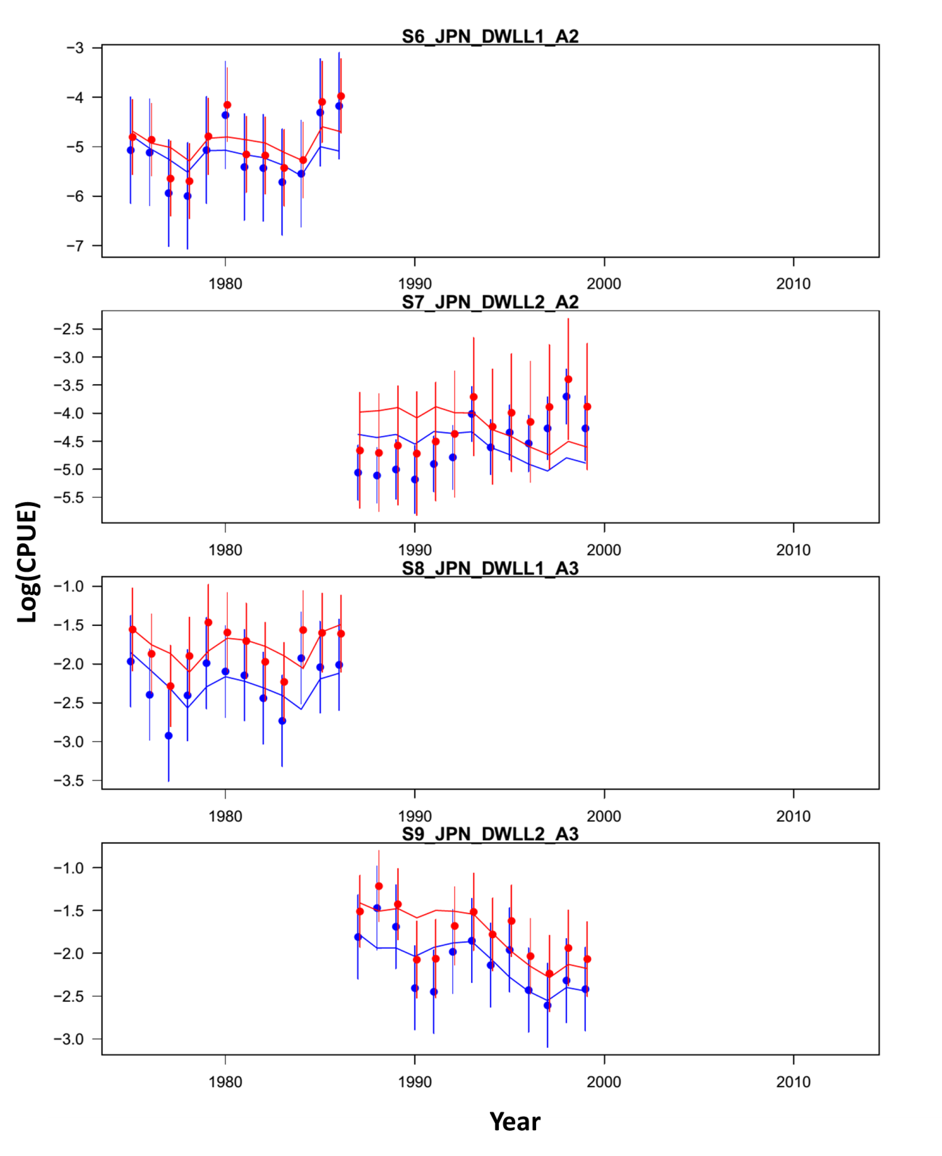

Figure 9. Continued.

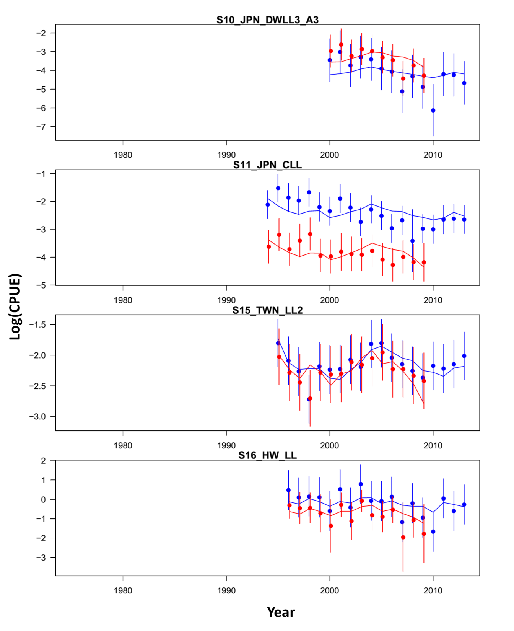

Figure 9. Continued.

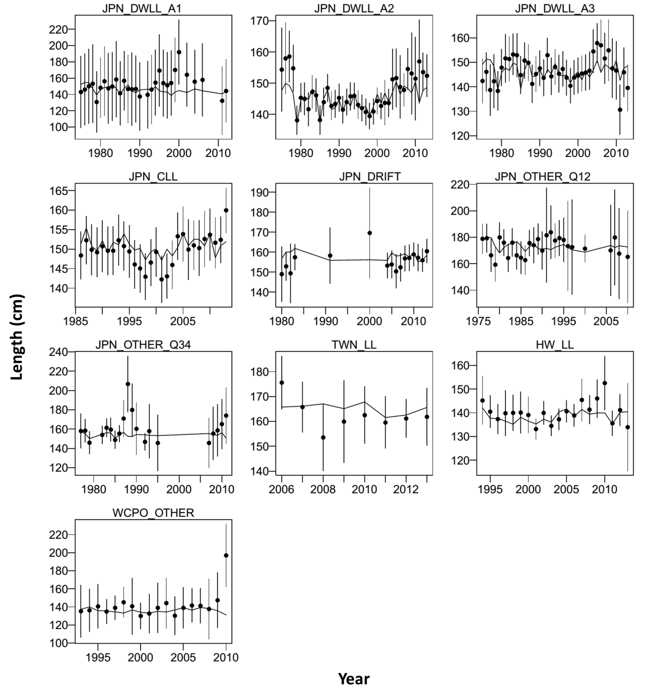

Figure 10. Model fit (lines) to mean size of the composition data (points, showing the observed mean age and 95% credible limits around mean age with the re- weighted multinomial effective sample sizes (vertical lines). See Table 3 for descriptions of the data.

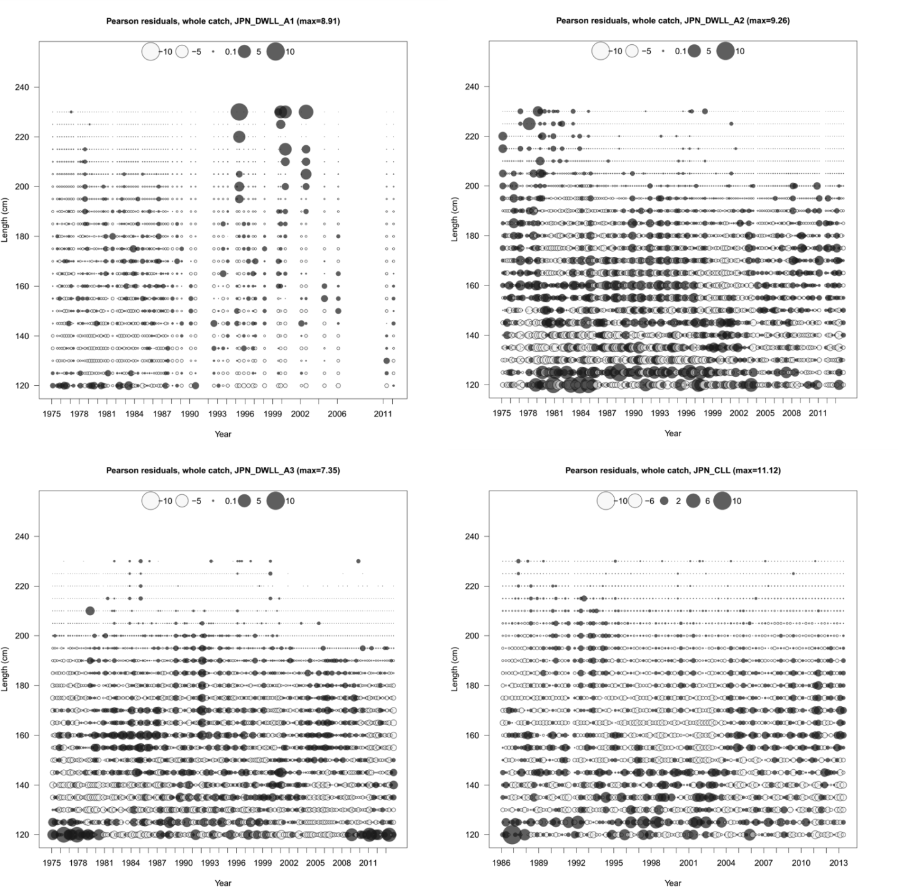

Figure 11. Pearson residual plots of model fits to the length-composition data for the Western and Central North Pacific Ocean striped marlin fisheries used in the assessment model.

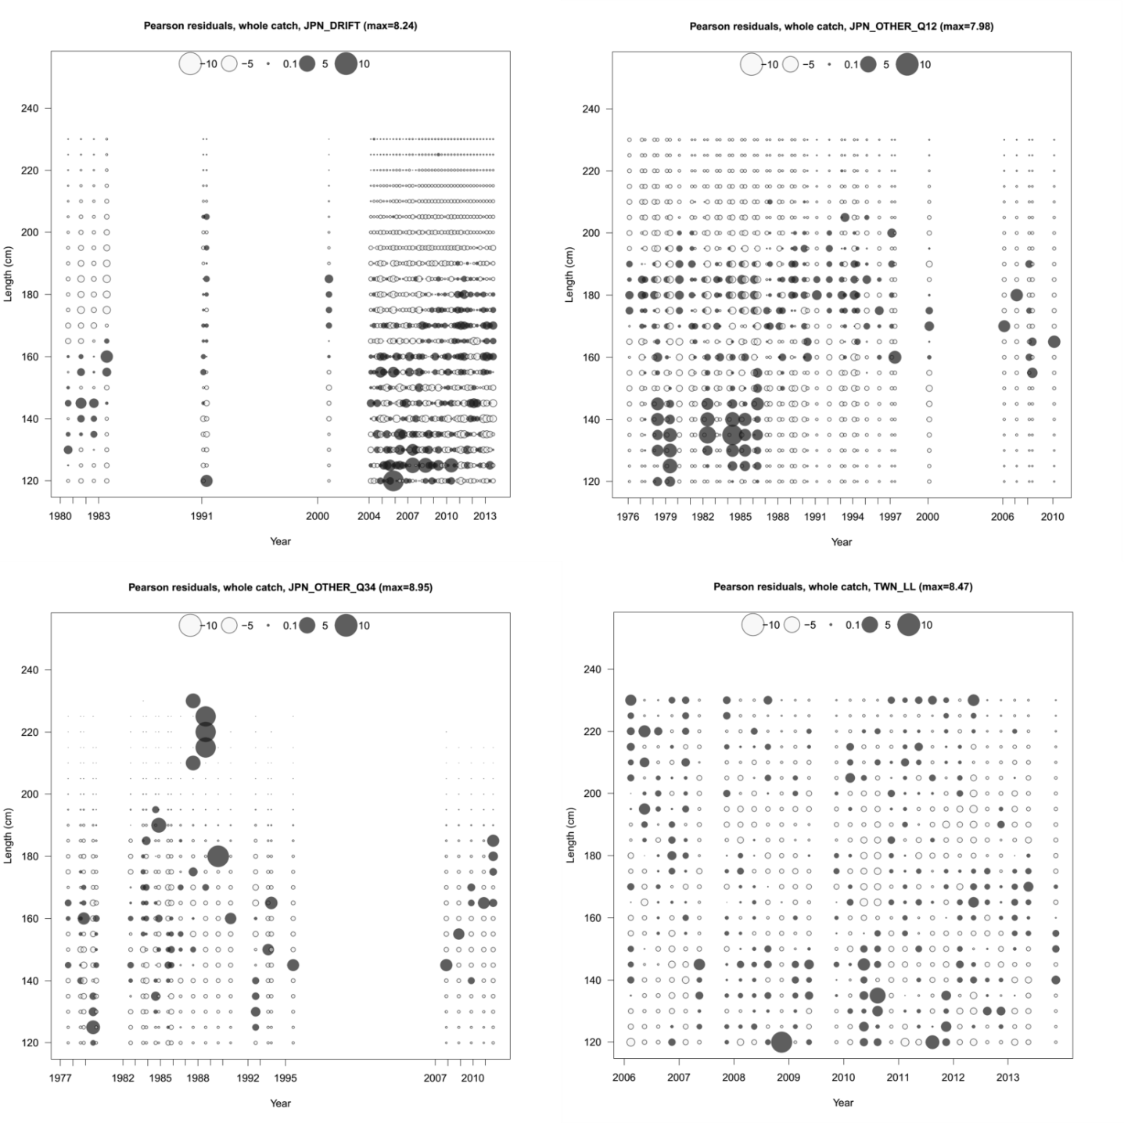

Figure 11. Continued.

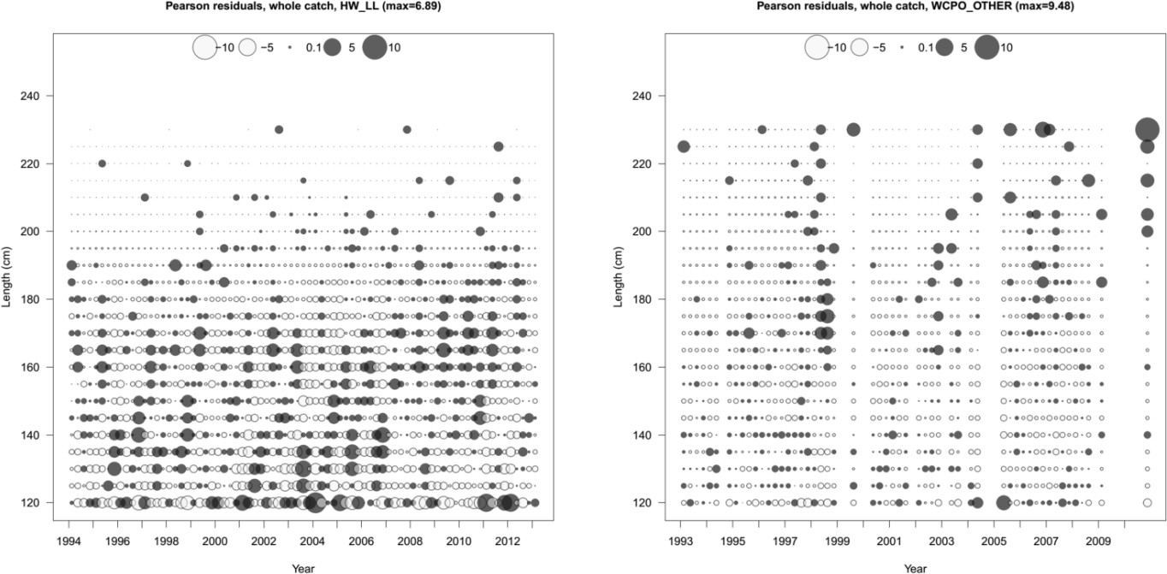

Figure 11. Continued.

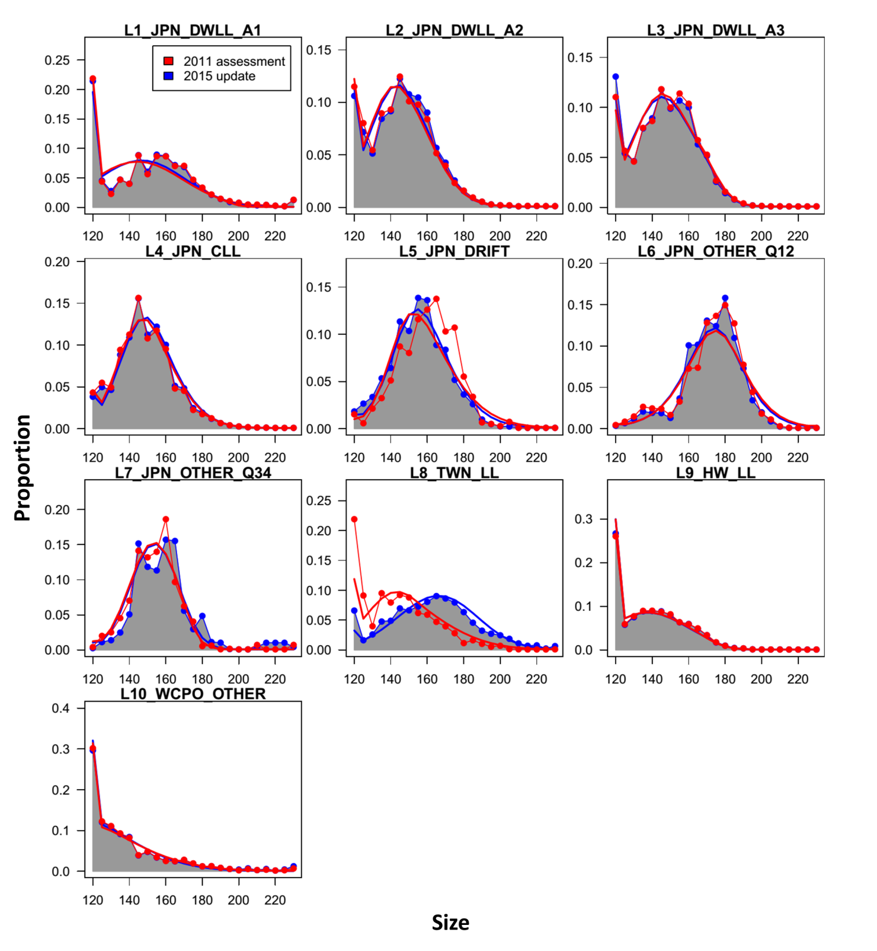

Figure 12. Comparison of observed (gray shaded area and blue bots) and model predicted (blue solid line) length compositions for fisheries used in the updated stock assessment for the Western and Central North Pacific Ocean striped marlin. Red colors indicate observed (dots) and predicted (line) length compositions from the 2011 assessment.

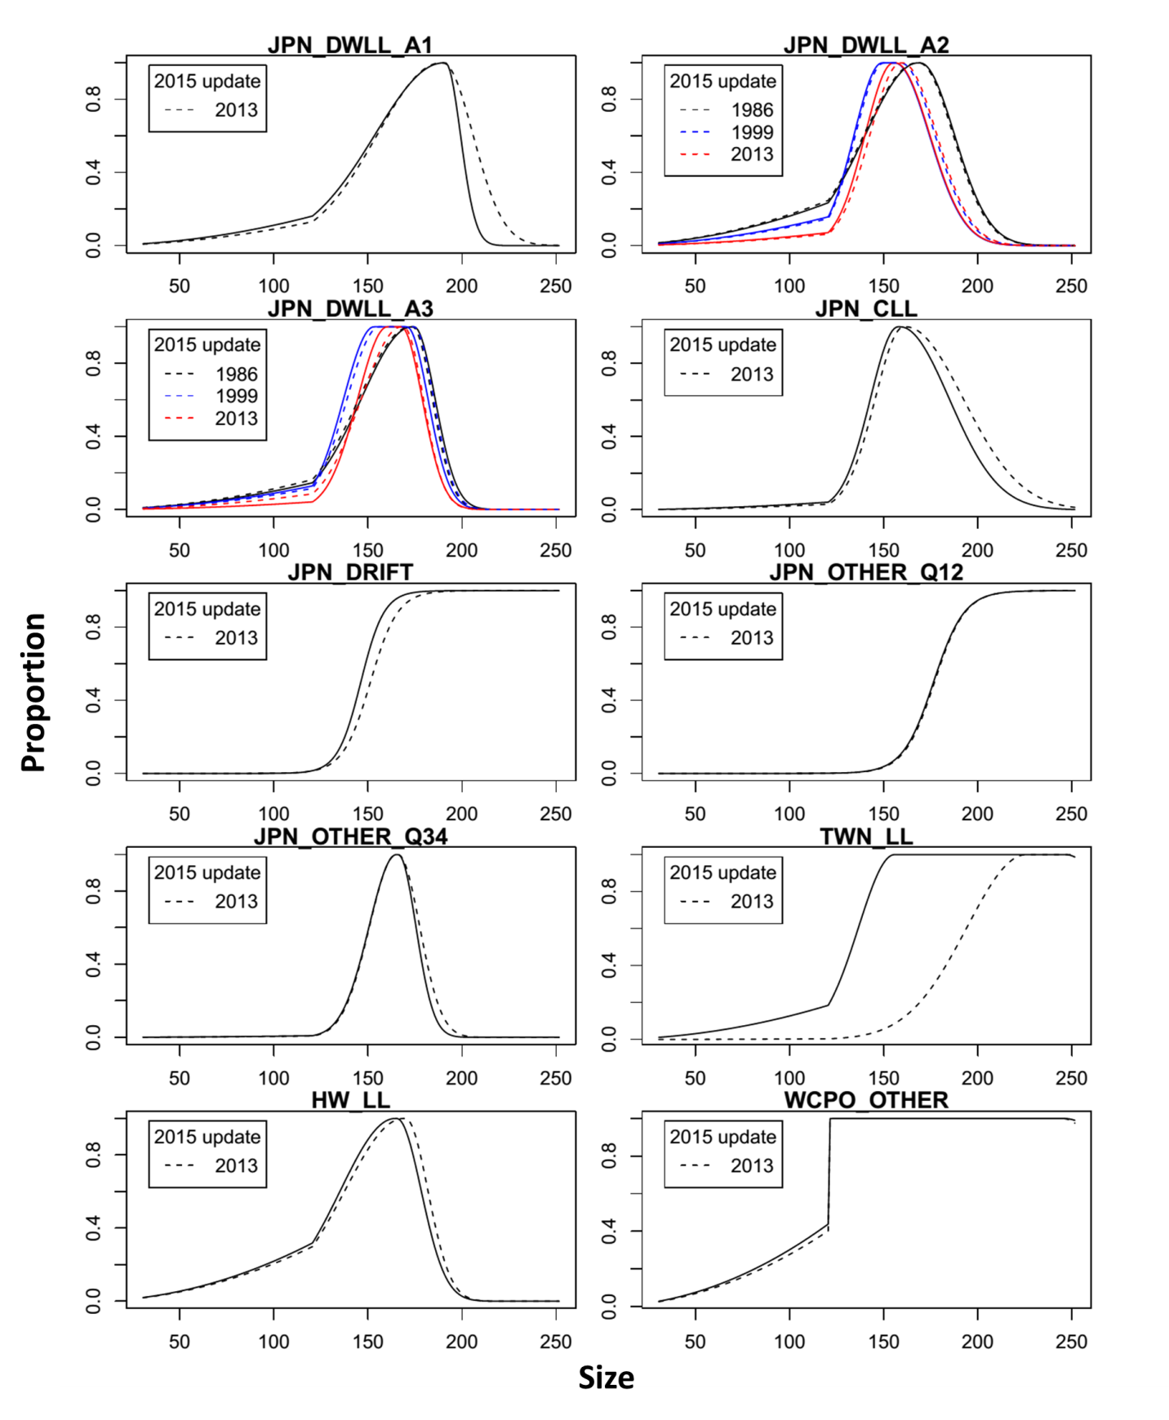

Figure 13. Comparison of length-based selectivity of fisheries for the Western and Central North Pacific Ocean striped marlin between the 2011 stock assessment (solid lines) and the 2015 update (dash lines).Different colors denote the selectivity curves by time blocks. The number in the legend donates the last year of the selectivity estimate of each time block.



Figure 14. Comparison of time series of total biomass (age 1 and older) (a), spawning biomass (b), age-0 recruitment (c), and instantaneous fishing mortality (year-1) (d) for the Western and Central North Pacific Ocean striped marlin between the 2011 stock assessment (red) and the 2015 update (blue). The solid line with circles represents the maximum likelihood estimates for each quantity and the shadowed area represents the 95% asymptotic intervals of the estimates (± 1.96 standard deviations). The solid horizontal lines indicated the MSY-based reference points.



Figure 15.1. Trends in population biomasses (black) and catch (blue) of Western and Central North Pacific Ocean striped marlin (*Kajikia audax*) during 1975-2013.

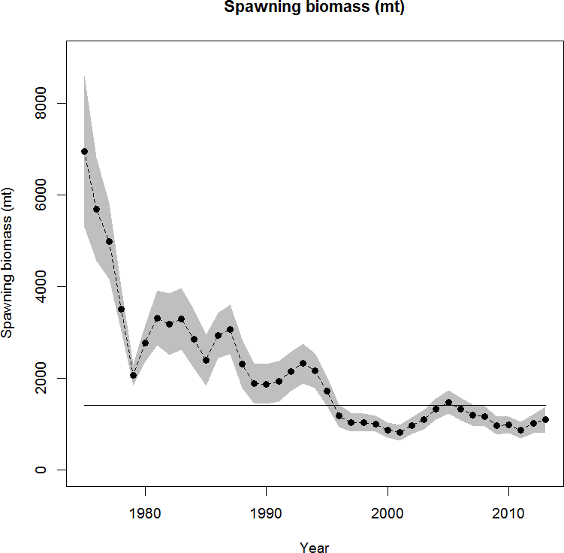

Figure 15.2. Trends in estimates of spawning biomass of Western and Central North Pacific Ocean striped marlin (*Kajikia audax*) during 1975-2013 along with (mean ± 1.96×SD) confidence intervals.

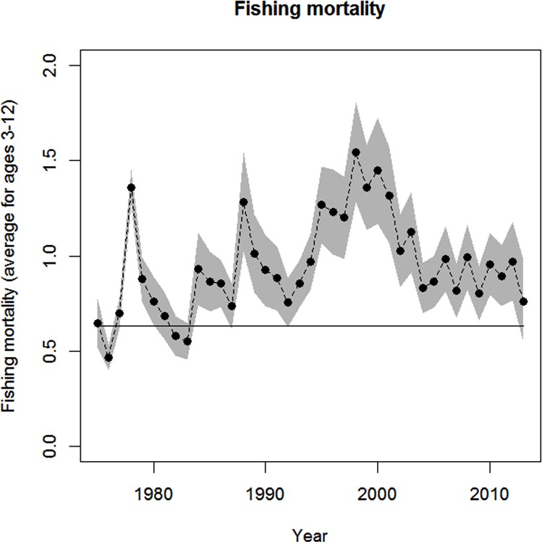

Figure 15.3. Trends in estimates of fishing mortality of Western and Central North Pacific Ocean striped marlin (*Kajikia audax*) during 1975-2011 along with (mean

± 1.96×SD) confidence intervals.

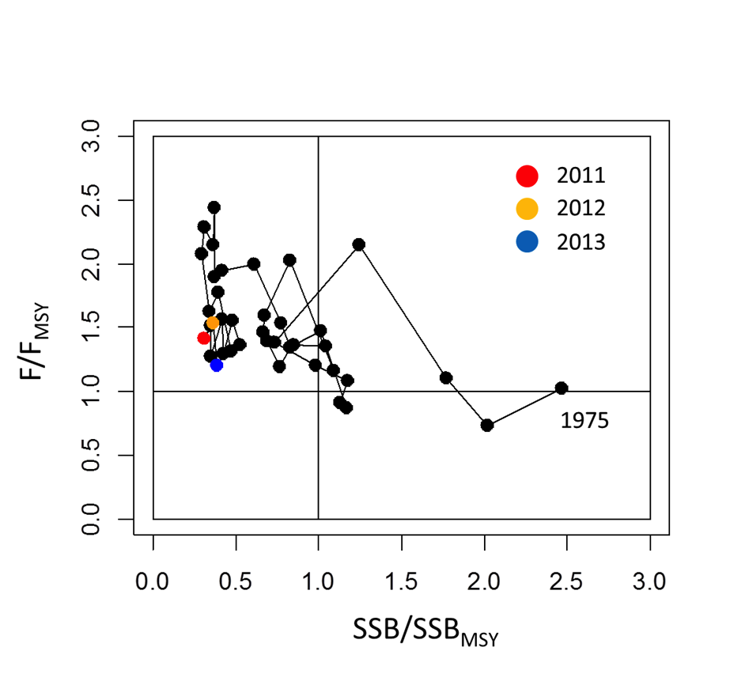

Figure 15.4. Kobe plot of the trends in estimates of relative fishing mortality and spawning biomass of WCNPO striped marlin (*Kajikia audax*) during 1975-2013.

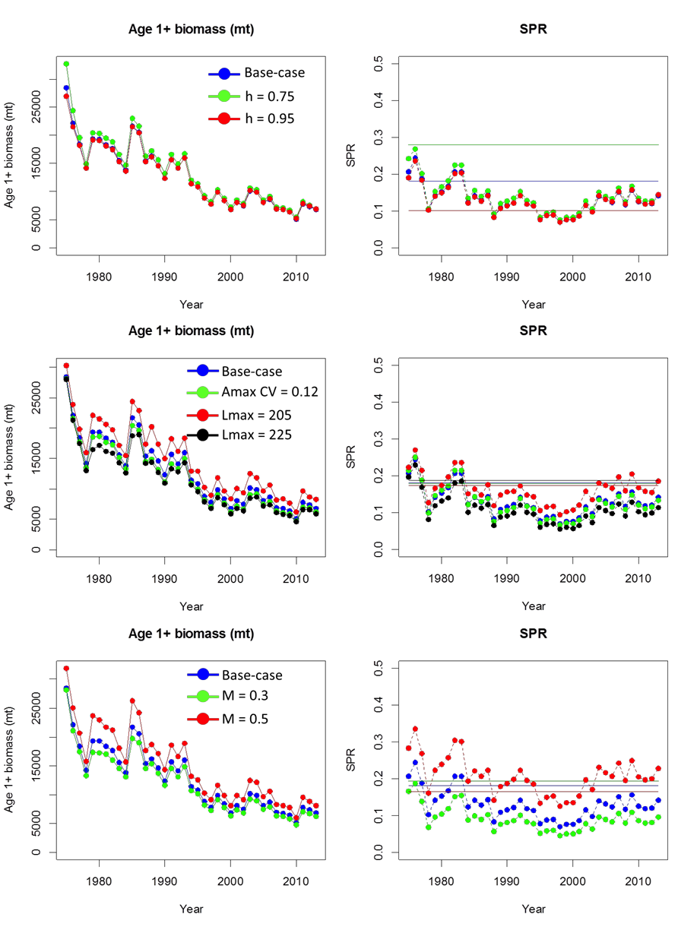

Figure 16.1. Results of sensitivity runs, point estimates of age 1+ biomass (first column) and SPR (second column) for steepness sensitivity runs (first row), growth sensitivity runs (CV and value of length at age max; second row), and natural mortality sensitivity runs (third row). Horizontal lines in SPR plots reflect *F*MSY reference point.

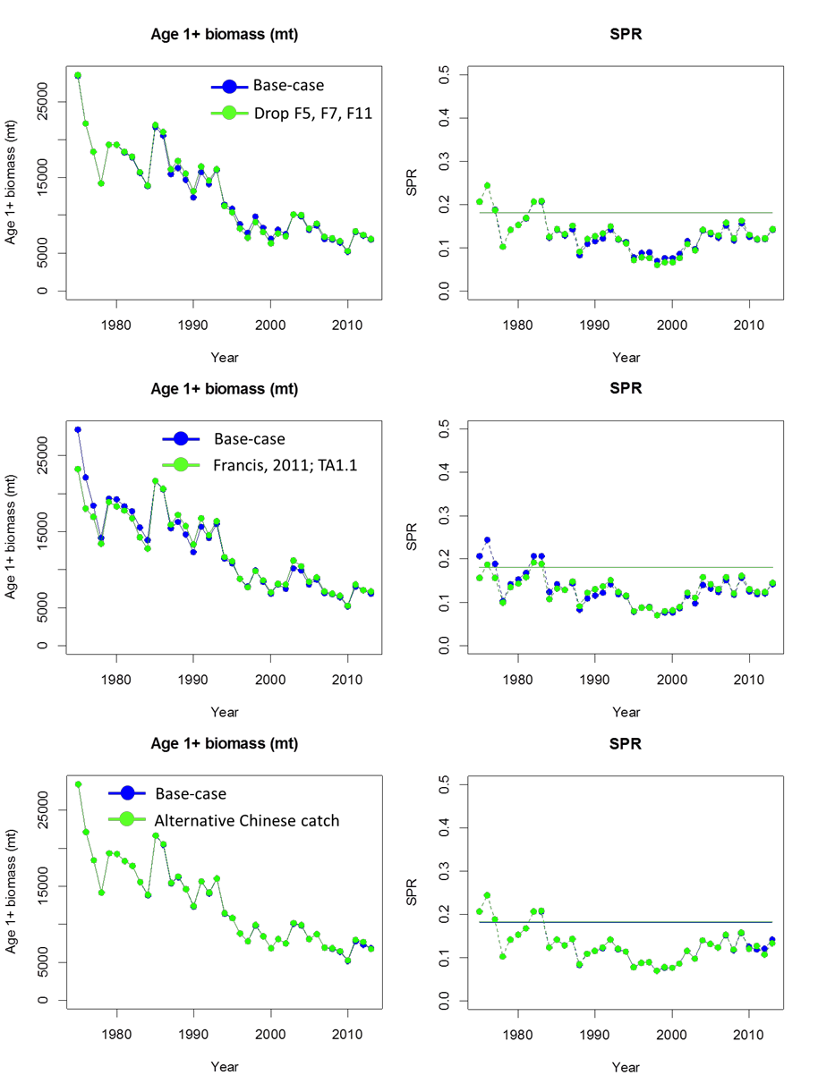

Figure 16.2. Results of sensitivity runs, point estimates of age 1+ biomass (first column) and SPR (second column) for excluding fits for some fleets (F5, F7, and F11; first row), alternative weighting approach from last assessment (second row), and alternative source for Chinese catch data (third row). Horizontal lines in the SPR panels show the *F*MSY reference point.

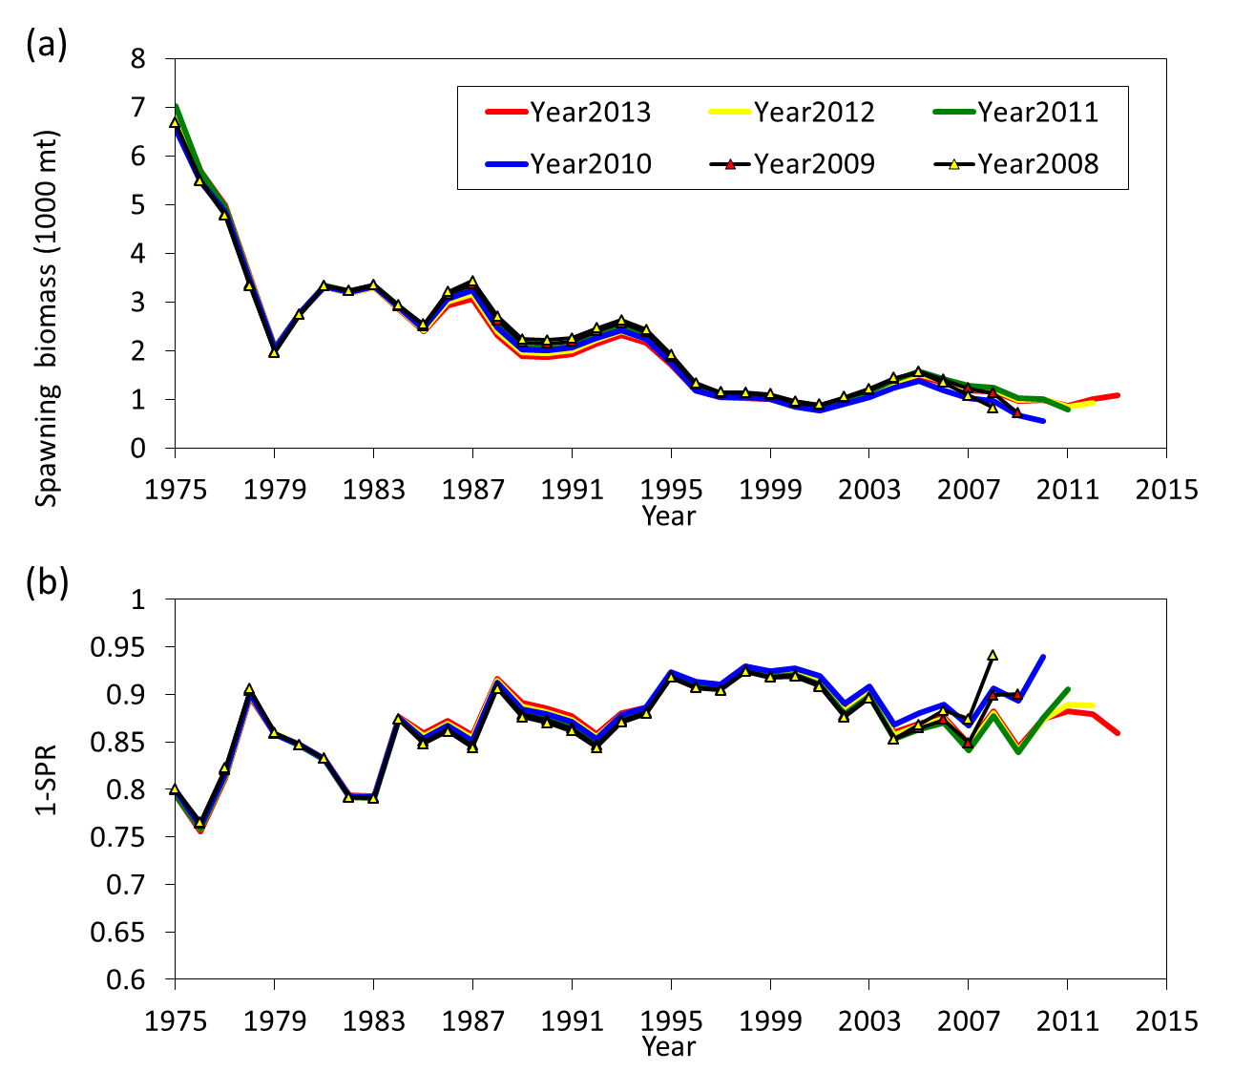

Figure 17. A five-year retrospective analysis of the base case for estimates of spawning biomass (SSB) (a) and fishing intensity index (1-SPR) (b).

# Appendix 1

Table A1.1. Correlation matrices of various abundance indices for time periods of 1975-1986 (a), 1987-1999 (b), and 2000-2013 (c). Colors indicate levels of correlation (blue: high positive correlation, red: high negative correlation). See Table 2 for descriptions of each abundance index.

(a) 1975 – 1986

S6 S8 S12 S14

|  |  |  |  |  |
| --- | --- | --- | --- | --- |
| S2 | 0.68 | 0.44 | -0.23 | -0.09 |
| S6 | | 0.53 | -0.29 | 0.09 |
| S8 | | | -0.40 | -0.17 |
| S12 | | | | -0.04 |

(b) 1987 – 1999

|  |  |  |  |  |  |  |  |
| --- | --- | --- | --- | --- | --- | --- | --- |
|  | S7 | S9 | S11 | S12 | S14 | S15 | S16 |
| S3 | 0.29 | 0.36 | -0.44 | -0.12 | 0.08 | -0.38 | -0.14 |
| S7 |  | -0.33 | 0.39 | 0.76 | 0.70 | -0.77 | -0.49 |
| S9 |  |  | 0.56 | -0.43 | -0.21 | 0.63 | 0.13 |
| S11 |  |  |  | - | - | 0.30 | 0.22 |
| S12 |  |  |  |  | 0.87 | - | - |
| S14 |  |  |  |  |  | - | - |
| S15 |  |  |  |  |  |  | 0.52 |
| (c) 2000 – 2013 | | | | | | | |
| S5 | | S10 | S11 | S13 | S15 | S16 | |

|  |  |  |  |  |  |  |
| --- | --- | --- | --- | --- | --- | --- |
| S4 | 0.03 0.01 | | 0.13 | 0.21 | 0.04 0.11 | |
| S5 | | 0.55 | 0.69 | -0.01 | -0.20 | 0.02 |
| S10 | | | 0.76 | -0.42 | 0.11 | 0.74 |
| S11 | | | | -0.28 | 0.21  0.22 | 0.31 |
| S13 | | | | | -0.29 |
| S15 | | | | | | 0.04 |

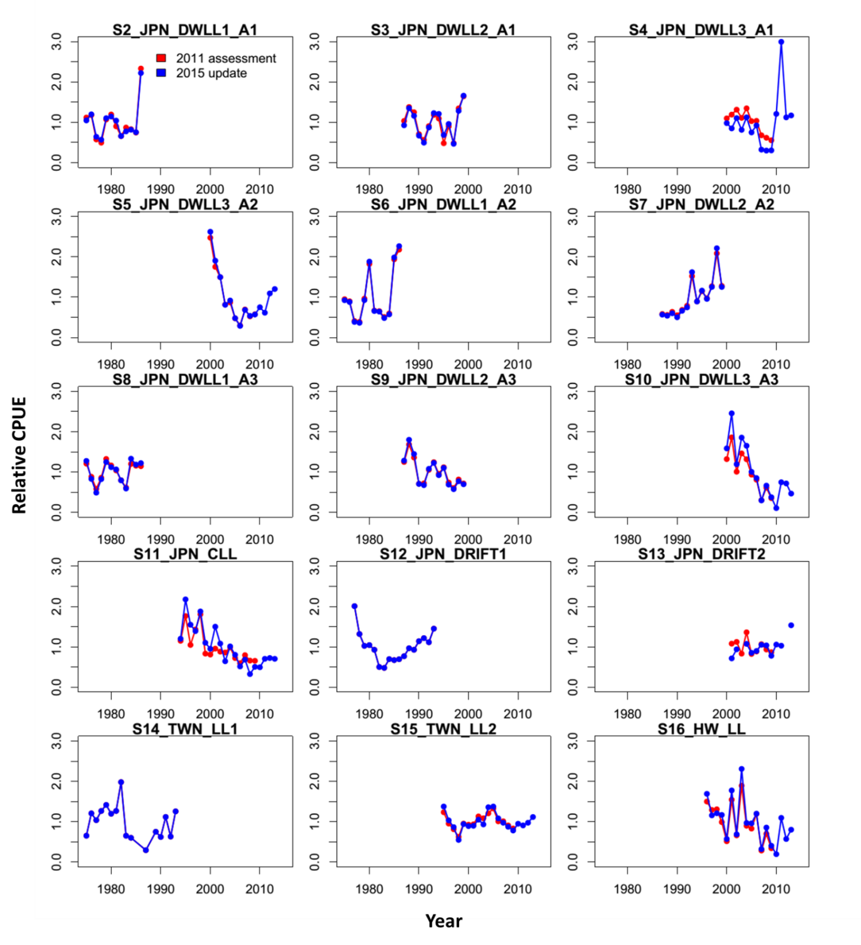

Figure A1.1. Comparison of relative abundance indices (in relative scale) of catch- per-unit-effort (CPUE) for Western and Central North Pacific Ocean striped marlin *Kajikia audax* used in the 2011 stock assessment and the 2015 update. The red line represents the 2011 stock assessment; the blue line represents the 2015 update.

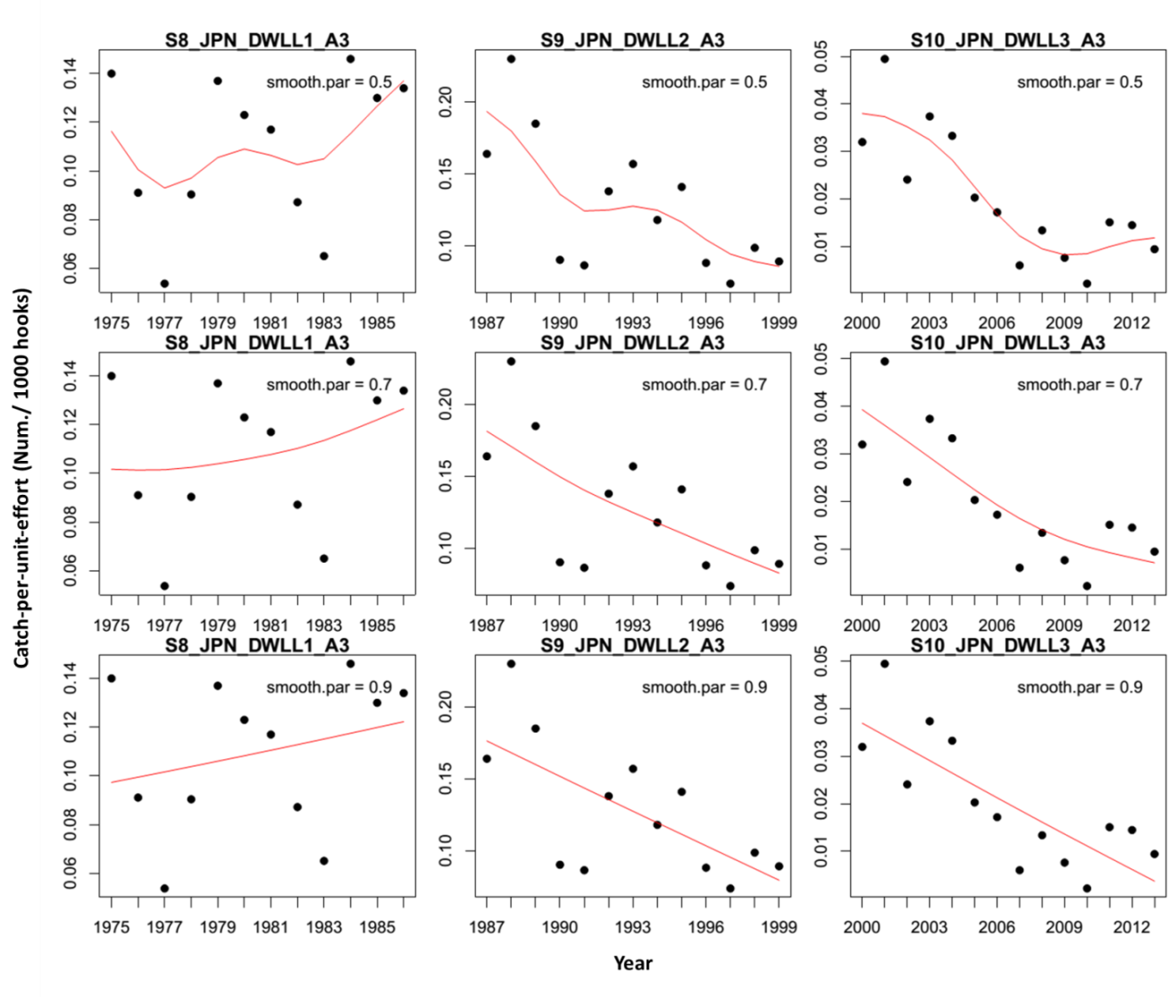

Figure A1.2. Examples of fits of a data smoother to Japanese distant water longline catch-per-unit-effort (CPUE) indices in area 3 (see Table 2 for definitions). Three smooth parameter values (0.5, 0.7, 0.9) were used with each of three fisheries (S8, S9, S10) in order to estimate the total error of the abundance data set.

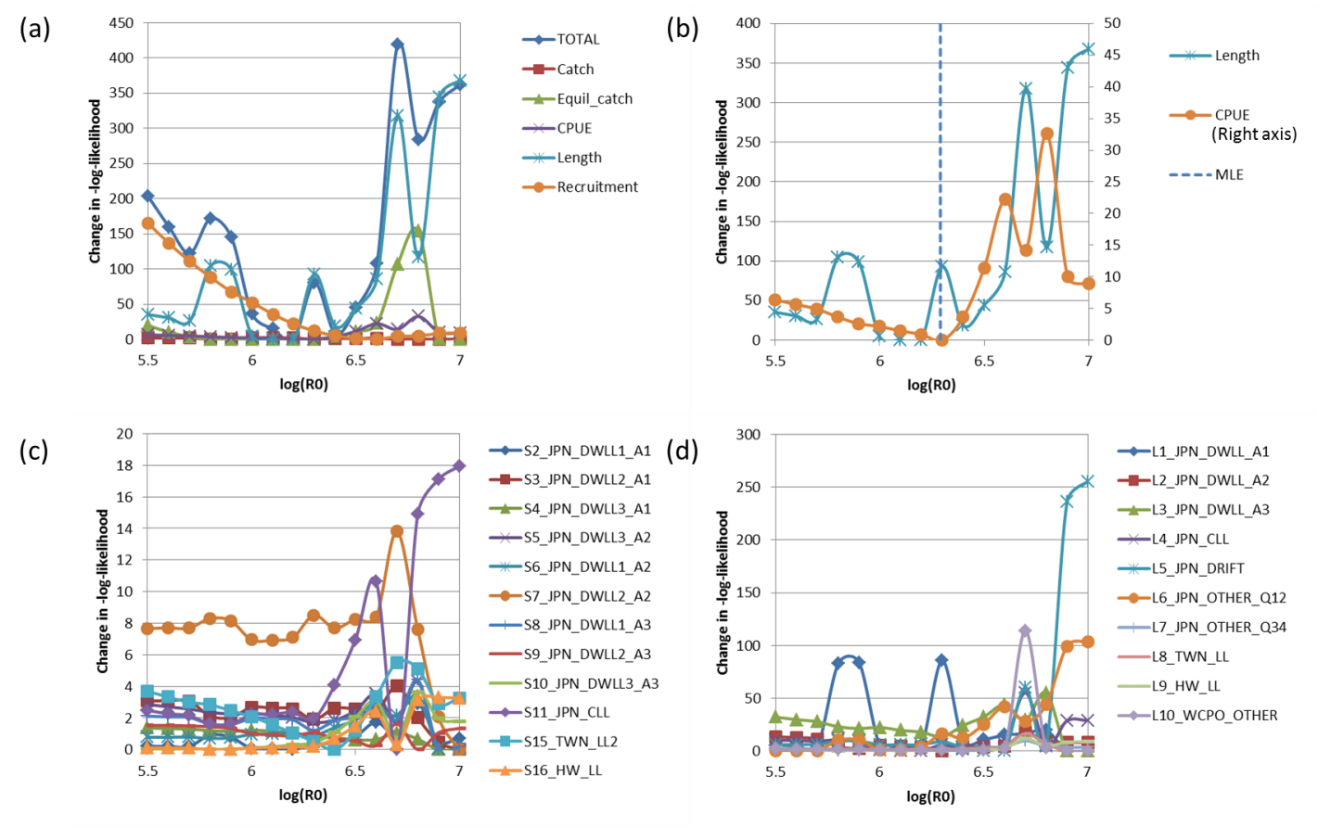

Figure A1.3. Profiles of the relative-negative log likelihoods for: (a) the different main likelihood components; (b) fleet-combined abundance index and size composition components; (c) fleet-specific abundance index; and (d) fleet-specific size composition over fixed values of the virgin recruitments in log-scale (log(R0)) from model using the Francis (2011)’s TA1.1 method. See Tables 2 and 3 for the definitions of abundance and size composition data sets by fishery.

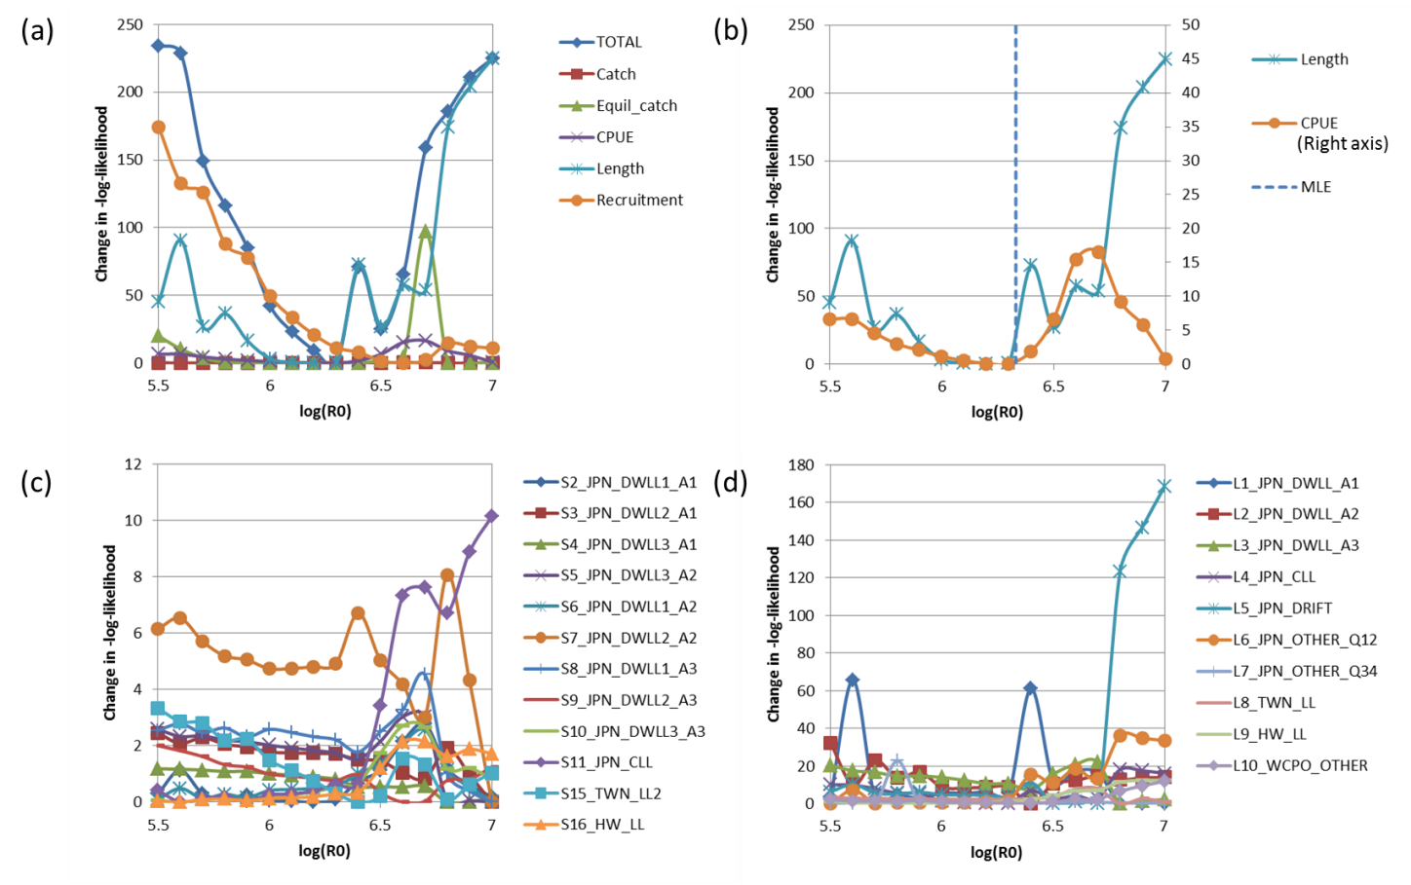

Figure A1.4. Profiles of the relative-negative log likelihoods for: (a) the different main likelihood components; (b) fleet-combined abundance index and size composition components; (c) fleet-specific abundance index; and (d) fleet-specific size composition over fixed values of the virgin recruitments in log-scale (log(R0)) from model using the Francis (2011)’s TA1.8 method. See Tables 2 and 3 for the definitions of abundance and size composition data sets by fishery.

# Appendix 2

ISC/15/BILLWG-2/1

## Stock Projections for the Western and Central North Pacific Ocean Striped Marlin Stock

**ISC Billfish Working Group**

**Document Prepared By**

Yi-Jay Chang, Brian Langseth, Hui-Hua Lee, and Jon Brodziak

### Future Projections

Stock projections were conducted to evaluate the probable impacts of alternative harvest rates on future levels of spawning stock biomass and catch for the Western and Central North Pacific striped marlin stock. These stochastic projections included estimates of the variability of population numbers at age from the stock assessment and uncertainty about future recruitment. These uncertainties reflected the incompleteness of knowledge about current stock size and future stock productivity.

*Basic dynamics of projections*

To follow the previous projection analyses, stock projections were conducted using the same software as in the previous assessment. Striped marlin population dynamics were modeled using methods described by Punt (2010). In the updated projections, the following quantities from the updated base-case model were used:

1. Terminal numbers at age (2013) to start projection;
2. Selectivity at age for each fishery to govern age structure of catch by fishery;
3. Weight at age for each fishery to govern the weight of catch within fishery;
4. Fecundity at age (population weight at age *proportion mature at age) to calculate spawning biomass;
5. Assumptions of future recruitment process;
6. Natural mortality to govern natural deaths;
7. Maximum age treated as a plus group for projection.

*Data structure for projections*

We used the same data structure as the last assessment for the projection analyses (ISC 2012). More specifically, the projection began July 1st, which corresponded to the timing of recruitment in the stock assessment model (season 3). Therefore, the estimates of fecundity-at-age, natural

mortality-at-age, and spawning biomass derived from the stock assessment model were adjusted according to the birth season.

*Compilation of fleet selectivity patterns and weight-at-age*

The assessment model contained a total of 18 individual fisheries with 10 fisheries containing observations of the size distributions. Fisheries without observations of the size distributions were assumed to share a selectivity pattern with a similar fishery that was consistent with the assumptions in the stock assessment. To simplify projections the fisheries were reduced from 18 to 3 based on similarity of the selectivity patterns, defined as follows:

1. Asymptotic fishery: JPN_DRIFT (F5), JPN_SQUID (F7), JPN_OTHER_Q12 (F11), TWN_LL (F13), TWN_OSLL (F14), and TWN_CF (F15);
2. Longline fishery: All domed-shape selectivity patterns that did not take age 0 catch including the JPN_DWLL_A2 (F2), JPN_DWLL_A3 (F3), JPN_CLL (F4), JPN_OLL (F6), JPN_BAIT (F8), JPN_NET (F9), JPN_TRAP (F10), JPN_OTHER_Q34 (F12), and KOR_LL (F18);
3. Age 0 fishery: Domed-shaped selectivity patterns that allow age 0 catch including the JPN_DWLL_A1 (F1), HW_LL (F16) and WCPO_OTHER (F17).

Selectivity at age *a* by fishery *f* used in the projections was calculated using derived quantities obtained from the stock assessment model as:

*Cy* , *f*

*a*

*S* 1 *f*

 

*a y Ny*

*y a*

where *f* is the aggregated fisheries used in the projections that have similar selectivity pattern,

*Cy*,*f* is the aggregated catch (in numbers) by fishery *f* at age *a* in year *y*, *Ny* is the number of fish

*a a*

at age *a* in the start of birth year *y*.

Selectivity-at-age within fishery was the average of fishery selectivity-at-age for the season 3 during 2007-2009. Furthermore, fishery selectivity was normalized so that the maximum selectivity was unity across ages for each fishery. Similarly, catch weight-at-age for each fishery was the average of fishery weight-at-age for season 3 during 2007-­‐2009.

*Uncertainty*

Three key sources of uncertainty were considered in the stochastic projections, the estimated numbers at age in the final year of the stock assessment (i.e. 2013), which was the first year of the projection, alternative processes that govern future recruitment, and the future performance of the fishery under each of the alternative management options.

As in the 2011 assessment, uncertainty in the initial population size-at-age for the projections was characterized using bootstrapping. For the future recruitments, three different recruitment hypotheses including re-sampled recruitments from 2007-2011 (low recruitment hypothesis) and 1994-2011 (medium-term recruitment hypothesis) (Figure A2.1) as well as simulated recruitment

based on the estimated stock-recruitment relationship and the estimated recruitment variability parameter (σR = 0.62). As in the previous assessment, no autocorrelation was assumed for the recruitment deviations.

*Harvest scenarios*

Projections started in 2013 (July 1st-June 30st) and continued through 2020. The first two years of the projection (2013, 2014) were assumed to have the current exploitation level (F12.2%) as the average of the period 2010-2012. Starting on July 1st, 2015, additional projections with varying fishing intensities were conducted. Life history and fishery parameters used in the projections are the same as those developed in the base case model (Table A2.1). Spawning stock biomass in terminal projection year (2020) relative to 2015 was used as the performance measure to describe the future performance of the fishery by percentiles (5th, 25th, median, 75th and 95th) of 4,000 simulations (40 simulations for 100 samples of population sizes). Stock projections were conducted for 8 years, using 6 constant harvest rate scenarios and 4 constant catch scenarios.

1. Constant spawning potential ratio fishing mortality percentage (*F*x%) levels (6 scenarios): Average during 2001-2003: *F*10%;

Average during 2010-2012 defined as current: *F*12%; *F*MSY: *F*18.1%;

*F*20%; *F*30%;

No fishing: *F*100%;

1. Constant catch (4 scenarios):

70% of average catches during 2010-2012: 2,216 mt;

80% of average catches during 2010-2012: 2,533 mt;

90% of average catches during 2010-2012: 2,849 mt;

80% of highest catches during 2000-2003: 3,490 mt (CMM 2010-01).

### Result of future projections

Projection results for alternative *F*x% and catch scenarios across three recruitment hypotheses were summarized in decision tables. Table A2.2 reports percentiles of spawning stock biomass in terminal projection year (2020) relative to 2015. Tables A2.3 and A2.4 show projected median values for spawning stock biomass and catch, respectively, from 2015 to 2020.

*Constant Fx% scenarios*

When the current (2010-2012) level of harvest is maintained (F12%), the stock is projected to have a 75% probability that SSB2020 < SSB2015 under the recruitment hypotheses of Ry = 2007- 2011. The risk that SSB2020 < SSB2015 is reduced to 25% and 5% under the recruitment hypotheses of Ry=1994-2011 and SR relationship, respectively (Table A2.2).

If fishing increases to 2001-2003 levels (F10%), the probabilities that SSB2020 < SSB2015 increase for all 3 recruitment hypotheses (range from 50% to 95%). Conversely, if fishing is reduced to the MSY level (F18.1%) the stock has a 0% chance that SSB2020 < SSB2015 for the Ry = 1994-2011

and SR relationship recruitment hypotheses, but a 5% chance that SSB2020 < SSB2015 for the Ry = 2007-2011 recruitment hypothesis.

When fishing is reduced to F30%, SSB2020 > SSB2015 for all recruitment hypotheses and has a 50% chance to rebuild to *SSB*MSY by 2019 and 2018 for the Ry = 1994-2011 and SR recruitment hypotheses, respectively (Table A2.3). If there is no fishing after 2015, spawning stock biomass will have a 50% chance to rebuild to the *SSB*MSY level by 2017 for all recruitment hypotheses.

Across all recruitment hypotheses, fishing at the *F*MSY (*F*18.1%) level provides a safe level of harvest if one takes less than a 50% risk (SSB2020 < SSB2015) as a threshold. Also, fishing at the *F*MSY (*F*18.1%) level under the Ry=1994-2011 and SR recruitment hypotheses would likely produce larger increases in catches from 2015 to 2020 than the current fishing level compared to the Ry=2007-2011 recruitment hypothesis (Table A2.4).

*Constant catch scenarios*

When catch is reduced 30% from the current level (2,216 mt; average 2010-2012), spawning stock biomass is projected to have a 5% probability of falling below the 2015 level for the Ry = 2007-2011 recruitment hypothesis, but 0% probability for the Ry=1994-2011 and SR recruitment hypotheses.

If catches increases to 3,490 mt (about 80% of highest catches during 2000-2003; the highest catch scenario), the stock is projected to have a 25% chance that SSB2020 < SSB2015 for Ry=2007- 2011, and 0% chance that SSB2020 < SSB2015 for both the Ry=1994-2011 and SR recruitment hypotheses.

Under the Ry = 2007-2011 recruitment hypothesis, none of the constant catch scenarios result in a 50% chance that the stock rebuilds to *SSB*MSY level within the projection period (2015-2020). For the Ry = 1994-2011 and SR relationship recruitment hypotheses, most of the constant catches scenarios allow the population to rebuild to the *SSB*MSY level within 2015-2020, except for constant catches of 3,500 mt (Table A2.3).

Across all states of nature, constant catches at levels ≤ 2,850 mt appear sustainable if one takes a 50% risk as a threshold. Although constant catches at levels ≤ 3,500 also has less than a 50% chance that SSB2020 < SSB2015, constant catches at levels ≤ 2,850 mt would likely produce more stable catches over time among the 3 recruitment hypotheses (Table A2.4).

Table A2.1. Age-specific model parameters used in the projection.

|  |  |  |  |  |  |  |  |  |  |
| --- | --- | --- | --- | --- | --- | --- | --- | --- | --- |
| **(season 3)** | **at-age** | **Weight- at-age** | **Selectivity- at-age** |  | **Weight- at-age** | **Selectivity- at-age** |  | **Weight- at-age** | **Selectivity- at-age** |
| 0 0.00 | 0.51 | 2.92 | 0.00 |  | 2.43 | 0.00 |  | 2.43 | 0.00 |
| 1 1.16 | 0.45 | 33.37 | 0.08 |  | 30.24 | 0.30 |  | 24.62 | 0.66 |
| 2 5.52 | 0.42 | 46.13 | 0.28 |  | 38.97 | 0.77 |  | 36.02 | 0.95 |
| 3 14.63 | 0.39 | 56.95 | 0.50 |  | 46.04 | 1.00 |  | 46.20 | 1.00 |
| 4 27.00 | 0.38 | 66.64 | 0.66 |  | 52.31 | 0.97 |  | 54.94 | 0.93 |
| 5 40.15 | 0.38 | 75.30 | 0.76 |  | 57.85 | 0.84 |  | 62.19 | 0.82 |
| 6 52.36 | 0.38 | 82.90 | 0.83 |  | 62.65 | 0.70 |  | 68.12 | 0.72 |
| 7 62.90 | 0.38 | 89.42 | 0.88 |  | 66.71 | 0.59 |  | 72.94 | 0.64 |
| 8 71.65 | 0.38 | 94.91 | 0.91 |  | 70.10 | 0.50 |  | 76.84 | 0.58 |
| 9 78.76 | 0.38 | 99.47 | 0.94 |  | 72.90 | 0.43 |  | 79.98 | 0.54 |
| 10 84.47 | 0.38 | 103.20 | 0.96 |  | 75.18 | 0.39 |  | 82.51 | 0.52 |
| 11 89.01 | 0.38 | 106.22 | 0.97 |  | 77.04 | 0.35 |  | 84.53 | 0.50 |
| 12 92.62 | 0.38 | 108.66 | 0.98 |  | 78.53 | 0.32 |  | 86.14 | 0.48 |
| 13 95.47 | 0.38 | 110.62 | 0.99 |  | 79.73 | 0.30 |  | 87.43 | 0.47 |
| 14 97.71 | 0.38 | 112.17 | 0.99 |  | 80.68 | 0.29 |  | 88.44 | 0.47 |
| 15 101.17 | 0.38 | 114.64 | 1.00 |  | 82.01 | 0.27 |  | 89.93 | 0.46 |

**Age**

**Fecundity- age-age**

**Natural mortality-**

**Fishery 3 (asymptotic-shape)**

**Fishery 2 (domed- shape)**

**Fishery 3 (young domed-shape)**

Table A2.2. Decision table of projected percentiles of relative spawning stock biomass in 2020 relative to 2015 (SSB2020/SSB2015) for alternative states of nature (columns) and harvest scenarios (rows). Fishing intensity (Fx%) alternatives are based on 10% (average 2001-2003), 12% (average 2010-2012 defined as current), 18.1% (MSY level), 20%, 30%, and 100% (no fishing). Catch alternatives

are based on the 70%, 80%, and 90% of average catches during 2010-2012 (2,216; 2,533; and 2,849 mt), and 80% of average catches during 2000-2003 (3,490 mt). Red blocks indicate the declining trend of SB in 2020 from 2015 where SSB2020/SSB2015 is less than one.

### Run Harvest scenario

1 *F*2001-2003 = *F*10%

2 *F*2010-2012 = *F*12%

* 1. *F*MSY = *F*18%
  2. *F*20%
  3. *F*30%
  4. *F*100%
  5. 70% of average catch C2010-2012 = 2216.2 mt
  6. 80% of average catch C2010-2012 = 2532.7 mt
  7. 90% of average catch C2010-2012 = 2849.4 mt
  8. 80% of average catch C2000-2003 = 3490.1 mt

### Recent Recruitment Medium-Term Recruitment Stock-Recruitment Curve

|  |  |  |  |  |  |  |  |  |  |  |  |  |  |  |  |
| --- | --- | --- | --- | --- | --- | --- | --- | --- | --- | --- | --- | --- | --- | --- | --- |
| **5th** | **25th** | **50th** | **75th** | **95th** |  | **5th** | **25th** | **50th** | **75th** | **95th** | **5th** | **25th** | **50th** | **75th** | **95th** |
| 0.46 | 0.58 | 0.68 | 0.80 | 0.92 |  | 0.63 | 0.78 | 0.86 | 0.94 | 1.02 | 0.59 | 0.76 | 0.91 | 1.08 | 1.32 |
| 0.57 | 0.71 | 0.82 | 0.94 | 1.08 |  | 0.78 | 0.94 | 1.04 | 1.12 | 1.21 | 0.79 | 1.00 | 1.18 | 1.37 | 1.65 |
| 0.92 | 1.10 | 1.25 | 1.40 | 1.56 |  | 1.26 | 1.44 | 1.55 | 1.66 | 1.78 | 1.42 | 1.71 | 1.95 | 2.22 | 2.59 |
| 1.02 | 1.22 | 1.38 | 1.53 | 1.72 |  | 1.41 | 1.59 | 1.71 | 1.82 | 1.94 | 1.60 | 1.92 | 2.18 | 2.46 | 2.86 |
| 1.56 | 1.83 | 2.05 | 2.22 | 2.45 |  | 2.12 | 2.36 | 2.49 | 2.62 | 2.78 | 2.51 | 2.91 | 3.25 | 3.62 | 4.13 |
| 4.26 | 4.77 | 5.23 | 5.55 | 5.93 |  | 5.45 | 5.91 | 6.17 | 6.37 | 6.66 | 6.43 | 7.09 | 7.78 | 8.46 | 9.31 |
| 0.92 | 1.21 | 1.67 | 2.06 | 2.53 |  | 1.58 | 2.19 | 2.56 | 2.87 | 3.16 | 2.04 | 2.99 | 3.70 | 4.52 | 5.58 |
| 0.90 | 1.05 | 1.39 | 1.74 | 2.24 |  | 1.32 | 1.82 | 2.21 | 2.54 | 2.86 | 1.67 | 2.54 | 3.29 | 4.13 | 5.27 |
| 0.88 | 1.01 | 1.19 | 1.48 | 1.96 |  | 1.25 | 1.53 | 1.89 | 2.22 | 2.58 | 1.46 | 2.17 | 2.91 | 3.76 | 4.95 |
| 0.87 | 0.97 | 1.09 | 1.19 | 1.54 |  | 1.19 | 1.31 | 1.44 | 1.70 | 2.06 | 1.39 | 1.71 | 2.31 | 3.13 | 4.40 |

Table A2.3. Projected trajectory of median spawning stock biomass (SSB in mt) for alternative states of nature (columns) and harvestscenarios (rows). Fishing intensity (Fx%) alternatives are based on 10% (average 2001-2003), 12% (average 2010-2012 defined as current), 18.1% (MSY level), 20%, 30%, and 100% (no fishing). Catch alternatives are based on the 70%, 80%, and 90% of

average catches during 2010-2012 (2,216; 2,533; and 2,849 mt), and 80% of average catches during 2000-2003 (3,490 mt). Green

blocks indicate the projected SSB is greater than MSY level (*SSB*MSY = 2,819 mt).

**Recent Recruitment Medium-Term Recruitment Stock-Recruitment Curve**

**Run Harvest scenario**

|  |  |  |  |  |  |  |  |  |  |  |  |  |  |  |  |  |  |  |
| --- | --- | --- | --- | --- | --- | --- | --- | --- | --- | --- | --- | --- | --- | --- | --- | --- | --- | --- |
|  | **2015** | **2016** | **2017** | **2018** | **2019** | **2020** | **2015** | **2016** | **2017** | **2018** | **2019** | **2020** | **2015** | **2016** | **2017** | **2018** | **2019** | **2020** |
| 1 *F*2001-2003 = *F*10% | 1127 | 937 | 821 | 774 | 766 | 765 | 1182 | 1093 | 1051 | 1020 | 1014 | 1017 | 1185 | 1130 | 1111 | 1096 | 1085 | 1084 |
| 2 *F*2010-2012 = *F*12% | 1127 | 1058 | 985 | 940 | 927 | 927 | 1182 | 1225 | 1241 | 1227 | 1220 | 1225 | 1185 | 1264 | 1314 | 1346 | 1383 | 1402 |
| 3 *F*MSY = *F*18% | 1127 | 1316 | 1393 | 1412 | 1420 | 1414 | 1182 | 1496 | 1709 | 1794 | 1825 | 1837 | 1185 | 1540 | 1812 | 2019 | 2198 | 2316 |
| 4 *F*20% | 1127 | 1373 | 1495 | 1541 | 1559 | 1559 | 1182 | 1557 | 1830 | 1951 | 2001 | 2024 | 1185 | 1601 | 1936 | 2200 | 2425 | 2583 |
| 5 *F*30% | 1127 | 1581 | 1924 | 2142 | 2264 | 2313 | 1182 | 1780 | 2310 | 2647 | 2850 | 2949 | 1185 | 1824 | 2447 | 2986 | 3473 | 3856 |
| 6 *F*100% | 1127 | 2045 | 3109 | 4168 | 5105 | 5894 | 1182 | 2266 | 3611 | 5020 | 6270 | 7290 | 1185 | 2307 | 3797 | 5521 | 7380 | 9222 |
| 7 70% of average catch | 1324 | 1639 | 1829 | 1981 | 2100 | 2207 | 1378 | 1883 | 2368 | 2837 | 3217 | 3533 | 1391 | 1910 | 2556 | 3333 | 4190 | 5153 |
| 8 80% of average catch | 1324 | 1545 | 1639 | 1720 | 1774 | 1837 | 1378 | 1791 | 2168 | 2526 | 2807 | 3048 | 1391 | 1820 | 2356 | 3010 | 3745 | 4576 |
| 9 90% of average catch | 1324 | 1478 | 1494 | 1519 | 1556 | 1572 | 1378 | 1702 | 1997 | 2254 | 2443 | 2604 | 1391 | 1738 | 2170 | 2708 | 3360 | 4049 |
| 10 80% of average catch | 1324 | 1466 | 1463 | 1456 | 1448 | 1438 | 1378 | 1648 | 1798 | 1886 | 1946 | 1978 | 1391 | 1683 | 1945 | 2281 | 2743 | 3211 |

C2010-2012 = 2216.2 mt C2010-2012 = 2532.7 mt C2010-2012 = 2849.4 mt C2000-2003 = 3490.1 mt

Table A2.4. Projected trajectory of catch (mt) for alternative states of nature (columns) and harvest scenarios (rows). Fishing intensity (Fx%) alternatives are based on 10% (average 2001-2003), 12% (average 2010-2012 defined as current), 18.1% (MSY level), 20%,

30%, and 100% (no fishing). Catch alternatives are based on the 70%, 80%, and 90% of average catches during 2010-2012 (2,216;

2,533; and 2,849 mt), and 80% of average catches during 2000-2003 (3,490 mt).

**Recent Recruitment Medium-Term Recruitment Stock-Recruitment Curve**

**Run Harvest scenario**

|  |  |  |  |  |  |  |  |  |  |  |  |  |  |  |  |  |  |  |
| --- | --- | --- | --- | --- | --- | --- | --- | --- | --- | --- | --- | --- | --- | --- | --- | --- | --- | --- |
|  | **2015** | **2016** | **2017** | **2018** | **2019** | **2020** | **2015** | **2016** | **2017** | **2018** | **2019** | **2020** | **2015** | **2016** | **2017** | **2018** | **2019** | **2020** |
| 1 *F*2001-2003 = *F*10% | 3858 | 3289 | 2943 | 2843 | 2861 | 2850 | 4229 | 3995 | 3882 | 3820 | 3811 | 3836 | 4270 | 4167 | 4101 | 4051 | 3985 | 3986 |
| 2 *F*2010-2012 = *F*12% | 3391 | 3124 | 2838 | 2768 | 2760 | 2775 | 3707 | 3775 | 3757 | 3715 | 3710 | 3725 | 3744 | 3928 | 4031 | 4133 | 4166 | 4232 |
| 3 *F*MSY = *F*18% | 2458 | 2622 | 2646 | 2607 | 2590 | 2591 | 2674 | 3130 | 3335 | 3372 | 3381 | 3405 | 2697 | 3254 | 3632 | 3971 | 4213 | 4393 |
| 4 *F*20% | 2254 | 2478 | 2559 | 2517 | 2528 | 2530 | 2451 | 2953 | 3201 | 3265 | 3290 | 3315 | 2472 | 3070 | 3494 | 3872 | 4141 | 4363 |
| 5 *F*30% | 1525 | 1861 | 2068 | 2136 | 2178 | 2194 | 1652 | 2198 | 2558 | 2712 | 2791 | 2846 | 1665 | 2284 | 2797 | 3250 | 3624 | 3907 |
| 6 *F*100% | 0 | 0 | 0 | 0 | 0 | 0 | 0 | 0 | 0 | 0 | 0 | 0 | 0 | 0 | 0 | 0 | 0 | 0 |
| 7 70% of average catch | 2216 | 2216 | 2216 | 2216 | 2216 | 2216 | 2216 | 2216 | 2216 | 2216 | 2216 | 2216 | 2216 | 2216 | 2216 | 2216 | 2216 | 2216 |
| 8 80% of average catch | 2533 | 2533 | 2533 | 2533 | 2533 | 2533 | 2533 | 2533 | 2533 | 2533 | 2533 | 2533 | 2533 | 2533 | 2533 | 2533 | 2533 | 2533 |
| 9 90% of average catch | 2802 | 2792 | 2782 | 2813 | 2847 | 2849 | 2849 | 2849 | 2849 | 2849 | 2849 | 2849 | 2849 | 2849 | 2849 | 2849 | 2849 | 2849 |
| 10 80% of average catch | 2802 | 2760 | 2718 | 2653 | 2641 | 2644 | 3034 | 3310 | 3476 | 3490 | 3490 | 3490 | 3012 | 3447 | 3490 | 3490 | 3490 | 3490 |

C2010-2012 = 2216.2 mt C2010-2012 = 2532.7 mt C2010-2012 = 2849.4 mt C2000-2003 = 3490.1 mt

10 August 2015 BILLWG

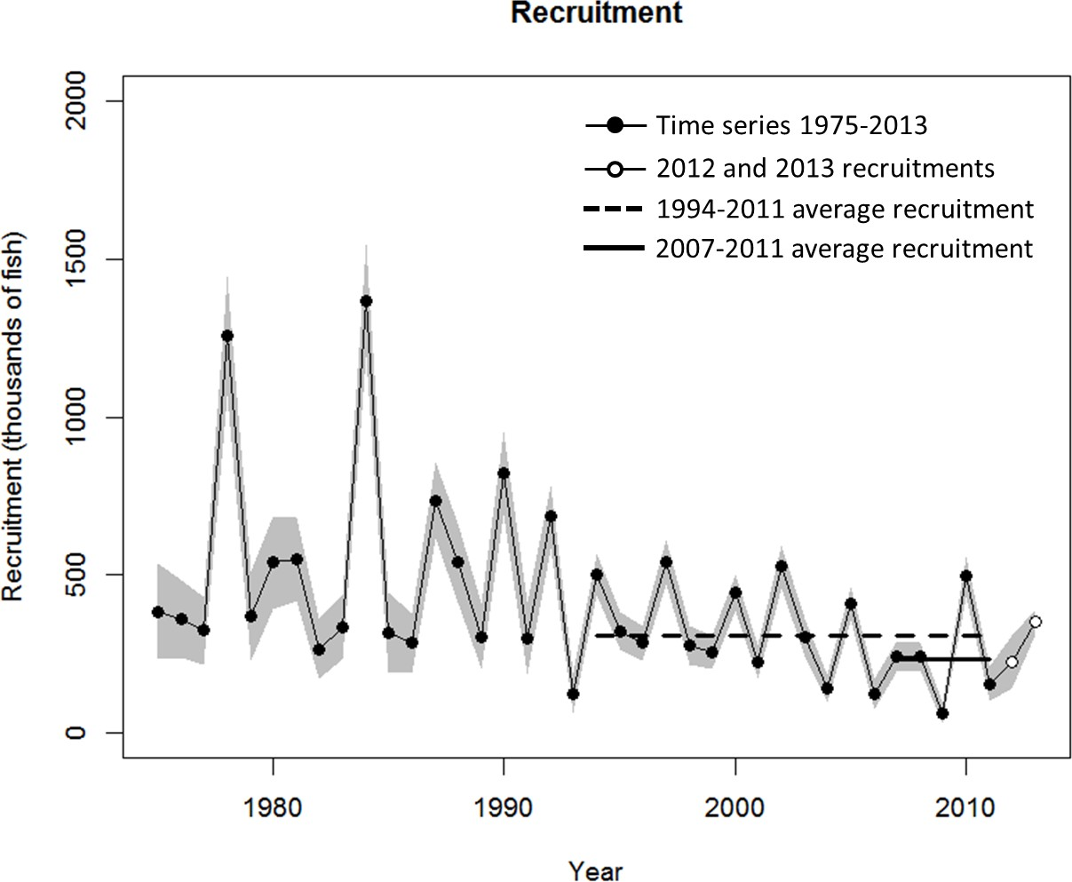

Figure A2.1. Historical trends in recruitment of WCNPO striped marlin (age -0) estimated by the update SS3 base-case model and the assumed periods of medium (1994-2011) and low (2007-2011) recruitments used for future projection scenarios.

97